Re: Department of Health and Human Services – Request for Information on Electromagnetic Fields (EMFs), Radiofrequency (RF) Radiation, and Wireless Radiation Exposure

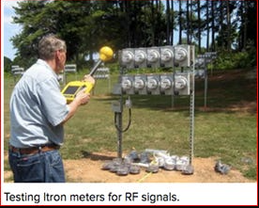
Not a biologically-based health/safety test
The smart meter health and safety question NEVER should have been diverted to local politicized battles for the right to an opt out meter.
This was a massive failure of federal policy which has proceeded under the administrations of both political parties.
The assumptions fueling the entire smart grid agenda(s) require review, and immediate intervention to protect a portion of the population from further harm, and to prevent further ratepayer investment in an inappropriate technology choice.

Confronting the Smart Meter Narrative with a focus on the “Health and Safety” “Science” past and present – among other issues

“We live in a society exquisitely dependent on science and technology in which hardly anyone knows anything about science and technology. This is a clear prescription for disaster”- Carl Sagan
Introduction/Overview: Smart Meters, Health and Beyond
Numerous writers working in the area of ‘clean energy’ have used the term “low hanging fruit”.
Edu.ba explains, “This metaphor refers to tasks, opportunities, or solutions that are easiest to achieve and provide quick results with minimal effort. Just as fruits hanging on the lower branches of a tree are the easiest to pick, low-hanging fruits in professional and personal contexts represent easy wins that require less investment but offer immediate benefits.”
The term reportedly has its roots in business and marketing, but denotes potentially far more nefarious potentials regarding the misdirection of public sentiment.
Low hanging fruit can be part of an intentional strategy of compartmentalization and manipulation, to create support for a particular agenda that would not be accepted if fully and transparently disclosed.
For example, during the Obama administration, the drive to increase the adoption of solar energy was tied to the claim that smart meters would be required, without mention of the long-range plan to eventually tie smart meters to a much larger agenda.

The industry’s talking point was that technicians needed to be able to shut down the solar systems to work on the lines, for safety. The obvious point that the meters were only necessary on homes with solar systems has never been addressed.

The strategy resulted in inadequately informed solar proponents also becoming smart meter advocates.

Another instance of industry messaging is that smart meters would/will eliminate the previous truck rolls and carbon costs necessary for starting and stopping service in the case of a move/relocation.

Less attention is given to the fact that the smart grid has greatly increased the costs of electricity, potentially resulting in increased remote (no contact) power shut offs for non-payment for low-income ratepayers. Where is that data?

Could the smart meter health issue be investigated as part of a larger effort to re-evaluate the cost-benefits of the entire paradigm?

Assessing “Health Impacts”

A 2012 health impact assessment investigated Commonwealth Edison’s proposal to introduce “smart metering” in western metropolitan Chicago, specifically looking at how the technology could affect the risk of exposure to life-threatening extreme temperatures.

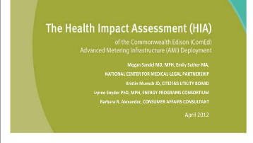

In short, the study focused on utility cost impacts and poverty.

The combination of remote shut-offs enabled by digital meters and poverty can have deadly results, especially when families without power resort to candles for lighting, or use alternative heat sources.

This early HIA research (2012) did not include questioning the impact of increased radiofrequency radiation exposures or grid impacts.

(Also ignored in the promotion of smart meter benefits is the potential hacking risk introduced by the remote, wirelessly enabled shut-off. Installing insecure infrastructure is the equivalent of a blank check to the industry for future security expenditures.

Scrutinizing the Integrity of Behavioral Modification Agendas for Real World Impacts

Very little scrutiny has been directed to the intended behavioral modification models enabled by smart meters, because many consumers have widely accepted the premise that the end goal is sustainability.
They also assume that the utilities are adequately regulated.
An assumption is that punitive pricing is needed to evoke behavioral change, without ever testing any alternative approaches, including education about peak loads.
Early on in the smart meter discussion in the Northeast, former RI Utility Commissioner Paul Roberti noted that the expectations imposed/facilitated by time varying rates do not correspond to real world circumstances – for example, the push to shift consumers to run appliances in the middle of the night.
Like whack-a-mole for utilities, this issue became more prominent due to the scenario of unattended EV charging and fires during sleep hours.
The fact that sleep disturbance accompanied nighttime appliance use, including in densified housing, (washers and dryers proximal to occupied residences that previously promoted quiet hours)) was also downplayed in favor of the ideals of clean energy.
Yet despite all of the perhaps unintended but apparent “Late Lessons from Early Warnings”, former Rhode Island regulator Paul Roberti stated,
“Despite the reservations of some high profile state officials, Consumer Reports says that a national smart-meter implementation across the United States is ‘all but a given.’ “
The question is why.

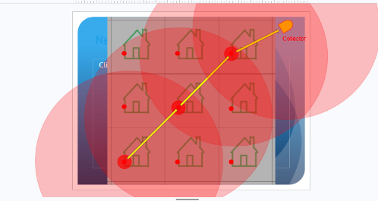
The choice of mesh network technology on the basis of compromised science is creating devastating consequences for some individuals.
Billing Inequities Resulting from Time Varying Rates

Through an extensive multi-year billing analysis in Ohio, research analyst Vince Welage has documented that time-of-use/time varying rates benefit higher consumption households with reasonable discretionary load, such as an EV charger or central air conditioning.

Households with lower consumption are subsidizing the savings awarded to high usage ratepayers, for example with central AC and EV chargers. Fixed charges and riders comprise a higher portion of the bill for low usage consumers, many of whom already observe a conservation lifestyle.

The cost shifting burden is especially pronounced for customers paying an opt out fee for a non-transmitting meter if it is even available

Any increase in costs for essential services drives a portion of the population towards the crisis of “heat or eat.”

Societal Risks of Lack of Disclosure and Informed Consent, and Compartmentalization

Insights about the risks of lack of disclosure and compartmentalization in organizations were identified by Lisa Martino-Taylor In her 2011 dissertation as a doctoral candidate at the University of Missouri.

She investigated the Manhattan Project and the covert human conducted on poor black communities by the U.S. government, involving ionizing radiation.

In 2018, her work was published as the book Behind the Fog: How the U.S. Cold War Radiological Weapons Program Exposed Innocent Americans.

As reported here: Lisa Martino-Taylor | The first secret city [] “when I started looking at the larger context about larger military contracts at the time, there was a lot of evidence that it was part of a national program that in fact included: injection, ingestion and inhalation studies on radiological materials done by a highly coordinated group of scientists-turned-military-officers that were working on the Manhattan Atomic Bomb Project. They were doing these studies around the country and they were looking for an area to target for an inhalation study. St. Louis was their closest match for Stalingrad and Moscow.”
”Parsons and the Army falsely described the experiments in the St. Louis Post-Dispatch as feasibility studies related to testing “a kind of smoke screen” to protect the St. Louis urban population from potential aerial attacks by foreign enemies.” []

Was/is sustainability the smokescreen for smart meter surveillance and control?

The narrative changes based on the prevailing political sentiment, but smart meter deployment has proceeded, uninterrupted, - without adequate transparency and scrutiny or post market monitoring and investigation.

Compartmentalization and Lack of Disclosure: Smart Meters

As a recent example of smart grid compartmentalization, when two young women arrived unannounced at my residence last spring to replace a non-working gas meter, they explained that the new meter only transmitted data once a month for billing purposes.

They could not provide a contact number for the utility when I demonstrated with a professional grade detection meter that this was not the case.

They apparently knew nothing about the specifications for the meter. I don’t think that they were lying. I think they were trained to respond in certain ways if asked.

In her research, Lisa Martino-Taylor described how college students were recruited to disperse aerosols over the St. Louis community, with no knowledge of the actual agenda.

This somewhat mirrors the approach to a lesser degree) that was used in Worcester MA for the National Grid smart meter pilot program. Earnest students at Clark University interested in sustainability were specially selected to “wear the face of the utility in the community” to promote the smart meter pilot to the public and to increase acceptance by reinforcing the idea that the pilot was created with neighbors within the community, for the community.

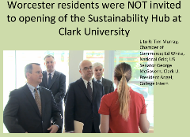

(The Sustainability Hub mentioned in the slide was a high tech dedicated storefront opened in a former bar on a corner of the Clark University campus, where ratepayers could learn about clean tech and ask questions about their bills – financed by ratepayers. Several public servants noted that rather than funding the pilot with its both on-and-off books expenses, that ratepayers would benefit more from lower bills. Although opponents of the pilot did not engage in any property destruction or violence, when the Sustainability Hub held is grand opening, there was a heavy police presence and the public was specifically not invited. The Sustainability Hub costs vastly exceeded its approved budget. over budget, yet the DPU continued to authorize additional funding. The facility was renamed the Propaganda Pub by community advocate Clare Donegan)

Were the students exploited?

The Question of Smart Meter Health Safety was Reduced to the (Highly Politicized and Patchwork) Question of Opt Outs Policies, Posing Endangerment to a Portion of the Population. This is not Science.

In Worcester, MA, the auto-enrollment, behind-schedule, and over-budget pilot was in fact co-created with a large number of actors, behind the scenes, and foisted on the community, with the public in the role of guinea pigs.

Then Attorney General Martha Coakley objected to the pilot program’s size, cost, and scope. She objected to the automated shut-off noting that it posed a hacking risk. (The pilot’s authorization proceeding MA DPU 11-129 is filed at: Docket No.11-129 – Mass DPU Fileroom)

The pilot program featured a no-fee opt out, which was heavily promoted as indicative of the utility’s commitment to customer choice.

The no-fee opt out was only necessary because the meters were being installed on the premises of auto-enrolled customers.

This was just one aspect of the pilot’s theater that did not correspond with the long range plans for the utility
.
Another was that the pilot was rewarding customers who visited the website even once, so that they could be counted as “active participants.” The pilot was gamified with participants eligible to receive Ipads and gift cards.

These practices have not been replicated in any actual deployment.

The pilot was conducted several years after other deployments were already completed in other states, and the pilot appeared to be designed specifically to address and nullify many of the issues that had emerged.


“Voices of Experience” is a DOE-curated collection of utility and customer stories that can help utilities, policymakers, and consumers understand how smart meters are being deployed, what works, and how to improve engagement and trust. Voices of Experience: New Guide Offers Utilities’ Insights on Engaging with Smart Grid Customers | Department of Energy

The pilot did not monitor for health or environmental impacts.

Many local and state public servants played supporting roles for the utility, including planning officials, the property assessor, and in particular, the health department’s alarming report.

In addition, serious concerns about the results reporting have been documented and never addressed publically. Misleading claims about cost and energy savings continue to be repeated in current proceedings.

One approach to investigating the health and safety aspects of smart meters would be a larger investigation involving other agencies, that would include but not be limited to the question of how health issues were addressed.

Giving the relevant individuals and agencies an opportunity to self-report the need for improved policies regarding both transparency, and specifically the information about how often the meters transmit, and health and safety requirements, could be a diplomatic starting point.

Soliciting whistle blower reports and placing high emphasis on citizen science would also be helpful.

Regarding health, valuable data and insight about harm is held within the community of injured ratepayers and those who have attempted to assist.

Bending Science – Decision-based Evidence Making vs. Evidence Based Decision Making Highlights the Risks of Misuse of Data, especially if it Involves Harm to Health and it is Never Even Collected

In their book Bending Science: How Special Interests Corrupt Public Health and the Environment, Thomas O. McGarity and Wendy E. Wagner have identified corruption in the science/policy-making pipeline.
Bending Science — Grokipedia:
“Bending science refers to the deliberate distortion or selective presentation of scientific research by special interests to influence regulatory decisions, litigation, and public policy, often in domains affecting public health and the environment.¹
This practice involves tactics such as commissioning biased studies, amplifying uncertainty in data, suppressing inconvenient findings, and deploying legal maneuvers to challenge evidence, thereby delaying or derailing protective measures.²
The concept was systematically articulated in the 2008 book Bending Science: How Special Interests Corrupt Public Health and the Environment by University of Texas law professors Thomas O. McGarity and Wendy E. Wagner, published by Harvard University Press.²
Drawing on public records and case studies, the authors outline a repertoire of strategies employed primarily by corporations and advocacy groups, including "strategic delay" through endless data requests and "tactical diversion" via alternative research narratives that prioritize economic interests over empirical rigor.¹
These methods exploit gaps in regulatory frameworks, where science informs but does not dictate policy, allowing interested parties to "bend" findings without outright fabrication.³
While the framework highlights industry-driven abuses—such as those seen in tobacco, chemical, and pharmaceutical sectors—empirical patterns indicate that analogous manipulations occur across ideological lines, including by government entities seeking to align science with political agendas, as documented in critiques of federal research oversight.^{45 –}
Claimed Patterns of Influence McGarity and Wagner posit that special interests systematically "bend" science by exploiting vulnerabilities in the research and regulatory processes to generate uncertainty about health risks, a tactic they trace as originating with the tobacco industry's playbook in the mid-20th century and extending to sectors like chemicals and pharmaceuticals by the 1980s and 1990s.¹⁶
This manufactured doubt involves commissioning studies designed to highlight methodological limitations or conflicting data, thereby equating well-supported consensus views with minority opinions lacking empirical backing, which delays regulatory action despite accumulating evidence of harm.¹⁷
The authors argue this pattern persists due to incentives where industries prioritize short-term profits over long-term public health, funding research through proxies to obscure direct conflicts of interest.¹⁸
A recurring mechanism claimed is the strategic funding of research by trade associations and product defense firms, which selectively amplify uncertainties—such as variability in exposure assessments or animal-to-human extrapolations—to undermine regulatory thresholds, often without transparent disclosure of sponsorship.¹⁶
This extends to influencing peer review and publication by supporting journals or panels predisposed to skepticism, creating an illusion of scientific debate where none substantively exists based on the weight of evidence.
The book contends these tactics are not ad hoc but institutionalized, with industries investing millions annually in "sound science" campaigns that rhetorically demand higher evidentiary standards for regulation than for product approval.¹⁷
Influence on regulatory agencies like the EPA, FDA, and OSHA is asserted to occur through substantial lobbying expenditures, coupled with revolving door placements in which many senior appointees had prior industry ties, predisposing decisions toward prolonged data requests or risk reassessments favoring deregulation.¹⁹
McGarity and Wagner highlight how this political bending integrates with scientific manipulation, as agencies face pressure to incorporate industry-generated data, effectively stalling rules on substances linked to significant health risks and fatalities, such as silica dust or certain pesticides, until political winds shift.¹⁸
These patterns, per the authors, erode public trust in science by prioritizing adversarial litigation-style scrutiny over precautionary principles grounded in probabilistic risk assessment “.¹⁶
Bending Science — Grokipedia
According to the criteria in the book Bending Science, both the Worcester National Grid smart meter pilot program and the current FCC’s re-opening of 13-84 bear the marks of corruption of the science pipeline.

I believe that the public’s tolerance for bent science, combined with exorbitant utility bills, is waning.

The Health Question and Opt Out Debacle is Unfolding Now in Real Time in MA, RI, and parts of New York; These Are Health Issues that Never Should Have Been Politicized and Dismissed

Some Massachusetts residents are currently seeking opt-outs from the new AMI meters. (Opt out meters are required by the MA state regulator to be offered as part of its grid modernization authorization, with the option for the utility to impose a surcharge.)

Although the MA DPU specified an analogue opt out, utilities across the county claim that analogues are no longer available, and instead are providing a digital meter with the radio turned off. This does not resolve the issue of polluted power quality, and radio off meters have been found to have been reactivated after installation.

You can see DPU confirm opt-out fees in Order DPU 21-80-B, -81-B, -82-B, https://fileservice.eea.comacloud.net/FileService.Api/file/FileRoom/15824167
D.P.U. 21-80-B/D.P.U. 21-81-B/D.P.U. 21-82-B Document (not PDF) Pages 307-308
IV. OPT-OUT TARIFF
B. Proposals
NSTAR Electric submitted an AMI opt-out tariff modeled after National Grid’s existing AMR opt-out tariff (D.P.U. 21-80, Exhs. ES-AMI-1, at 41; ES-AMI-6). NSTAR Electric proposed the following fees: (1) $42 for the removal of an advanced meter or installation of an analog meter; (2) $34 for monthly meter reading; and (3) $42 for the re-installation of an advanced meter (D.P.U. 21-80, Exh. ES-AMI-6, at 1).
National Grid submitted a modified version of its existing AMR opt-out tariff, M.D.P.U. No. 1215 (D.P.U. 21-81, Exhs. NG-AMI-1, at 23-24; NG-AMI-7; NG-AMI-8). National Grid proposed the following fees: (1) $26 for the removal of an advanced meter or installation of an analog meter; (2) $11 for monthly meter reading; and (3) $26 for the re-installation of an advanced meter (D.P.U. 21-81, Exh. NG-AMI-7, at 2). The fees in the proposed tariff are unchanged from the existing tariff (D.P.U. 21-81, Exh. NG-AMI-8, at 2).
Unitil did not submit an opt-out tariff and requested a waiver from the opt-out tariff requirement (D.P.U. 21-82, Exh. Unitil-KES-1, at 22). Unitil cited its unique situation, where AMI metering has been in place for more than ten years without an opt-out tariff and meter data is not transmitted through radio frequencies (D.P.U. 21-82, Exh. Unitil-KES-1, at 22).

Special alert on document page 307, also document page 312: DPU specifically refers to "analog meters."

What is Happening in MA with Smart Meter Opt Outs?

One MA ratepayer recently moved to a home that already had a new transmitting smart meter installed. Due to dangerously high nighttime spikes in blood pressure seemingly provoked in the new residence, an opt out meter was requested as a matter of extreme urgency.

The utility National Grid (a UK company) initially indicated that there could be a one-month delay for receiving an opt out meter, in part because they are using a subcontractor to install the opt out meters.

(This information about the subcontractor was shared by an NGrid employee The customer had filled out the on-line form registering concerns about heath harm [being suddenly awoken with skyrocketing blood pressure]. The customer followed up with a phone call several days later to inquire about the delay in having the meter removed, with no response.
A form letter was sent in the mail from the utility describing how to undo the opt out request if it was in error.
During a subsequent ½ hour call the employee explained that the opt out requests needed to be consolidated because an independent contractor is used, and that a one-month delay might occur.
After a call to the regulator, the utility reported that they would replace the meter on a Friday, but they never showed up or informed the ratepayer that they were not coming. The utility regulator who had also been contacted called and claimed that the home did not have a smart meter.
The delay tactics in providing an opt out meter are examples of unnecessary administrative overlays that increase costs for all ratepayers.

Also in Massachusetts, the investor-owned utility Eversource recently contacted its opt out customers because the opt out meters it had installed were found to be transmitting.

Those customers who paid an opt out fee were being surcharged each month. Now another meter needs to be ordered and installed. The utility appropriately offered to refund the opt out fees, but the debacle in terms of providing an opt out meter continues.

Opting out is not even effective in densified housing, indicating that health is not being viewed as a legitimate issue.

This is not science.

The utility National Grid came to install an opt out meter that was found to be still transmitting, even though the customer filled out the paperwork for an opt out meter.
She was then instructed to call back and to request a non-com meter, stating that the meter that they provided for an opt out meets the needs of some customers because it uses a different type of radiowaves?

The choice to utilize a mesh network may be the reason for the utility to want to place a transmitting meter on some opt out premises?

Vendors can program the meters to whatever specs the industry needs. For example, APS in Arizona provides a true non-transmitting meter that does not pollute premise power quality for its opt out customers - the Itron C1S meter.

Placing a national priority on providing a true non-harming analogue meter on homes where health harm is an issue is possible. Utilities cannot assure the safety of all ratepayers with the current technology choice.

Previous History of Opt Out Provisions

The NCSL (National Conference of State Legislatures) may be regarded as an authority for providing decision-makers with up-to-date information about smart meter opt out policies across the country. Note that the organization presents smart meters as inevitable, and as progress.
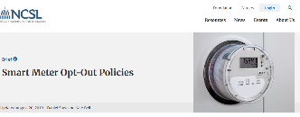
Smart Meter Opt-Out Policies
Updated August 20, 2019

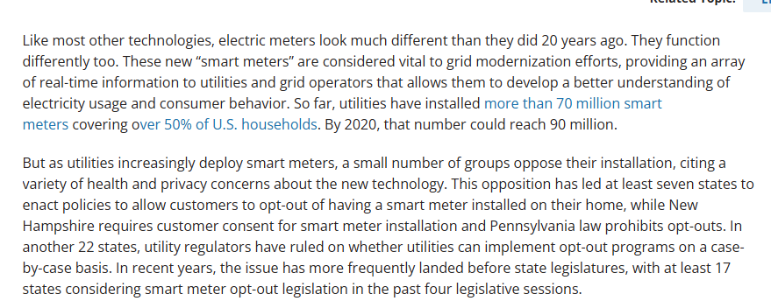

The opt out information has not been updated. I will return to the question of the science promoted by NCSL later in this testimony.

Epstein; A development built around "asset tracking, video surveillance, and smart devices"

Very few utility consumers are yet aware of the revelations contained within the Epstein files regarding the creation of surveillance-ready communities, as reported by Alisa Valdes-Rodriguez here:

“Sandia National Laboratories sits on Kirtland Air Force Base in Albuquerque. It is responsible for the non-nuclear components of American nuclear weapons — the triggering systems, the delivery mechanisms, the backbone of how America’s arsenal actually works. []

Mesa del Sol broke ground in 2005 and was under active development through at least 2015. Zorro Ranch — Epstein’s New Mexico property — sat approximately 60 miles to the north, also on state-adjacent land, also operating during this same window. Both properties had relationships with New Mexico’s State Land Office. Both operated under the political protection of the Richardson-Denish administration. Richardson himself — documented in the Epstein files as having visited Little Saint James and having continued meeting with Epstein in his Manhattan townhouse as late as 2018 — was the governor who personally pushed the Mesa del Sol tax financing through the Legislature.

Mesa del Sol’s own planning documents describe a development built around "asset tracking, video surveillance, and smart devices" — with a stated goal of creating what the developers called a "safe neighborhood networking solution." That’s where Sandia’s interest lay.
Smart meters were installed in residential buildings. Granular data on residents' energy consumption, movement patterns, and daily behavior was collected continuously and is publicly available today on machine learning research platforms. A real-life Truman Show, for military surveillance of civilians.
Sandia National Laboratories — the nuclear weapons facility whose systems Robert Maxwell compromised with backdoored surveillance software in 1985 — was the technical partner overseeing this infrastructure. Japan's government energy agency invested $22 million in the project. Nine Japanese companies were involved.
The people of New Mexico were sold a hip, cutting-edge residential community. What we were actually being asked to move into at Mesa del Sol was a federally partnered, nationally significant data collection testbed — built on state trust land, financed with half a billion dollars in public bonds, developed by a company whose founding family appears in Jeffrey Epstein's files, with the second-in-command of the state's husband on the payroll. – Source
A community built for covert surveillance requires residents who are surveil-able.
Those whose energetic immune systems detect night-time data transfers and the fine tuning of 5G transmissions from cell towers to provide more coverage during commutes, or the addition of more antennas and more exposures. present an inconvenience.
Opt out Policies Do Not Imply Science
Unfortunately, the U.S. has chosen to proceed with the installation of smart meters and a “smart grid”, promoted in part via a carrot that consumers will “save money” and “make better energy decisions,” without disclosing that the cost of electricity may vary considerably based on the choices of for-profit monopoly corporations.
The smart meter health and safety question NEVER should have been diverted to local politicized battles for the right to an opt out meter.
This includes punitive surcharges, double billing, excluding densified housing from reasonable protections, not providing an analogue opt out meter to address polluted power quality, and not investigating and addressing the reported health harm and acute onset of disability.
This was a massive failure of federal policy which has proceeded under the administrations of both political parties.
The meters are introducing undisclosed increased surveillance and customer behavioral control capabilities enabled by time-of-use/time varying rates billing schemes.
Evidence that the demand to power data centers may be met in part by diverting electricity from residences, enabled by the meter technology, are now emerging in some states, including Ohio.
With a new national/political focus on supporting the growth of AI and 6G, the health and safety question has been overlooked completely.
Many legitimate concerns about smart meter deployment that could have informed future design and policy making were minimized, ridiculed, dismissed and ignored, including but not limited to adverse health effects.

In Contrast, The German Approach to Intelligent Metering
Germany has instituted a very different policy for its intelligent metering, and is only installing a transmitting module on the homes of consumers with reasonable discretionary load.
The German digital meters also are not collecting and transmitting personal usage data whereas in the United States the dual use smart meters are being incorporated into a surveillance and control grid – (at significant additional complexity and cost to ratepayers).
Germany’s approach to intelligent metering not only reduces upfront costs, and does not require the data collection, transmission, and storage but it most likely does not introduce two simultaneous risks introduced in the United States – the increased radio frequency exposures and the pollution of the home electric supply with high voltage transients introduced by the digital device, which them emanate into the occupied living space.
German citizens may be more attuned than Americans to the risks of both propaganda and state and/or other centralized abuses of power.
Why Question Smart Meters Now?
A 2017 Arizona court case resulted in a ruling allowing for a non-transmitting meter to be installed for those requesting the opt out, with a $5/month surcharge for a manual read.
The entire smart meter agenda could have benefitted from the testimony and ruling of the Arizona court case brought by Warren Woodward against APS.
Vermont has a no-fee opt out.
Many customers cannot afford the punitive opt out fees being charged, and the state of Pennsylvania is not offering a smart meter opt out, with devastating health impacts for some ratepayers.
As the AMI infrastructure is installed in the last few states, there is an opportunity to revisit the issue of health and safety in real time, an/or to document the results of meter installations and removals with appropriate science.
Smart Meters are Costing Ratepayers $$$, Loss of Privacy, and Health
Many Americans are experiencing the consequences of rising costs for essential services including heat, electricity, gas, propone, and water, with no relief in sight.
In addition, many Americans are objecting to surveillance as they become aware of automated license plate readers and other technologies aimed not at adversaries, but inward towards the nation.
And, as information is being brought to light in any number of areas about wrong-doing, including the Epstein files, at least a portion of the population supports corruption being addressed.
Individuals who are committed to the ideal of clean energy have extended an unquestioning attitude of trust and policy support for the ideals of progress in clean energy, but are vastly uninformed about unintended consequences.
Much of the surveillance agenda has also proceeded under the guises of “safety.”
Data centers have become a flashpoint for the upcoming election, but scrutiny of the effects of all of the data flying through the air has yet to reach critical mass.
In a play out of the tobacco playbook, the wireless industry has focused the public’s attention on the issue of brain cancer and cellphones.
Cancer can take a long time to develop and the burden of proof is extensive.
Critical mass was reached in the tobacco wars when a Japanese researcher proved that the widows of smokers were also dying of lung cancer. In the years following, many other adverse outcomes, including other types of cancer, became known.
In the case of RF, the source of the exposure is invisible, but in terms of the science, there may be new opportunities to verify adverse effects on the brain, including the impairment of the brain’s detoxification system.
Like tobacco, it is likely that we will soon understand that there is a basis for the fact that different individuals will experience different adverse impacts from the same exposure.
But in addition to supporting non-industry science, another approach would be for Health and Human services to simply investigate the “science” that has been historically promoted by the industry and its regulators about the juxtaposition of RF and the utility grid.
Why Mention Tobacco Scientists?
Many groups and individuals especially on the political left have been chronicling the fossil fuel industry’s use of what has become known as the tobacco industry playbook and its impact on scientific integrity, litigation, and policy making.
But the same groups and individuals cast a blind eye when they received complaints about the experts testifying in favor of smart meter health and safety.
Low hanging fruit would be reversing the burden of proof of safety back to the industry and regulators, and away from the public to prove harm.
This would include rejecting the so-called expertise of a very small number of product defense/ mercenary tobacco scientist whose opinions are bought and paid for, and whose work prevailed with public utility commissions, legislatures, and municipalities across the county.
Product Defense and Smart Meters
With smart meters,tobacco science came to the rescue of another inadequately regulated industry that was causing harm.
But it was no longer product defense.
Compromised expertise was used offensively against the public because there were inadequate checks and balances to prevent the erosion of science pertaining to health and safety.
It is not too late to bring integrity to the safety inquiry.

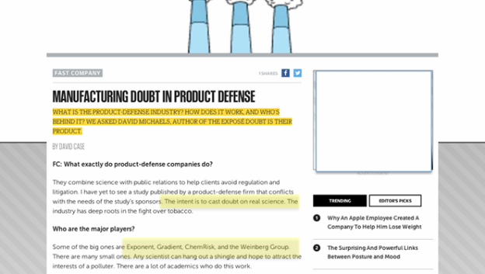
Manufacturing Doubt in Product Defense - Fast Company

Early Framing of the Smart Meter Health and Safety Issue
From the start, the industry, regulators, and allied interests shifted the “burden of proof” for harm to the public, instead of requiring biologically-based premarket proof of safety.
Massachusetts and Rhode Island and parts of New York are currently deploying smart meters, and the state of the safety conversation is now on display on the websites of the investor-owned utilities involved. Not much has changed in 15 years.
These deployments offer an opportunity to witness the current state of the health science unfolding in real time.
National Grid’s MA site currently offers; Meter Safety | National Grid (accessed 10/20/27)
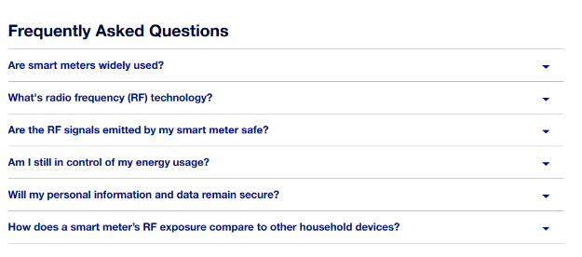
Scrolling down to the question:
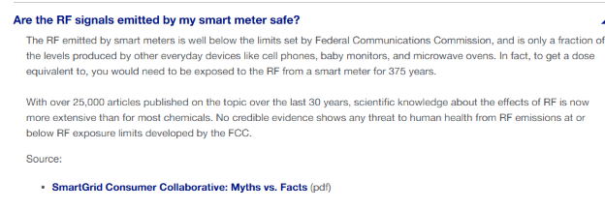
(Working link to unsubstantiated flyer from the SmartGrid Consumer Collaborative from screen shot above.:1009-WaltBaum04.pdf)
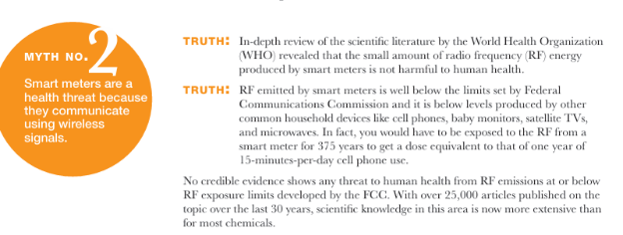
Re; the quote referencing the 375 years comparison to cellphones offers no source for the calculations.
The word “credible” is utilized to strategically to nullify reported harm.
The link to another page on the website takes the reader here:

The drop down menu is below.
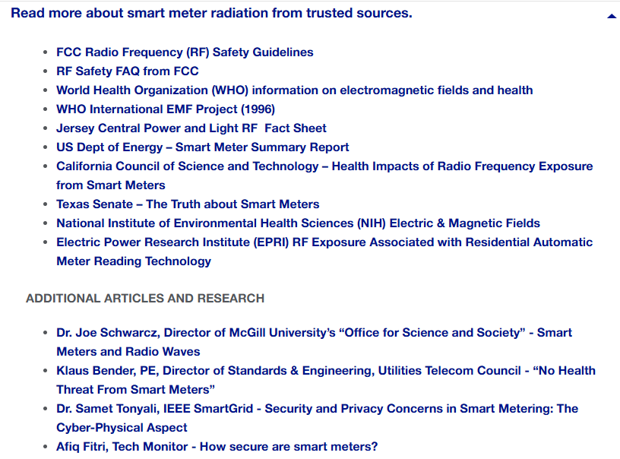
(Hyperlinks are not live because this is a screen shot. Listings are edited for length).
In the first grouping of resources, the Jersey Central Power and Light RF Sheet is here:
New Jersey Smart Meter radio frequency fact sheet
In fact, smart meters produce significantly less RF exposure than other common electric devices, such as cell phones, baby monitors, wireless routers, laptop computers and microwave ovens. What’s more, RF exposure depends partly on the proximity of the RF source to a person. Smart meters are usually located on the outside of your house in a metal box, away from your daily routine activity. Due to the extremely brief exposure to the radio waves that smart meters produce, there have been no long-term health effects identified as a result of the installation of smart meters, according to a study conducted by the California Council on Science and Technology.3
The CCST “study” linked above is described here:
Abstract Smart Meters are electronic monitoring devices that continuously measure the electricity output from each household and business. They communicate on a regular basis back to the utility. The goal is to enable power companies to better understand patterns of power consumption throughout the day and adjust power generation accordingly.
At the request of Assembly Member Jared Huffman (Marin) and Assembly Member Bill Monning (Santa Cruz), CCST agreed to compile and assess the evidence available to address the following two issues:
- Whether FCC standards for SmartMeters are sufficiently protective of public health taking into account current exposure levels to radiofrequency and electromagnetic fields.
- Whether additional technology specific standards are needed for SmartMeters and other devices that are commonly found in and around homes, to ensure adequate protection from adverse health effects.
CCST found that, given the body of existing, generally accepted scientific knowledge regarding smart meters and similar electronic devices, the FCC standard provides an adequate factor of safety against known RF induced health impacts of smart meters and other electronic devices in the same range of RF emissions. At this time, there is no clear evidence that additional standards are needed to protect the public from smart meters or other common household electronic devices.
The final version of the report takes taking into account input and reviews received during the public comment period in January. Comments received as part of this process have also been released.

The CCST paper is not a “study.” It is an opinion.
It was “published March 31, 2011 (Last Updated: February 20, 2015)”
The link to Texas Senate – The Truth about Smart Meters is a link to the same flyer that is provided by the Smart Grid Consumer Collaborative, a non-profit industry group which incidentally has no consumers, and has since been rebranded The Smart Energy Consumer Collaborative:

“SECC is a nonprofit organization that works to learn the wants and needs of energy consumers in North America, encourages the collaborative sharing of best practices in consumer engagement among industry stakeholders, and educates the public about the benefits of smart energy technology”.

Most of the resources listed are from the engineering community, and none represent research regarding smart meters and human health and biology.
The allied organizations are simply parroting a theory that there are no non-thermal impacts for non-ionizing RF radio frequency radiation, and therefore smart meters are safe.

In the second grouping of additional resources, there are four listings:
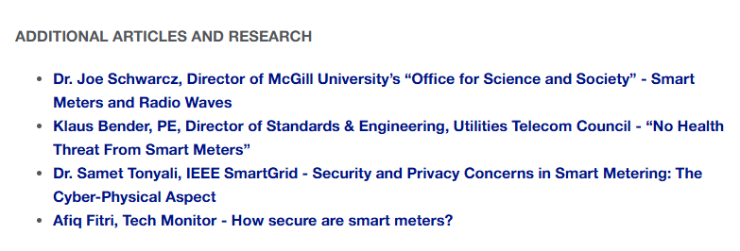
The first link is an article, not a study: Dr. Joe Schwarcz, Director of McGill University’s “Office for Science and Society” - Smart Meters and Radio Waves is the article “Smart Meters and Radio Waves "Are the new Smart Meters from Hydro Quebec safe? Are they different from a cordless or cell phone when it comes to RF emissions?" March 20, 2017
AuthorJoe Swartz is listed as a PhD, not a MD:
Cell phones, microwave ovens, wi-fi, smart meters. What do they have in common? They all emit radiation in the radiofrequency range. And they all radiate controversy. Given that these devices are set to become as commonplace as light bulbs, it is understandable that questions arise about their possible health effects. There are all sorts of allegations that exposure can trigger ailments ranging from headaches to cancer. Allegations, however, do not amount to science. And there is a lot of science to be considered.
The “smart meters” that are being installed by electrical utilities monitor the use of electricity and relay the information via a built-in radio transmitter. But the radiation to which people are exposed from these meters quickly drops off with distance, as with the light bulb, and is way below established safety limits. Furthermore, the smart meters only transmit for a few milliseconds at a time for a grand total of a few minutes a day! Cordless phones, cell phones, routers, baby monitors, video game controls and especially operating microwave ovens expose us to similar radiation, usually at far higher levels. Smart meters are responsible for a very small drop in the radiofrequency photon bucket. []
It must be pointed out, though, that safety standards are essentially based on the heating of tissues. But what about the possibility of “non-thermal” effects? What if radiofrequency photons cause damage by some other mysterious mechanism? Over the last 30 years more than 25,000 peer-reviewed papers have been published on electromagnetic fields and health, many devoted to non-thermal effects. Health agencies do not find present evidence persuasive of a hazard at ordinary exposure levels, and given the extent of research that has been carried out, it is unlikely that one will be identified in the future.
Despite the weak evidence, the International Agency for Research on Cancer has classified electromagnetic fields associated with radiofrequencies as “possibly carcinogenic,” indicating a level of suspicion without any implication that the fields actually cause cancer. This notion pertains to cell phone use and has nothing to do with the far weaker fields associated with wi-fi and smart meters. I would have no issue with a smart meter in my house.
What then about those consumers who claim they have developed symptoms after smart meters were installed? I think it is appropriate to consider John Milton’s poetic view of the power of imagination: “The mind is its own place, and in itself can make a heaven of hell and a hell of heaven.”
Translation: It’s all in their heads.

The Second Link: Klaus Bender, PE, Director of Standards & Engineering, Utilities Telecom Council - “No Health Threat From Smart Meters” 2010, Excerpted from the Fourth Quarter 2010 Issue of the UTC JOURNAL. 9 pages
“So, when confronted with complaints that say smart meters cause a variety of health effects, ask the compliantant to produce the science to support the claim. The conversation should end shortly thereafter. “

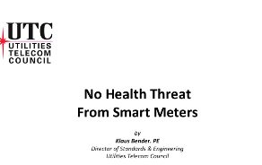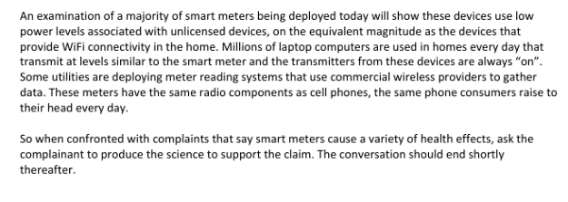

Third Resource: Dr. Samet Tonyali, IEEE SmartGrid - Security and Privacy Concerns in Smart Metering: The Cyber-Physical Aspect July 2018 re Security, not Health

Fourth Resource: Afiq Fitri, Tech Monitor - How secure are smart meters? August 2022, How secure are smart meters? Despite huge investments in cybersecurity by energy companies, concerns persist about the vulnerability of smart meters to breaches, not Health

The Smart Grid Consumer Collaborative’s work (mentioned on pages 13,14) and still being disseminated on utility websites.

In how many other product fields do these offerings pass as proof of safety, and in how many other fields is “science” this old passed off as up-to-date?

Who was the Smart Grid Consumer Collaborative? Members included a number of public utility commissions, environmental groups, and industry groups, all of whom ignored reported harm
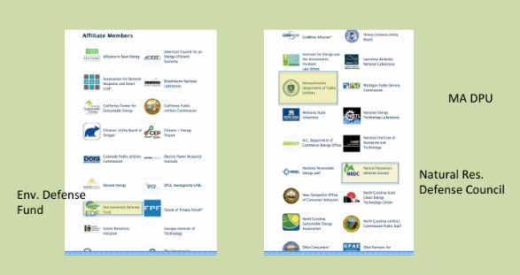

Who is/was the Smart Meter Safety Expert for the Smart Grid Consumer Collaborative?

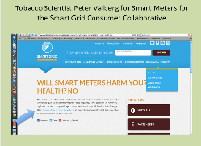

Gradient Tobacco Scientist Peter Valberg

Valberg’s testimony submitted in Maryland was referenced in other state’s proceedings.
For example here for Florida Power and Light: Microsoft Word - Valberg Testimony_4-5-2012.docx
Nome of the links in his testimonies actually reference smart meter safety research because no actual health and safety research was conducted

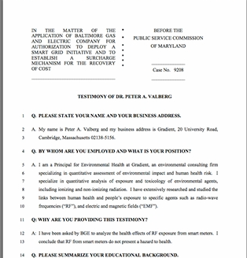
Microsoft Word - Valberg Testimony_4-5-2012.docx 11 pages
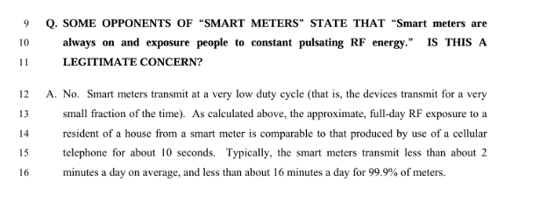
Despite the fact that ratepayers in many areas objected to the compromised science and reliance on this source of expertise, Valberg and/or other tobacco scientists prevailed.
Does this constitute malfeasance on the part of some decision-makers?
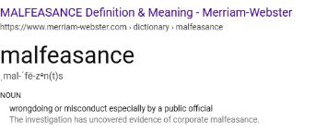
How Many Transmissions?
The obfuscation of the actual number of times that a meter transmits came to light in California, after an explosion of health complaints associated with the highly publicized installations over fifteen years ago.
As reported by the EMF Safety Network here: PG&E’s Big Confession
“PG&E’s paltry, inconsistent and contradictory information on RF emissions from Smart Meters is unbelievable and at odds with other RF expert findings. Several PG&E bulletins and spokespersons make varying claims on how often the Smart Meter electric meters transmit RF, anywhere from every hour to every 4 to 6 hours to 2% or 4% of the time.
We just wanted the facts, but the CPUC rubber stamped PG&E’s claims of RF safety and dismissed our application stating:
” All radio devices in PG&E’s Smart Meters are licensed or certified by the FCC and comply with all FCC requirements.”
“Smart Meters produce RF emissions far below the levels of many commonly used devices.”
PG&E provides information from Richard Tell Associates on their website titled, “Supplemental Report on An Analysis of Radiofrequency Fields Associated with Operation of the PG&E SmartMeter Program Upgrade System”
This report states Smart Meters transmit at 1 watt with 0 antennae gain. It claims:
The 1 watt transmitter is configured to transmit data approximately once every four hours back to the company so its duty cycle is very small (the actual data transmission duration during any four hour period will vary, however, depending on how often a particular meter transmitter acts as a repeater for other nearby meters).
From PG&E’s Smart Meter FAQ: SmartMeters™ utilize a low power (1 watt) wireless radio to send customer energy-usage information wirelessly to PG&E for data collection.….
Do electric SmartMeters™ constantly emit RF? PG&E answers:
No. SmartMeters™ communicate intermittently, with each RF-signal typically lasting from 2 to 20 milliseconds. These intermittent signals total, on average, 45 seconds per day. For the other 23 hours and 59 minutes of the day, the meter is not transmitting any RF.
In a letter to Congresswoman Lynn Woolsey, the FCC writes, “the devices [Smart Meters] normally transmit for less than one second a few times a day and consumers are normally tens of feet or more from the meter face…”
CPUC administrative law judge Amy Yip-Kikugawa ordered all investor owned utilities (IOU’s ) to answer Smart Meter radio frequency (RF) questions. PG&E’s answers are an astounding confession!
Question 2: How many times in total (average and maximum) is a smart meter scheduled to transmit during a 24-hour period?
PG&E says the average number of RF pulses for the electric meter would be about 10,000, per meter, per day and the maximum number over 190,000.
90% of these pulses are for the mesh network maintenance (signals bouncing from homes) and only 6 pulses are for reading the meter data. This doesn’t include Home Area Network transmissions.
How about peak power figures? The PG&E electric meter transmits at 900MHz with 1 watt of transmit power. It has an antennae gain 4.0 dBi for a peak level power of 2.5 watts. That’s two and a half times more than their safety data stated. The wireless gas meters transmit between 4 and 5 times a day at 132-794 mW. Answers provided by San Diego Gas and Electric and So Cal Gas were similar, although PG&E electric meters appear to be five times stronger, just like Sage Associates found in their study. – EMF Safety Network.
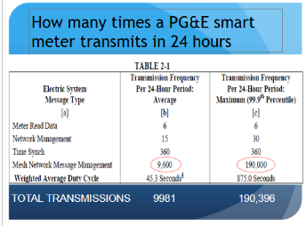

Forensic Evidence in a Massachusetts Home, Transmissions Every Ten Seconds
In her anonymous testimony to the HHS; “Submitted by Anonymous: An 80-year old Massachusetts widow and grandmother driven from my owner-occupied townhouse – by smart meter radiofrequency radiation, when harm had already been reported years earlier,” forensic evidence is provided indicating that the meters being deployed in MA were transmitting every 10 seconds. Exposures from banks of meters have never been questioned by the FCC or the industry.
Readings from a Townhouse with Multiple Meters, Explanation Courtesy a Certified Building Biologist:
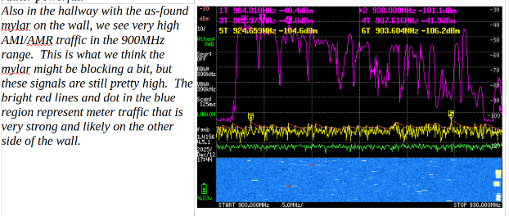

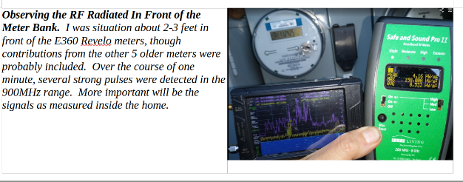
There is a very strong local FM radio station but the smart meters were at least double that strength (>= 4 dB).
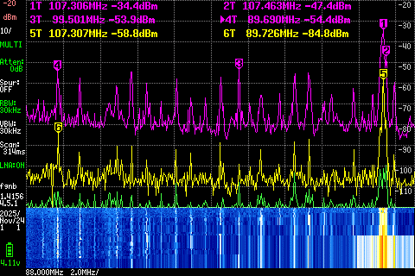

Other signals in the condo were generally at least 4X - 40X lower in peak value than the ongoing smart meters (~6 - 16 dB). The owner does not employ much wireless technology in her home, except for short periods.
When the neighbor is active, then their WI-FI or cell signal do increase the exposure, but it is for a relatively short time period by comparison to the 24/7 impact of the smart meters for those dozens of condos.
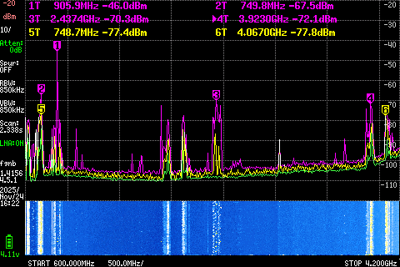

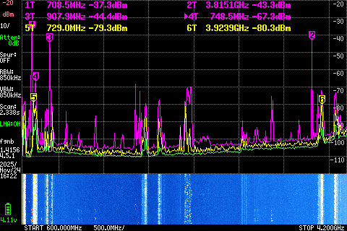

Everywhere in the apartment, there is a constant assault from the NGrid AMI/AMR meters.
The blue represents the history of the last 10 seconds.
Every little horizontal 'dash' represents a short data pulse portion on the order of a few milliseconds in duration.
There is not a second that went by in which some AMI/AMR RF broadcast was detected inside her condo.
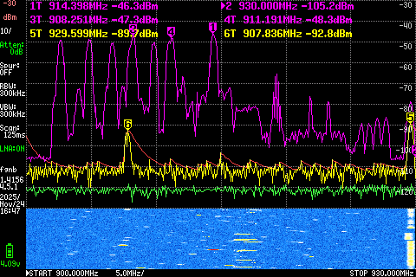

Here is the current claim that National Grid makes about how often the meters transmit:
Meter Safety | National Grid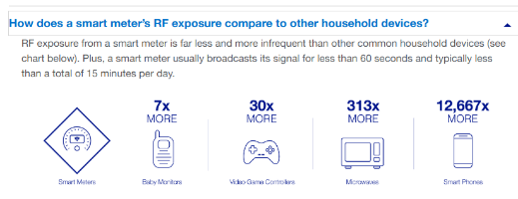
Meter Safety | National Grid

Eversource currently avoids the question about how often the meters transmit, simply referring to “low levels”

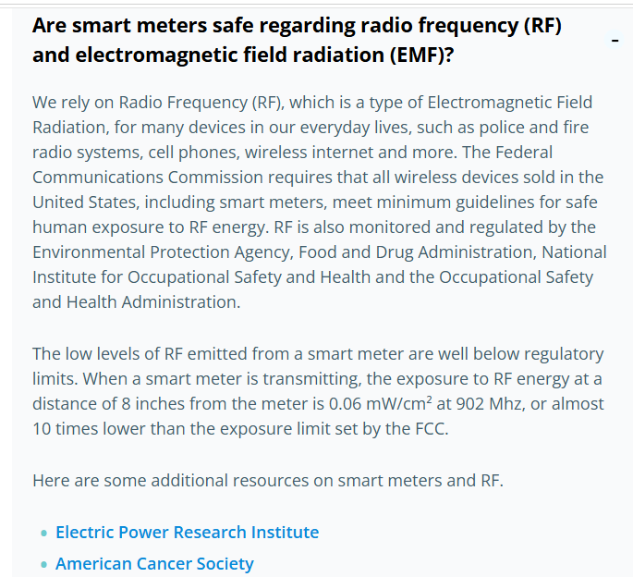

Any investigation of the biological impact of the meters on health requires accurate data about the actual exposures created by the meters and supporting infrastructure.
This includes not averaging the peak exposures, and paying attention to the all of the variables for the different transmissions.
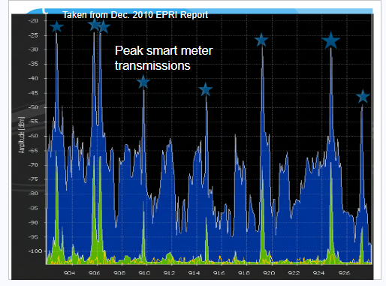
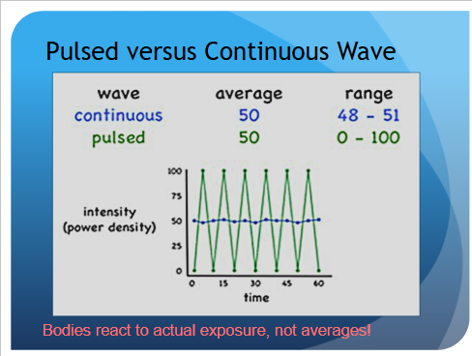

Beyond the Smart Grid Consumer Collaborative, how extensively has the reach of tobacco science infiltrated the smart meter safety discussion?

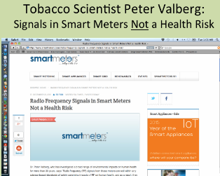

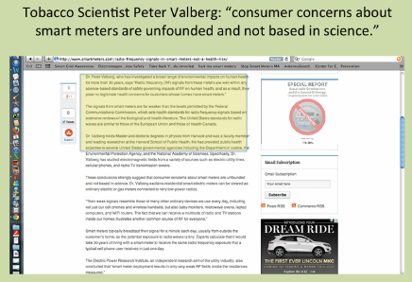
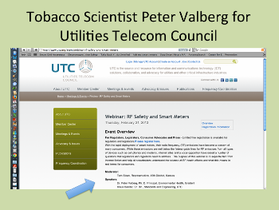
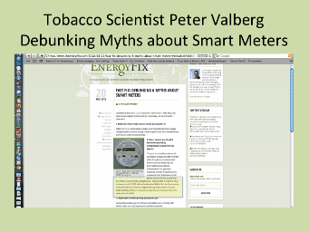
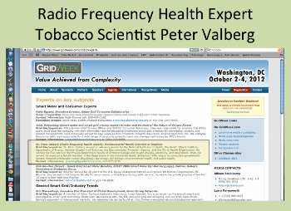
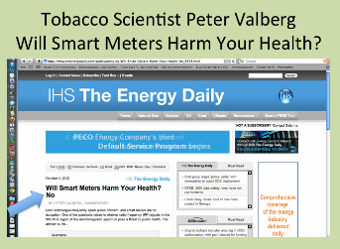
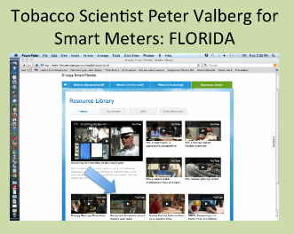
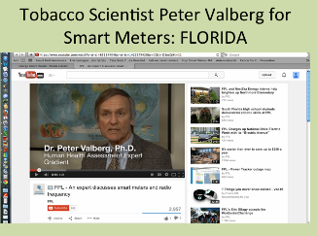

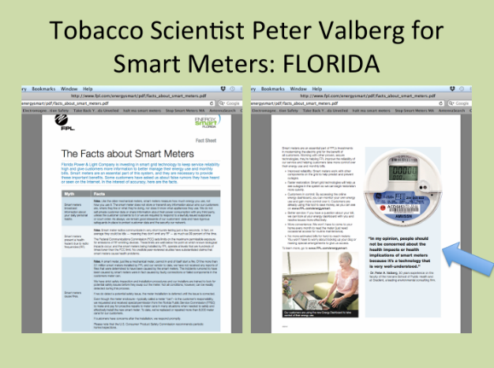

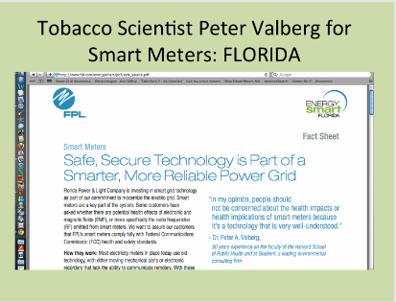
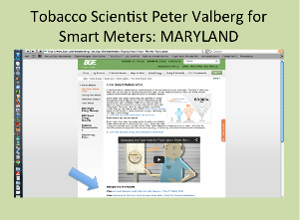

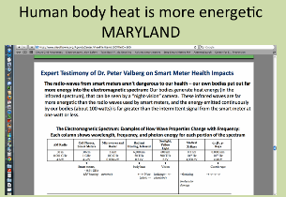

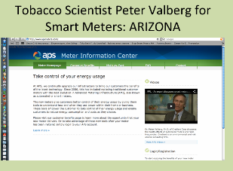
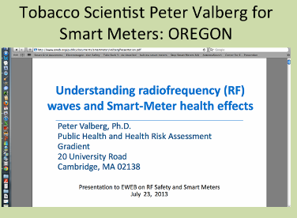
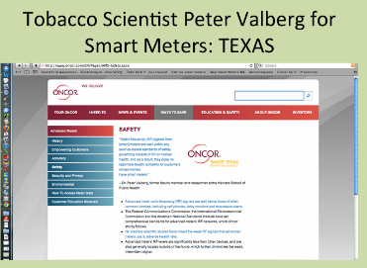
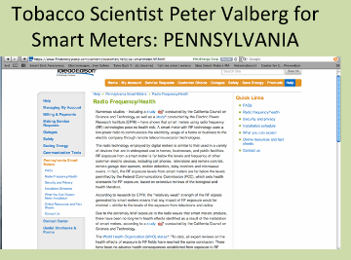

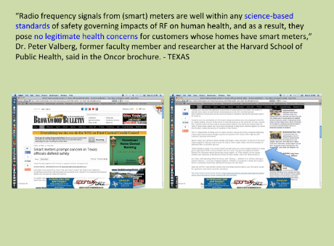
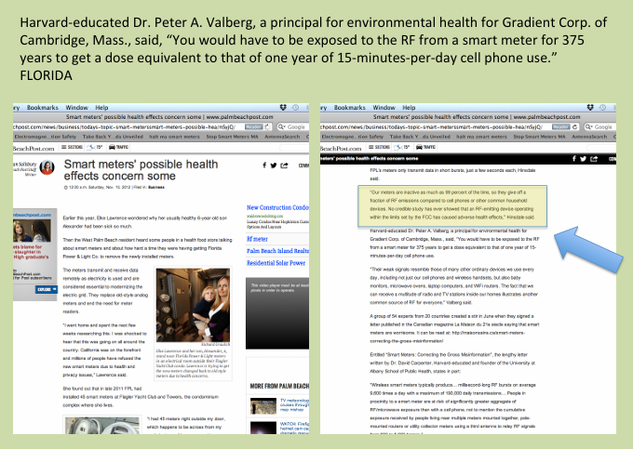

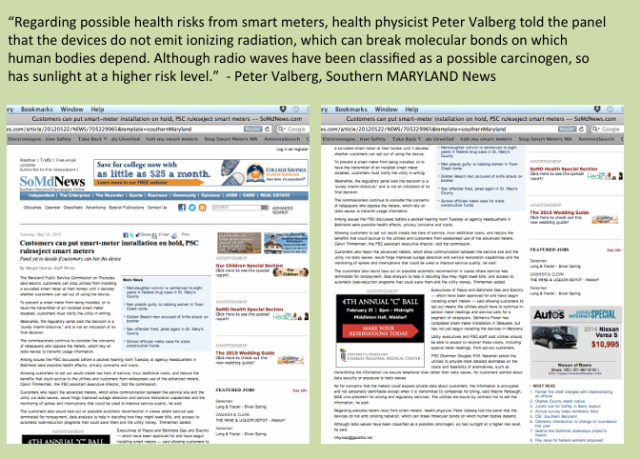
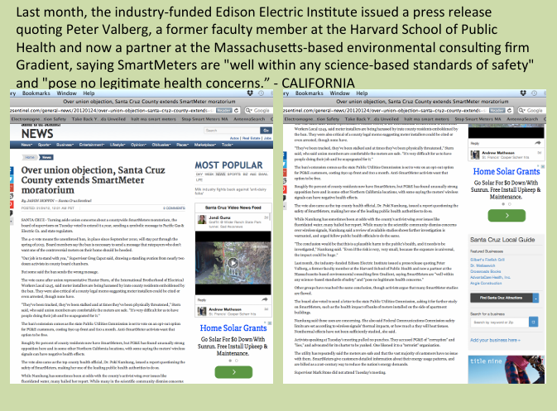

Why would this professional organization with a presumed high level of expertise promote the opinion of a tobacco scientist to address health concerns?

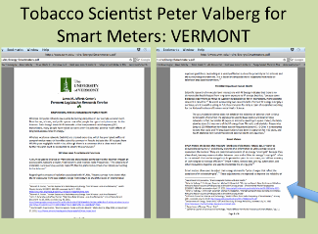
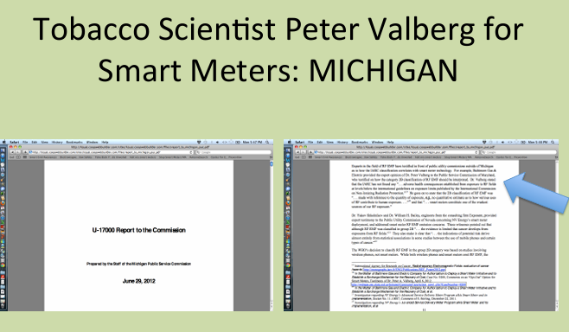
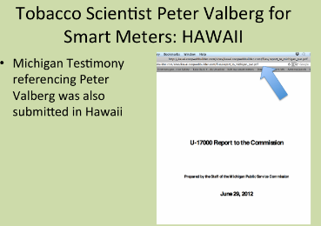
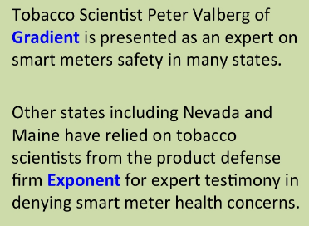
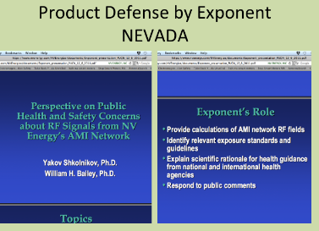
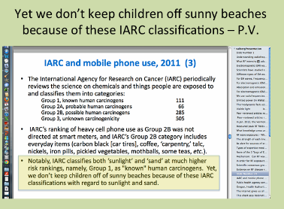
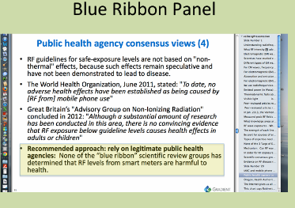
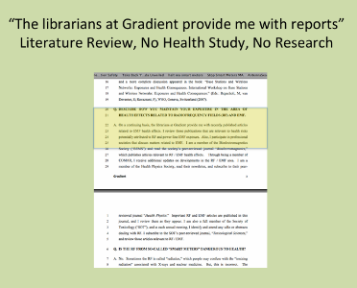
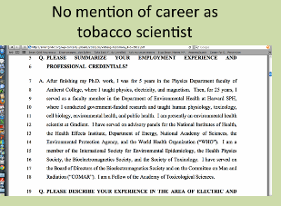
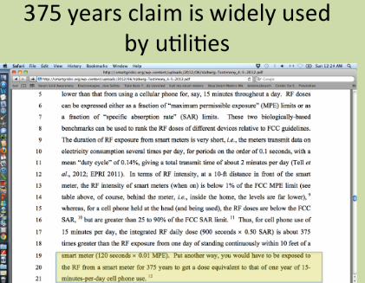

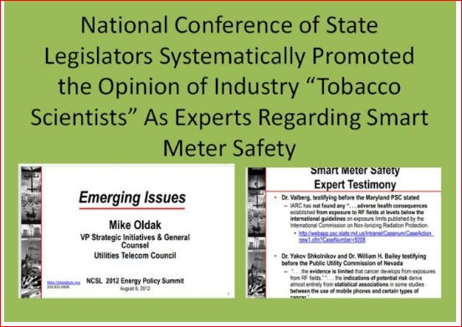
In 2012, Mike Oldak of the Utilities Telecom Council assured the NCSL National Conference of State Legislatures that smart meters were safe, based on the opinions of product defense experts from 2 firms, Gradient and Exponent. The firms and individuals involved literally worked in defense of the cigarette industry.
The quote from Peter Valberg states that the World Health Organization found no harm, despite the fact that the agency’s IARC declared RF a possible human carcinogen in 2011. He did it by quoting an older testimony.
This resource from the Utilities Telecom Council has been removed from the NCSL website, as have other earlier posts about smart meters. The damage was already done.

Product Defense is Not Health and Safety Science
From Environmental Working Group:
"They profit by helping corporations minimize public health and environmental protection and fight claims of injury and illness. In field after field, year after year, this same handful of individuals and companies comes up again and again...
They have on their payrolls (or can bring in on a moment's notice) toxicologists, epidemiologists, biostatisticians, risk assessors, and any other professionally trained, media-savvy experts deemed necessary.
They and the larger, wealthier industries for which they work go through the motions we expect of the scientific enterprise, salting the literature with their questionable reports and studies.
Nevertheless, it is all a charade.
The work has one overriding motivation: advocacy for the sponsor's position in civil court, the court of public opinion, and the regulatory arena [where these studies benefit their sponsors] not because they are good work that the regulatory agencies have to take seriously but because they clog the machinery and slow down the process.

Public health interests are beside the point. Follow the science wherever it leads? Not quite. This is science for hire, period, and it is extremely lucrative." –David Michaels

Only by discovering the facts behind the scene and by bringing to light the true motivation of profit-driven public relations campaigns can we promote and defend the health of the environment and the safety of consumer products. For a veteran in the subject who may have participated in some of the struggles described in Defending Science, or for a new member of the environmental and occupational health community, this book is a great introduction to the state of the field and the battles ahead that still need to be fought.

Source; Environmental Working Group How industry shanghaied science, A review of Doubt is Their Product: How Industry's Assault on Science Threatens Your Health by David Michaels.
Too Many Roads Lead Back to Peter Valberg, Gradient, and Rigged Science

Vinyl Chloride
In Feb. 2016, David Heath of the Center for Public Integrity published the article, Making a cancer cluster disappear as part of the series, Science for Sale, co-published with Vice.com.
The cancer cluster in question was the largest cluster of work-related brain tumor fatalities ever reported.
The likely culprit? Vinyl chloride.
The other culprit? The Chemical Industry’s Successful Application of Tobacco Science
Another Co-Collaborator: The World Health Organization’s IARC International Agency on Research on Cancer
One of the experts? Peter Valberg
“One such expert, Peter Valberg of Gradient Corp., wrote that the families in McCullom Lake were citing early studies linking vinyl chloride to brain cancer but failed to cite more recent reviews.
“These in-depth summaries and updates of worker cohorts do not support a causal link between VC exposure and brain cancer,” Valberg wrote.” – Center for Public Integrity
Can Valberg’s testimony be applied regarding the lack of more recent reviews for smart meters and radio frequency radiation?
Tobacco
Peter Valberg’s work is also featured in the “Science for Sale’ series article “Meet the ‘rented white coats’ who defend toxic chemicals when he, along with Evan Nelson, came up with a scheme to defend the asbestos industry by shifting the blame for mesothelioma to tobacco.
“There was an obvious problem with Nelson’s “science.” Researchers for decades have exhaustively analyzed data on the health of hundreds of thousands of smokers. Since 1964, the U.S. Surgeon General has summarized the findings of study after study, none of which shows evidence that tobacco causes mesothelioma.
It seems incredulous that Valberg would shift the blame for mesothelioma on tobacco because he is, literally, a tobacco scientist for Phillip Morris.

Valberg and Smart Meters and Cigarettes, MA DPU 2014
Valberg testimony for Phillip Morris is dated February of 2014 for his work to de-certify a class action lawsuit application in Ohio concerning light cigarettes. “PM USA’s expert, Dr. Peter Valberg, relied on his review of numerous published studies evaluating the smoking behaviors of consumers who switched to light cigarettes in forming his opinions.”
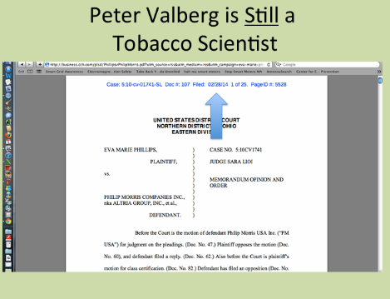

That was the same week that he testified before the Massachusetts Department of Public Utilities over-riding citizen health concerns about wireless smart utility meters.
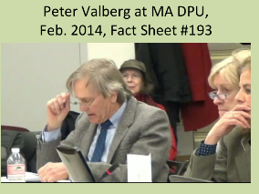

As previously noted his (outdated) opinion also formed the basis of a presentation given to the National Conference of State Legislatures justifying smart meter safety in 2012.
Public utility commissions across the U.S. were influenced by or relied on Valberg’s opinion when authorizing the installation of wireless utility meters, despite reported harm, including the acute onset of neurological complaints, microwave illness, disability, and sensitivity to electromagnetic fields.
Previous generations witnessed public servants questioning the addictive nature of tobacco products.
Hopefully these generations will see the recovery of science integrity and the removal of product defense from public policy making for utilities and telecommunications.

Thank you for your kind attention, Patricia Burke

Industry commentator David Roberts of VOLTS has used the term low-hanging fruit repeatedly, including here: US electricity emissions are halfway to zero If you squint just right, here What's going on with geothermal? and here Trump's latest attempt to save coal
The Health Impact Assessment (HIA) of the Commonwealth Edison (ComEd) Advanced Metering Infrastructure (AMI) Deployment | Health Impact Assessment
Smart meter skepticism gains traction in R.I., Mass. Published Aug. 12, 2013 Also, This letter was sent in 2025 to RI Energy's Director of Government Affairs regarding the ongoing implementation of "smart meters" and privacy concerns about collection, usage, and storage of people's data. LETTER Re: RI Energy Smart Meters - ACLU of Rhode Island
Ohio Utility Energy Disparity; Charges Lack Conditional Exemptions – Ohio Roundtable, Feb 12, 2025
See the March 2026 article by the Ohio Register: Kim Georgeton Joins In HB 427 Opposition n November of last year, Mayor John Marra of the Village of Timberlake, Ohio issued formal opposition to the bill to the Ohio House Energy Committee. What HB 427 really does, Marra said, is “[give] utilities legal authority to: • Remotely control air conditioners, water heaters, or other appliances during grid events; • Bid aggregated household load reductions into PJM’s capacity market for profit; and • Collect performance incentives from the Public Utilities Commission of Ohio (PUCO).” “Customers can override an event—but too many overrides mean being barred from participation. When participation determines whether a family gets a $25-$50 rebate, ‘voluntary’ quickly becomes coerced compliance.” “Demand-response programs already exist for industrial users who can shift loads safely without affecting household comfort,” Marra said. “HB 427 flips that model upside-down, using private homes as grid-stabilizing equipment while data centers and crypto-mines consume electricity without any curtailment obligation.” “The irony,” Marra said, “is that demand response itself is essential for grid protection. During the 2022 Winter Storm Elliott, demand-response actions kept PJM from cascading outages across the Midwest and Appalachia. That system worked because industrial users bore the burden, not families in their homes. But under HB 427, as hyperscale data centers ramp up to consume thousands of megawatts, utilities will instead reach into our living rooms to reduce load – because there will be nothing left to shed from the industrial side.” Data centers are at, well, the center of the growing problem of a maxed-out electrical grid in Ohio. It seems to be no coincidence that a bill to allow utilities to choose how much power consumers are allowed to use at “peak” times would be introduced at this time.
Germany’s Intelligent Metering: Which households will get a smart meter? Anyone who has an above-average electricity consumption of 6000 kilowatt hours or more per year will receive a smart meter. Such high electricity consumption arises, for example, if there is an electric car in the household that is charged via a wallbox. Electricity customers who operate a solar system with an output of more than seven kilowatts will also receive the intelligent control system with a communication module. Anyone who operates a controllable night storage heater or a heat pump is still excluded from the smart meter obligation, but can opt for it if they wish. Source: Digitale Stromzähler 2026: alle Infos auf einen Blick | LichtBlick
Digital electricity meters record electricity consumption in detail A digital electricity meter measures the consumption in your household and breaks down the data in detail. A display replaces the classic counting disc. The digital meter can neither receive data from the outside nor pass on information to third parties. You still have to read your electricity consumption manually. For classic households with average consumption, these meters are sufficient. Source: Digitale Stromzähler 2026: alle Infos auf einen Blick | LichtBlick (translates at link)
See the testimony from epidemiologist Dr. Sam Milham from an Arizona court proceeding along with other resources posted here: Dr. Samuel Milham: “Smart meters are a public health hazard.” | Smart Grid Awareness Most people assume that when adverse health complaints are reported due to “smart” meters that the likely cause would be the intentional wireless RF emissions transmitted through air from the smart meter back to the utility. These reported health effects are certainly plausible based upon the evidence already presented at this website [2][3]. However, there are additional possible sources of electromagnetic field (EMF) exposure associated with smart meters, e.g., dirty electricity (DE). As explained by Dr. Milham [1]: “Dirty electricity” or “dirty power” are terms coined by the electric utilities to describe the electrical pollution consisting of high frequency voltage transients and harmonics riding along on the 50 or 60 Hz wave form and contaminating the electricity delivered to users. … The APS “smart” meters are electronic devices which replaced the old electromechanical analog meters used to measure electric power consumption for billing purposes. The smart meters have circuitry to measure power consumption and a microwave transmitter to send this information to the utility. The health effects of microwave exposures are well known. All transmitters, including the microwave transmitters in smart meters, operate on direct current (DC). The APS smart meters contain a switching mode power supply (SMPS) which changes the utility 60 Hz alternating current to DC. … Because it is at the front end of a building’s wiring, the dirty electricity from the smart meter’s SMPS has a gateway into that building’s wiring, and also into the earth via the house ground. The house wiring acts as an antenna and the fields capacitively couple to the body through the air within 6 to 8 feet of the house wiring or extension cords plugged into the outlets. … I believe that our evolutionary balance, developed over the millennia, has been severely disturbed and disrupted by man-made EMFs. I believe that man-made EMFs, especially dirty electricity, are chronic stressors and are responsible for many of the disease patterns of electrified populations. … It is my professional opinion that smart meters are a public health hazard. References at lnk.
This includes both David Michaels’ book Doubt is Their Product, and Naomi Oreskes Merchants of Doubt. “ “Michaels served as Assistant Secretary of Labor for Occupational Safety and Health under U.S. President Barack Obama. [] Doubt is Their Product documents how the tobacco industry's tactics spawned a multimillion dollar industry that is dismantling public health safeguards in areas far from tobacco. Product defense consultants, he argues, have increasingly skewed the scientific literature, manufactured and magnified scientific uncertainty, and influenced policy decisions to the advantage of polluters and the manufacturers of dangerous products. To keep the public confused about the hazards posed by climate change, second-hand smoke, asbestos, lead, plastics, and many other toxic materials, industry executives have hired unscrupulous scientists and lobbyists to dispute scientific evidence about health risks. In doing so, they have not only delayed action on specific hazards, but they have constructed barriers to make it harder for lawmakers, government agencies, and courts to respond to future threats.^{[2]} - Source Merchants of Doubt: How a Handful of Scientists Obscured the Truth on Issues from Tobacco Smoke to Global Warming is a 2010 non-fiction book by American historians of science Naomi Oreskes and Erik M. Conway. It identifies parallels between the global warming controversy and earlier controversies over tobacco smoking, acid rain, DDT, and the hole in the ozone layer. [] Oreskes and Conway are seen to demonstrate that the doubt merchants are not "objective scientists" as the term is popularly understood. Instead, they are "science-speaking mercenaries" hired by corporations to process numbers to prove that the corporations' products are safe and useful. Buchanan says they are salesmen, not scientists.^{[12]} Source

