Suggestions for Health Research/Low Hanging Fruit Regarding Smart Meter Safety:
Courtesy Physicians for Safe Technology:
Electrosensitivity Provocation Studies are Flawed
Some research suggests that electrohypersensitivity (EHS) is a psychologic condition to be dismissed with patient in appropriately sent for psychological evaluation, rather than for accurate diagnosis and treatment. Most clinical provocation studies, however, have poor design and serious methodologic flaws. Appropriately conducted studies, tailoring the source of non ionizing radation and timing to individual sensitivities, affirm symptom induction from the sources in affected individuals (Rea 1991). (full article go here). There is significant variation in the frequencies and pulsations of non-ionizing radiation which cause symptoms as well as the length of time for symptoms to appear after exposure. Some report symptoms after hours or even days. McCarty in 2011 conducted a study of an EHS self diagnosed female physician in a double-blinded EMF provocation procedure and found, “The symptoms were caused primarily by field transitions (off-on, on-off) rather than the presence of the field, as assessed by comparing the frequency and severity of the effects of pulsed and continuous fields in relation to sham exposure.” the author concluded,” EMF hypersensitivity can occur as a bona fide environmentally inducible neurological syndrome.” In addition, research (Belpomme 2022) has demonstrated objective biological responses to EMR in those with EHS, including oxidative stress biomarkers, low-grade inflammation, autoantibodies and neurovascular abnormalities. A Russian document “Biologic Effects of Radiofrequency Electromagnetic Fields” in 1974 reveals research performed and symptoms observed.
Options for New Research Approaches:

Chinese Medicine
Adopting an attitude of humility and scientific diplomacy, and considering the bodies of knowledge (including historical research) from both Chinese and Russian/Eurasian scientists could help the U.S. to comprehend why certain individuals are more aware of the adverse impacts of both radio frequency radiation and polluted power quality on health.
According to Chinese medicine, individuals possess different constitutional strengths and weaknesses with the 14 meridian electromagnetic pathways and their relationship to the deeper organs.
The U.S. could utilize experts in Chinese medicine’s pulse diagnosis to asses how different individuals respond to invasive exposures at the organ level, far in advance of the development of disease. But for those who have been subjected to long term exposures with accumulated damage, the evidence trail can be further refined.
Brain Detoxification
As new information has been recently discovered about the brain’s unique glymphatic detoxification system, determining whether or not RF/EMF is contributing to the explosion of neurological diseases via impaired detoxification can be determined.
Sleep
Measuring reported sleep interference and other symptoms relative to nighttime exposures can be achieved using standard accepted medical testing protocols.
3 recent references follow:
A Chinese Medicine Perspective Courtesy Ross Rosen by Permission

EMF Exposure and Fragility
Diagnosing the Impacts of Radiation on our Physical and Emotional Well-being
Ross Rosen Mar 09, 2023
Background
Years ago, back in 2008 to be exact, I began finding an explosion of alarming sensations on the radial pulse of many of my patients. And, in particular, it was in the younger population, pre-teens, teenagers and patients up to roughly 40 years of age. Specifically, I was finding significant Ropy pulses and a quality we now refer to as Leather-Hard. Of the roughly 90 pulse qualities and sensations within the Shen-Hammer pulse lineage, Ropy was generally confined to the elderly and those engaged in long-term aerobic exercises, and the Leather-Hard was never found in kids. Thus, my interest was piqued and I knew this trend was significant. Below is an image of the Ropy pulse from my text book: Heart Shock, Diagnosis and Treatment of Trauma with Shen-Hammer and Classical Chinese Medicine.
Heart Shock text

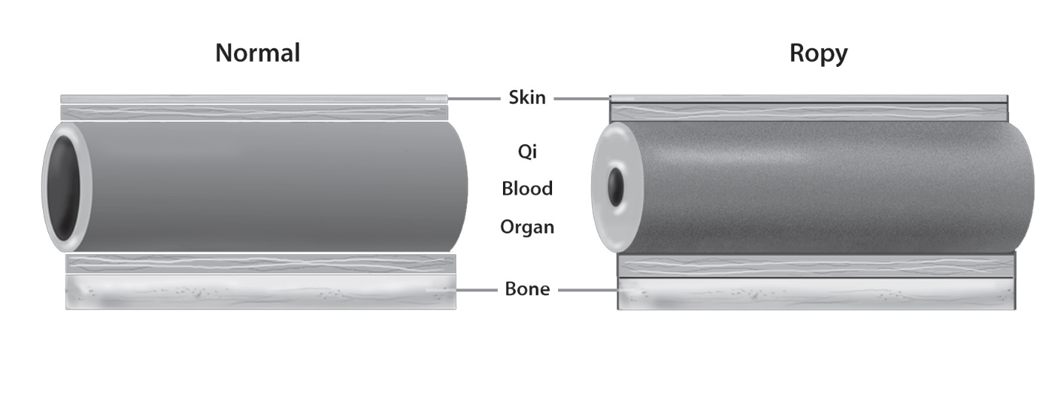

Ropy pulse: Reproduced with permission from Eastland Press
Leather-Hard and Ropy: Inflammation, Dryness, Toxicity
Leather-Hard is difficult to illustrate as it refers to the Hardness and Tension of the vessel wall, but often it is a further development and advancement that builds on the Ropy pulse. It is super important to understand the impact of what a Ropy pulse reveals. Ropy is a reflection of long-term inflammation in the vessels (and blood), wherein the heat/inflammation begins to cook the blood, making it more viscous and dense/thick. The vessel walls of course rely upon the moisture of the blood to keep it supple and elastic, and the heat from the inflammation dries out the blood making less nutrition/nourishment available for the vessels, and also, in and of itself, dries out the vessel wall. This vulcanization creates what western medicine would call atherosclerosis.
In Chinese medicine pulse diagnosis terms we see multiple effects: (1) blood deficiency (diminished volume of blood as the heat consumes it); (2) yin deficiency (decreased moisture content, which also points to a hormonal deficiency as hormones are reliant on, and essentially are, fluids); (3) heat/inflammation (which damages the qi-energy, and also sets the stage for multiple cascades of diseases and disorders related thereto); (4) blood stagnation (blood becomes harder to move as the blood gets thicker and more viscous; (5) stagnation of other elements due to the increased viscosity which creates ‘stickiness,’ eg, allowing for the aggregation of plaques/cholesterol, etc; (6) increases in calcium buildup (inflammation is acidic and the body’s response is to leech calcium from the bones into the blood to alkalize it); (7) taxation on the heart due to its need to propel thicker more viscous blood, and blood that is stagnating (potentially clotting) with increased plaque/cholesterol and calcium buildups; and a host of other downstream effects.
Now, the Leather-Hard pulse reflects a state beyond, where all of the foregoing processes are taking place behind the scenes, and an additional element of dryness toxicity emerges. Imagine a wet sponge that has been sitting out in the blazing sun as it dries and dries until it becomes smaller in size and eventually hard and brittle. This is what is happening to our vessels from radiation toxicity. Radiation is a heat source; it has the impact and effect of burning the internal landscape and terrain. It is especially problematic as our physiological landscape contains by most accounts at least 70% water. Water is required for all of our phsyiological activities and a diminishment therein will have significant impacts on our health. And this is exactly what I was seeing in my patients. Weird chronic debilitating curious diseases and signs and symptoms that patients would complain about, and that western medicine had found no diagnoses or explanations for.
Back in 2009 I published a paper alerting the medical community about this troubling trend called The Pulse, The Electronic Age and Radiation: Early Detection. You can access it here:
The Pulse, The Electronic Age and Radiation: Early Detection
Choppy: Blood Stagnation and Toxicity
Importantly contemporaneous to the Leather-Hard and Ropy qualities we often see the Choppy quality. Choppy is the pulse quality associated to, and diagnostic of, blood stagnation in the tissues. You can see the graphic of Choppy that is excerpted from my book here:
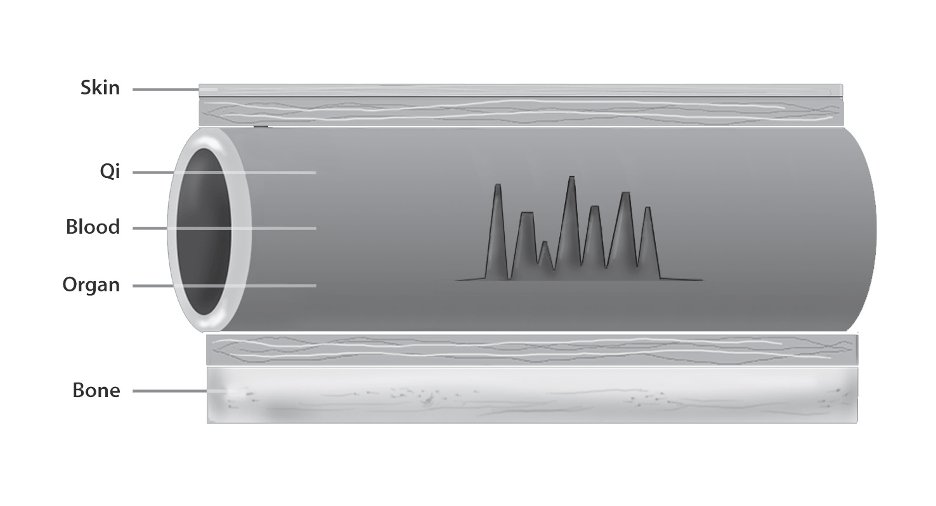
Choppy pulse: Reproduced with permission from Eastland Press
The Choppy quality when found in individual pulse postions/anatomical areas is associated to blood being stagnant in those associated areas. When found over the entire pulse it is a sign of toxicity (toxins have the impact of stagnating the blood circulation, impacting oxygenation, creating waste products that cannot be excreted, etc.). This is significant in and of itself, but combined with the Ropy and Leather-Hard qualities, it represents a significant toxic overload and an inability to engage in proper physiological functioning. This is a scenario ripe for significant debilitating and life threatening illnesses.
Fragility
So, clearly we can see how this can create fragility in our overall health picture from a physiological perspective. But, it also creates fragility in our emotional and psychological lives as well.
What we are looking at essentially is friability in our boundaries. In Chinese medicine, besides the regular anatomical organs, we also catalogue the Curious Organs, some of which include the vessels, the bones, the brain, etc. The Curious organs have significant roles physiologically, and also from an evolutionary perspective. Physiologically, we can see the impact of structure (bones), circulation and nourishment (vessels) and mental-emotional-phsysiological regulatory functions (brain/nervous system).
The brain and nervous system are very much related to our emotional and psychological health. The nervous system is intimately connected to the mind and the Heart from a Chinese medical point of view, and from the Shen-Hammer lineage, the integrity of the nervous system is one of the most important factors in understanding whether a stress (something that disturbs homeostasis) will have physical or mental-emotional implications. If the nervous system is strong, the stress will be somatized creating physical symptoms. If weak, one is more likely to experience mental-emotional-psychological symptoms.
So, what does this have to do with the Leather-Hard pulse? Our nervous systems are in many respects a front-line defense mediating, amongst other things, our relationships to the external environment. The constant onslaught of stress weakens the integrity of said nervous system, and due to its intimate relationship to the mind, creates demand and triggers a response from our psychological well-being and homeostasis. With a constant barrage of insults, nervous system integrity degrades and becomes weaker if the internal landscape is not well equipped with adequate resources to meet the ever present demands on it. We’ve already detailed above how the Ropy and Leather-Hard pulses are a direct reflection of significant diminishment of said resources. Thus, once these qualities are emerge, we are woefully ill-equipped to handle the demands being placed upon us: physically and emotionally.
Take a a look at this short clip below from one of my recent talks on stress and homeostasis:
feb 21 heart shock clip
Leather-Hard results most often from radiation. Prior to 2008 this quality was only seen in cancer patients who had undergone radiation therapy, and that quality was confined to the local anatomical area of the treatment site. Now, we are seeing wide swaths of the population presenting with Leather-Hard pulses systemically, meaning found over their entire pulses, eg radiation toxicity. Children, in particular, are the most vulnerable to this assault because their exposures to radiation are consistent and constant these days. Children are born into a world where they cannot escape Wifi, cell phones, cell towers, smart homes etc. etc. It is no wonder that the fragility of children in the current era is commonly remarked upon. One can simply take a look at statistics of mental-emotional conditions like anxiety and depression, or the significant increases in suicide and suicidal ideations over the past decade in children; the exponential increase is staggering and sobering. Their nervous systems are being bombarded 24/7 before they even have a chance to develop or mature. And, over the years, the radiation has become more and more ubiquitous, more intense, with smaller and smaller waveforms of increased densities.
Now what?
This all leaves us in an on-going scenario wherein our boundaries are permeable and our defenses are down. In future posts I will discuss other mechanisms at play in weakening our nervous systems, and also strategies for protecting and rehabilitating it in the wake of this constant challenge and exposure to toxic radiation. –Ross Rosen
Brain Detoxification Temperature of an Inanimate Dummy, Utilizing a Practice of “Averaging” Tissue Parameters
As a writer focusing on the EMF/RF health discussion, I recently shared an article where I referenced the brain’s glymphatic system.
“Spell check” doesn’t recognize the term, hinting that I am mistyping the word lymphatic.
In 1996 when President Bill Clinton signed the Telecom Act of 1996, the West had not yet “discovered” the glymphatic system.
There was no impetus in 1996 to test wireless devices or infrastructure for possible deleterious impacts on the brain’s unique, dedicated detoxification system because the Western mainstream medical model did not know that it even existed.
The discovery of this mechanism in the West was published by Pub Med in 2012.
The authors proposed the term “glymphatic” to describe the unique, energetic mechanics of the brain’s detoxification system.
What Did Evolving Science Say About Brain Detoxification, in 2012? Why Did This Discovery Not Inform Public Policy?
Pubmed link: A Paravascular Pathway Facilitates CSF Flow Through the Brain Parenchyma and the Clearance of Interstitial Solutes, Including Amyloid β - PMC
“A Paravascular Pathway Facilitates CSF Flow Through the Brain Parenchyma and the Clearance of Interstitial Solutes, Including Amyloid β”
Jeffrey J Iliff ^{1,*}, Minghuan Wang ^{1,2}, Yonghong Liao ¹, Benjamin A Plogg ¹, Weiguo Peng ¹, Georg A Gundersen ^{3,4}, Helene Benveniste ^{5,6}, G Edward Vates ¹, Rashid Deane ¹, Steven A Goldman ^{1,7}, Erlend A Nagelhus ^{3,4}, Maiken Nedergaard ^{1,*}

“Because it lacks a lymphatic circulation, the brain must clear extracellular proteins by an alternative mechanism. The cerebrospinal fluid (CSF) functions as a sink for brain extracellular solutes, but it is not clear how solutes from the brain interstitium move from the parenchyma to the CSF. We demonstrate that a substantial portion of subarachnoid CSF cycles through the brain interstitial space. On the basis of in vivo two-photon imaging of small fluorescent tracers, we showed that CSF enters the parenchyma along paravascular spaces that surround penetrating arteries and that brain interstitial fluid is cleared along paravenous drainage pathways. []
[] DISCUSSION We have identified a brain-wide pathway for fluid transport in mice, which includes the para-arterial influx of subarachnoid CSF into the brain interstitium, followed by the clearance of ISF along large-caliber draining veins. Interstitial bulk flow between these influx and efflux pathways depends upon trans-astrocytic water movement, and the continuous movement of fluid through this system is a critical contributor to the clearance of interstitial solutes, likely including soluble Aβ_{1–40}, from the brain. In light of its dependence on glial water flux, and its subservience of a lymphatic function in interstitial solute clearance, we propose that this system be called the “glymphatic” pathway (Fig. 5B and fig. S9).”
Source: A Paravascular Pathway Facilitates CSF Flow Through the Brain Parenchyma and the Clearance of Interstitial Solutes, Including Amyloid β - PMC
The Question of Impaired Detoxification and Disease Development
That spellcheck does not recognize the term “glymphatic system” is a minor inconvenience.
Regarding the question of the FCC’s stance on “safety,” what is far more urgent are these conclusions from the study’s researchers:
“Thus, in the human brain, paravascular pathways and AQP4-dependent bulk flow may be substantially more critical to brain function than in the rodent brain.”
AND
“The paravascular pathway and disease” Our finding that disruption of this pathway in Aqp4-null mice resulted in the failure of solute clearance may be of clinical relevance for neurodegenerative diseases in which the mis-accumulation of neurotoxic depositions contributes to disease development.”
This work presents direct implications for Alzheimer’s.
There may also be implications the development of brain and other head cancers and other neurological illnesses.
SLEEP Attention lapses due to sleep deprivation coincide with a flushing of fluid from the brain, research reveals
Nearly everyone has experienced it: After a night of poor sleep, you don't feel as alert as you should. Your brain might seem foggy, and your mind drifts off when you should be paying attention. A new study from MIT reveals what happens inside the brain as these momentary failures of attention occur. The scientists found that during these lapses, a wave of cerebrospinal fluid (CSF) flows out of the brain—a process that typically occurs during sleep and helps to wash away waste products that have built up during the day. This flushing is believed to be necessary for maintaining a healthy, normally functioning brain.
When a person is sleep-deprived, it appears that their body attempts to catch up on this cleansing process by initiating pulses of CSF flow. However, this comes at a cost of dramatically impaired attention.
“If you don’t sleep, the CSF waves start to intrude into wakefulness where normally you wouldn’t see them. However, they come with an attentional tradeoff, where attention fails during the moments that you have this wave of fluid flow,” says Laura Lewis, the Athinoula A. Martinos Associate Professor of Electrical Engineering and Computer Science, a member of MIT’s Institute for Medical Engineering and Science and the Research Laboratory of Electronics, and an associate member of the Picower Institute for Learning and Memory.
The researchers used a modified version of fMRI that allowed them to measure not only blood oxygenation in the brain, but also the flow of CSF in and out of the brain. They also measured each subject’s heart rate, breathing rate, and pupil diameter.
The participants performed two attentional tasks while in the fMRI scanner, one visual and one auditory. For the visual task, they had to look at a screen that had a fixed cross. At random intervals, the cross would turn into a square, and the participants were told to press a button whenever they saw this happen. For the auditory task, they would hear a beep instead of seeing a visual transformation.
Sleep-deprived participants performed much worse than well-rested participants on these tasks, as expected. Their response times were slower, and for some of the stimuli, the participants never registered the change at all.
During these momentary lapses of attention, the researchers identified several physiological changes that occurred at the same time. Most significantly, they found a flux of CSF out of the brain just as those lapses occurred. After each lapse, CSF flowed back into the brain. []
A unified circuit The researchers also found several other physiological events linked to attentional lapses, including decreases in breathing and heart rate, along with constriction of the pupils. They found that pupil constriction began about 12 seconds before CSF flowed out of the brain, and pupils dilated again after the attentional lapse.
“What’s interesting is it seems like this isn’t just a phenomenon in the brain, it’s also a body-wide event. It suggests that there’s a tight coordination of these systems, where when your attention fails, you might feel it perceptually and psychologically, but it’s also reflecting an event that’s happening throughout the brain and body,” Lewis says.
This close linkage between disparate events may indicate that there is a single circuit that controls both attention and bodily functions such as fluid flow, heart rate, and arousal, according to the researchers.
More information: Attentional failures after sleep deprivation are locked to joint neurovascular, pupil and cerebrospinal fluid flow dynamics, Nature Neuroscience (2025). DOI: 10.1038/s41593-025-02098-8.
This story is republished courtesy of MIT News (web.mit.edu/newsoffice/), a popular site that covers news about MIT research, innovation and teaching.

Smart Meters and Health
Many consumers are not aware that immediately coinciding with the installation of smart meters both in the U.S. and internationally, complaints of symptom onset, including acute disability emerged, - without scrutiny, or legislative or regulatory response.
The assumptions fueling the entire smart grid agenda(s) require review, and immediate intervention to protect a portion of the population from further harm, and to prevent further ratepayer investment in an inappropriate technology choice.

Thank you for your kind attention, Patricia Burke Oct. 21, 2026

