Sarah Aminoff
October 26, 2026
sarahaminoff@aol.com

This comment is in response to the U.S. Department of Health and Human Services Request for Information on September 17, 2026 welcoming input from educators, advocates and researchers to submit evidence and information on the potential health effects of electromagnetic fields (EMFs), radiofrequency (RF) radiation, and wireless radiation exposure.

My name is Sarah Aminoff, and I am a member of Safe Tech International, and a San Francisco, California educator. San Francisco has been a key test ground for driverless robotaxis, but being part of that experiment, was not what I was thinking about when I took my students on a field trips to Golden Gate park. People are able to opt out of TSA Airport Scanners due to cumulative radiation concerns, but not Waymo robot taxi exposures, yet both use millimeter frequencies, and the Waymo uses millimeter plus LiDAR. At 9th Avenue Lincoln Gate we encountered a Waymo robotaxi directly in front of us at a crosswalk in Golden Gate Park, and a second Waymo robotaxi at 9th and Irving,

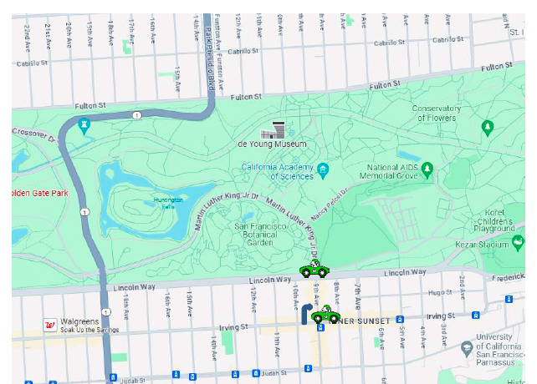

Map of Golden Gate Park and Lincoln Gate, showing with a Waymo at Golden Gate Park and 9th – was where the first Waymo created a pedestrian intrusion in the our walk path, and also on Irving making a left hand turn onto 9^{th.}.

What Steps to Reduce or Eliminate Exposure of Waymo Were Taken?
Since 2024 onwards, it has been hard to reduce exposure to Waymo, given California Public Utilities Commission has also approved expansion for the entire State of California. Here’s the link depicting California Waymo approval.
What we know: Waymo Robotaxis send out millions of radar sensors to create a 3D picture, using millions of radar millimeter sensors or laser pulses that impinge on an automobile or pedestrian and its a complex EMF soup. The Robocars use three primary sensors: cameras, LIDAR and radar. Radar uses millimeter wave frequencies to provide Waymo with crucial details like an object's distance and speed. LiDAR uses laser beams to create dense and accurate 3D maps. In the Waymo 5th Generation, there are 29 cameras mounted on the sides and top of the car, six radar sensors tracking larger objects and four LiDAR sensors, which use laser pulses to "see" the car's surroundings in 3D.
What is the Criteria for LiDAR Safety for Eyes? Automotive Lidar: Safety questions raised about 1550 nm lidar Anyone who has had cataract surgery no longer has the protective cornea to protect their eyes, any damage to the replacement lens is permanent.
(NHSTA) or DMV based on the FMVSS (FEderal Motor Vehicle Safety Standards)? Although the California Public Utilities Commission has stated Waymo meets federal regulations for FCC and DMV based on the NHSTA, what kind of scientific studies have been done to assert Waymo is safe, with a sensor array of LiDAR, RFR and mmWave?
To answer HSS question 5, what existing scientific, technical, or regulatory changes by federal health agencies, if any, would improve the assessment, disclosure, and regulation of wireless radiation exposure?
1) The FCC still fails to capture ubiquitous and aggregate exposures. An aggregate signal analysis has yet to be done for Waymo and other vehicles. Most of the compliance with federal standards are typically claimed for only one set of lights or emitters, as the FCC regulates RFR and Millimeter, yet on the Waymo 5th Generation there are 51 cameras/sensors. The aggregate signal of lights, cameras and antennas using LiDAR, RFR mmWave, IR and ultrasonic sensors, etc. must be analyzed specifically for the impact on the eyes and mainly for any potential retinal damage that may also adversely impact the brain's ability to process what it is seeing.
2) Time averaging dosimetry (power densities) should not be permitted, especially for mmWaves and RF, as peak exposures that fall within FCC limits when time averaged over 30 minutes, can have serious non-thermal bioeffects at a cellular level potentially inducing reactive oxygen species and DNA, and sperm damage, according to International Commission on the Biological Effects of Electromagnetic Fields (ICBE-EMF),

With driverless vehicles, radiofrequency radiation (RF) in the mmWave part of the spectrum and near IR poses possible deep thermal heating effects, yet the FCC relies on 30 minute dosimetry, averaging in peak exposures. Environmental Health Trust shares science research around the millimeter frequency concerns, including:

“A 2021 paper “Millimeter (MM) wave and microwave frequency radiation produce deeply penetrating effects: the biology and the physics”by Martin L Pall PHD reviews the science on how MMwaves can have highly penetrating effects stating that “in humans, MM-waves have penetrating effects including impacts on the brain, producing EEG changes and other neurological/neuropsychiatric changes, increases in apparent electromagnetic hypersensitivity and produce changes on ulcers and cardiac activity”

Agencies Need to Investigate Waymo’s Definition of Safety. Robotaxis are touted to “give commuters a potentially safer alternative than relying on the human behind the wheel”. What’s the definition of ‘safer’ here?

The FCC should mandate do a worst case scenario exposure calculation for driverless cars using all sensors on front, right passenger side and rear facing sides of the car, adding them all up. What is their safety for pregnant women children? And are they able to sense little bodies in front or back so they don’t run over them, as a child, dog and cat were hit.

Exhibits and Science

To answer Question 7, to the best of our knowledge, there are currently no accurate ways to measure or character either individual or population levels?

1) The FCC assessing for one vehicle only, not multiple cars According to Ron Kostoff in his article on radar and cars, ‘If you’re walking on a crosswalk in front of stopped traffic, you….could be exposed directly full body to a million microwatts/square meter. And, there’s no glass or metal to absorb or block the radiation. And, that’s with the assumption that you’re being radiated from one car only….what we really need to get are the codes the auto manufacturers use to compute actual radar exposures to car occupants and pedestrians. If some of the radars are mounted on the front bumper, then small children walking a crosswalk are most vulnerable. “

2) Technologies get approved without sufficient pre-market testing is another gap, see John Thomas article, Health Impact News, “Will Driverless Cars Cause DNA Damage and Cancer? April 15, 2018.” Has there been testing on people with pacemakers or children, or multiple radar exposures with several robot taxis waiting at the same street?

3) Time Averaging in Evaluating Dosimetry Levels in Smart Vehicles by the FCC is an inherent flaw and not accurate. If Waymo includes peak RF exposures and avoids time averaged dosimetry they might not successfully acquire a target and that could lead to other safety concerns with higher accident rates. Is this the inherent flaw in how driverless work, biological safety may be compromised for having the car work as advertised and peoples' injuries are just collateral damage necessary to advance technology? This mindset has to be changed with the technology fusion expected to occur with deployment of advanced phase of 5G IoT.

To answer Question 9, what, if any, technical and exposure-related information should be disclosed to consumers, residents, workers, schools, healthcare providers, and local governments?

What we know: Electromagnetic exposures have been implicated in potentially causing seizures, and yet Waymo is partnering with the Epilepsy Foundation in Arizona as a solution for people with epilepsy, yet biological impacts of EMF exposures aren’t mitigated. Waymo spokesperson, Katherine Barna, has addressed this issue publicly here: with an epilepsy video commercial. Do driverless vehicles endanger disabled individuals more than they are helping them? Robotaxis are touted to “give commuters a potentially safer alternative than relying on the human behind the wheel”. What’s the definition of ‘safer’ here? Is the data being manipulated and are there any errors and omissions?

FCC Permissible Exposure Limits do Not Inform Consumers

Waymo 5th generational Jaguar I-Pace Robotaxi
https://www.caranddriver.com/news/a31228617/waymo-jaguar-ipace-self-driving-details/
Lidar range – 1,000 feet
Optical camera range -1640 feet
Imaging Radar – 300 meters
Ultrasonic – near field, very close proximity

https://www.tangramvision.com/blog/sensing-breakdown-waymo-jaguar-i-pace-robotaxi
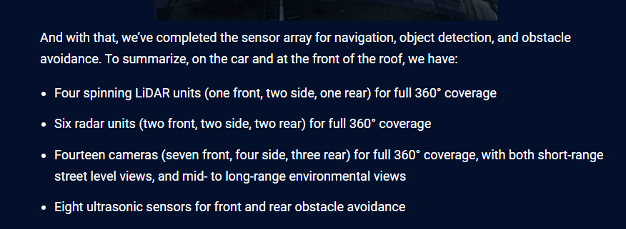

The Fifth generation of Waymo robotaxi (Jaguar I-Pace, 2022) has a total of 51 sensors with about half of them as shown above located in the front, side and roof of the car, which is the perspective I and other pedestrians encounter.

What consumers and health professionals need to know: The Waymo will tag a pedestrian as an ‘object detected” with a velocity vector as a moving target and an obstacle to avoid. During field trips, students, staff and I were being mapped with radar, lidar, ultrasonic signals and were also captured on optical cameras that use IR and LED beam lights. The LiDAR, Radar and Camera sensors can detect images from hundreds of meters. These are artificial exposures that are targeting every square centimeter of the body.

Here’s a video on Instagram from Havnwear:

“Riding in a Waymo sounds futuristic…
Until you scan it for EMFs 🚗📶
Between the LiDAR, radar, WiFi, and Bluetooth systems, these cars are constantly pulsing out signals—and your body’s sitting right in the middle of it.: 🛡️ You can ride the future—and still protect your health.“

All state and federal agencies should investigate Waymo ‘Safety’ Data with an educational campaign. San Francisco and other cities have recorded “dozens – perhaps hundreds or thousands – of incidents” in which autonomous vehicles were reported to:
- Drive erratically
- Block traffic
- Trapping other cars at the curb
- Entering construction zones
- Entering crime scenes and failing to follow directions
- Hit a small dog in 2023 – a fatality, and a bodega cat in 2025
- Get in the way of emergency vehicles
- A noise nuisance. Honk at each other, waking residents at night 4 am August 2024. when the vehicles are supposed to be idle - See San Francisco news tweet of the self-driving taxis reportedly honk when another. gets too close while trying to park, which sets off a chain reaction of all the “smart” cars honking at each other.
- Former Waymo Test pilot says self driving vehicles are dangerous, WVLT TV report, Nashville.
- Previously, a Phoenix, Arizona, police officer pulled over a Waymo vehicle that dangerously drove into oncoming traffic
- Are an assault vehicle to those that have electronic medical implants, eye surgeries, photosensitivity epilepsy, and EMF disabled.

American Disability Act (ADA) and medical implants
- Disabled groups combined are a fairly significant part of the population that various state and federal agencies may be hurting by approving these vehicles.
- Most disabled may be unaware of potential harm
- State and federal agencies should ensure Waymo is not violating any FCC radiofrequency interference rules for those with medical implants.
- State and federal agencies should ensure Waymo is in compliance with the ADA or Americans with Disabilities Act because violations will happen.

Waymo should be using computational simulation software to work out the 'bugs' not real people and traffic that creates inherent danger when the software did not account for a specific scenario. Proof that Waymo can’t account for all scenarios:
- Self-driving Waymo car kills dog amid increasing concern over robotaxis?
- Waymo is also under federal investigation for not obeying street rules
- Waymo hits cyclist
Waymo Has a Bike Problem Not Addressed by the DMV?
According to Safe Street Rebel: “Cyclists are more at risk with Waymo’s than those that are in other cars and in San Francisco Waymo illegally forces bikes and cars to swerve to heavy traffic: see video. “Executor director of the San Francisco Bicycle Coalition, says Waymo has stated that expecting its cars to respect bike lanes is "too high a bar" and that pulling into bike lanes is a "normal practice" that customers expect,” according to Planetcitizen.com.

According to the NHTSA "The National Highway Traffic Safety Administration’s Office of Defects Investigation is looking into 22 incidents in which Waymo’s robotaxis were “the sole vehicle operated during a collision” or “exhibited driving behavior that potentially violated traffic safety laws.”
Eye Safety and LiDAR
What is the criteria for LiDAR safety?: Automotive Lidar: Safety questions raised about 1550 nm lidar To reiterate, anyone who has had cataract surgery no longer has the protective cornea to protect their eyes, and any damage to the replacement lens is permanent. All the agencies need to coordinate synergistic exposures, not just combine frequencies.
Millimeter Absorbed by Skin and Eyes
it is known that millimeter waves (MMW) are absorbed by surface tissue such as skin and the cornea,
Dr. Joel Moskowitz, UC Berkeley School of Public Health citation of article on his website, “Millimeter waves (MMWs) are mostly absorbed within 1 to 2 millimeters of human skin and in the surface layers of the cornea.” Very few studies have been done on the effects of millimetre waves on humans. Clinical trials on a large population and for longer duration are required to establish the safety of millimetre waves.”
John Thomas’s article published back in 2018 in Health Impact News Will Driverless Cars Cause DNA Damage and Cancer? discusses the coming use of these multiple sensors and frequencies from driverless cars in combination with background RF/microwave radiationa lready in the environment from WiFi, cell towers, smart meters, etc. Thomas asks rhetorically.

Will we be able to enjoy the convenience of driverless cars if we will be suffering from illnesses caused by the microwave radiation they produce?
If the cost of DAS and driverless technology includes more cancer [3, 13], heart disease, and diabetes and dozens of other illnesses [14], then will this technology really benefit us?
If these technologies cause damage to the lenses and retinas of the eyes, cause glaucoma, and can lead to blindness, then do we need it? [3, 15]

Do we need it if the price includes damage to DNA and sperm? [3]

Road User Exposure from Smart Cars

Physicians for Safe Technology in the article, Driverless Cars” explains Antenna from Smart Cars disproportionately impact the eyes and head. In a 2022 open access research article in Sensors, Road User Exposure from ITS-5.9 GHz Vehicular Connectivity, Benini et al are apparently the first to look at the SAR levels from V2V/V2X antennas from “Smart Cars”.

Researchers found significant levels of radiofrequency radiation-Electromagnetic Frequency (RFR-EMF) absorbed by passengers and pedestrians especially in the eye and brain from antennas."

Low Frequency Electromagnetic Fields in Cars
Magnetic fields are an important issue in the HHS Request as low-frequency magnetic fields which are are ubiquitous in automobiles and driverless cars. Theodora Scarato of Environmental Health Science speaks of the failure of the FCC to include magnetic field:
“The FCC has never adopted limits for magnetic fields, despite their ubiquity in wireless devices and infrastructure and the growing body of evidence of biological effects. A comprehensive environmental review under NEPA must include these exposures, as infrastructure-related magnetic fields constitute a foreseeable and measurable environmental impact.”

Dr. Joel Moskowitz writes in Hybrid and Electric Cars: Electromagnetic Safety Risks:
“Given that magnetic fields have been considered "possibly carcinogenic" in humans by the International Agency for Research on Cancer of the World Health Organization since 2001, the precautionary principle dictates that we should design consumer products to minimize consumers’ exposure to ELF EMF. This especially applies to hybrid and electric automobiles as drivers and passengers spend considerable amounts of time in these vehicles, and health risks increase with the duration of exposure.”

Children’s Unique Physiology and Driverless Cars Such as Waymo

In 2026, the International Commission on the Biological Effects of Electromagnetic Fields (ICBE-EMF), an international group of scientists, physicians and researchers with expertise on the impacts of wireless technology on health, issued a position statement calling for safeguards to protect children from increasing levels of RF radiation.

They write:
“Children can be more vulnerable than adults to the health impacts of wireless radiation because it penetrates deeper and has higher absorption rates in regions of a child’s brain, and because their still-developing brains and physiological systems are more sensitive to environmental toxicants.”

And yet, the many state and federal agencies allow children to ride in driverless robot taxis (Waymo with adult supervision, or parental consent in the case of teens) while the FCC and other agencies fail to include children’s unique biology in their guidelines. Waymo and other driverless vehicles have multiple vehicular bumper sensors and if/when children are exposed to Waymo et al, e.g. idling outside schools during dismissal hours, this could prove harmful to children.

A new study from Europe which was just released found that children have higher RF absorption rates than adults in certain frequency ranges. Environmental Health Sciences summarizes some of the findings as follows:

- The child models had 1.5–1.9 times higher whole-body wireless radiation absorption rates than adult models at frequencies below 6 GHz.
- The child models also showed higher brain-to-skin wireless radiation absorption rates than adults at the higher frequencies just below 6 GHz.

Simulated 5G beamforming— which focuses 5G signal into a narrow, directed beam—created wireless radiation “hotspots” in the body. At some frequencies, these exceeded absorption limits in both child and adult models, even though the radiation reaching the body met the external exposure limit.“

Please note that Waymo uses Multiple-Input Multiple-Output (MIMO) and radar at 77 Giga-Hertz (GHz), millimeter (mm) electromagnetic wave length (e.g., 3.9 mm for 77 GHz)that rely on beamforming, according to this patent:
In summary, it is unknown what a million pulses of Waymo’s radar would do to the eyes of a pedestrian in all situations. Aggregate exposures all need to be measured, dosimetry exposures elimanted, and driverless cars should use RFR safety limits that are well below what FCC makes allowable for mmWaves to provide more of a safety factor because of how vulnerable the eyes and the brain are to this type of mmWave radiation. RFR monitoring, reporting and enforcement agencies responsible for human health must be included in 5G deployment of all wireless assets that are integrated into the grid.

Sarah Aminoff
San Francisco Educator

