TOPIC: RESPONSE TO HHS REQUESTS FOR INPUT REGARDING EMF AND HEALTH
CONTRIBUTOR: Martha Reed Herbert, PhD, MD
Board Certified Child Neurologist and Developmental Neuroscientist
Special Competence in Childhood Developmental Disorders
Concentration on Environmental Contributions to
Developmental and Medical Compromise
Researcher and Author Active in Retirement
TOPIC: Professional Reflections on Detection, Assessment and Remediation of Impacts
of Exposure to RF-EMF (Radiofrequency and electromagnetic fields)
and Areas of Controversy and Inadequacy

I am contributing these comments based upon my published papers, my decades of clinical experience, my decades of contributions to characterizing and educating about bio-environmental influences upon health, my decades of concerns about the inconsistencies in the formulations about new-to-nature technologies, and the paucity or total lack of education of practitioners and the public about what RF-EMR is regarding how it can affect people and living beings on earth, what metrics can be applied to characterize these impacts, and what kinds of remediations can be offered.

I have already uploaded my two-part exhaustive research paper titled “Autism and EMF? Plausibility of a Pathophysiological Link – Parts 1 &2,” Published in the peer-reviewed journal Pathophysiology in 2013, http://dx.doi.org/10.1016/j.pathophys.2013.08.001 and http://dx.doi.org/10.1016/j.pathophys.2013.08.002. I wrote the bulk of the paper which addressed the pathophysiology and my coauthor Cindy Sage write the policy commentary.

I took a “levels of integration” approach to the material. This approach laid out the following major topics. Screen shots of the Navigation Panes outlining Part 1 and Part 2 are pasted in below in the final two pages of this document.

Vulnerability of living structures to RF-EMF

Clearly, biological processes at all levels can be vulnerable to the impacts of RF-EMF exposure. This conceptual framework, even in its outline form, highlights the vulnerabilities and their interactions across multiple levels.

The telecom industry still maintains that the only metric for harm is the SAR metric. SAR stands for Specific Absorption Rate. SAR This metric is, frankly, hopelessly out of date. Specific absorption rate is a measure of the rate at which energy is absorbed per unit mass by a human body when exposed to a radio frequency electromagnetic field. It is defined as the power absorbed per mass of tissue and has units of watts per kilogram. SAR is usually averaged either over the whole body, or over a small sample volume. This approach totally neglects differences in absorption of cells which are microscopic and cannot be measured by this technology. Below is a table of the differential vulnerabilities of cells to such heating effects:

Enormous Differences in Absorption Between Brain Cell Types
The key physical variable mediating absorption differences is cell size and geometry — specifically the ratio of cell surface area to cell volume, and the dielectric properties of the cell membrane and cytoplasm. The energy deposited in a cell by an EMF is critically dependent on the geometry and physical composition of that individual cell — not the average properties of the tissue it sits in.

Cell Type | Approx. Diameter | Relative Conductivity | Key Absorption Consequence
Purkinje neurons | 50–100 µm soma | High (water, ion content) | Disproportionately high energy absorption; extreme thermal and non-thermal vulnerability
Large pyramidal neurons | 20–50 µm | High | High absorption; long axons act as antennas for RF energy concentration
Astrocytes | 10–20 µm | Intermediate | Moderate absorption; glial inflammatory response pathway
Oligodendrocytes | 10–15 µm | Lower (high lipid myelin) | Lower bulk absorption but vulnerable lipid membrane to phase transitions
Microglia | 10–15 µm | Variable | Sensitive immune-activation response; neuroinflammatory pathway
Capillary endothelial cells | 1–5 µm | High | Very high membrane-area-to-volume ratio; exquisitely sensitive to IFO mechanism; BBB permeability pathway
Source: Synthesized from Panagopoulos IFO-VGIC mechanism publications (2013, 2015, 2019, 2025) and Markov/Lai chapter in Mobile Communications and Public Health (2018).

This variability gives the lie to the out-of-date SAR measurement. Cells more vulnerable to high energy absorption are at great risk of failing to recover from RF-EMF exposures.

Here are some myths promulgated by the Telecom Industry that have been extensively rebutted by industry-independent research studies:

- 'Only thermal effects matter; non-thermal effects are not established.'
- 'Our devices comply with FCC SAR regulations; they are safe.'
- 'The industry's thermal-only model is sufficient — radiation doesn't meaningfully heat the brain.'
- 'Man-made EMF is no different from natural background radiation that humans have always lived with.'
- 'There is no dose-response relationship.'
- 'EHS (Electromagnetic HyperSensitivity) is psychosomatic; patients cannot identify EMF exposure in blinded studies.'
- 'IARC (International Agency for Research on Cancer, part of the WHO, World Health Organization) only classifies RF as a Group 2B possible carcinogen — that's weak evidence, the same as coffee.'
- 'Only industry-friendly science supports harm; independent science is mixed or negative.'
- 'Effects are too small at the cellular level to matter clinically.'
Here is a table of what SAR does not measure:

Parameter | SAR Captures? | Biological Relevance
Bulk tissue heating (average) | YES | Relevant only if thermal effects are the exclusive mechanism of harm — which the corpus disproves
Cell-type-specific absorption heterogeneity | NO | Individual neurons may absorb orders of magnitude more than gram-average SAR indicates
Polarization of the field | NO | Polarization is the categorical distinction enabling IFO mechanism — not captured by SAR
Signal modulation and pulse pattern | NO | Lai Ch.8 (2018) shows modulated vs. continuous-wave RF produce different biological effects at same SAR
Frequency-specific biological activity | PARTIAL | SAR is frequency-weighted but does not capture frequency-specific ion channel resonance effects
ELF components of wireless signals | NO | Panagopoulos 2025 establishes ELF/ULF components as the bioactive agents — not the RF carrier wave itself
Non-linear biological response thresholds | NO | SAR is a linear averaging metric; biological responses are demonstrably non-linear
Constructive interference hot spots | NO | Polarized fields create standing-wave hot spots within tissue that SAR measurements at tissue surface cannot detect

A systematic review titled “A scoping review and evidence map of radiofrequency field exposure and genotoxicity: assessing in vivo, in vitro, and epidemiological data” was published by Weller et al., 2025 in Frontiers in Public Health,Volume 13-2025, https://doi.org/10.3389/fpubh.2025.1613353 29 July 2025. Figure 13 included graphs assessing publication bias based on methodological preferences and potential conflicts of interest that may bias study results.

On the next page I will reproduce this fighre.

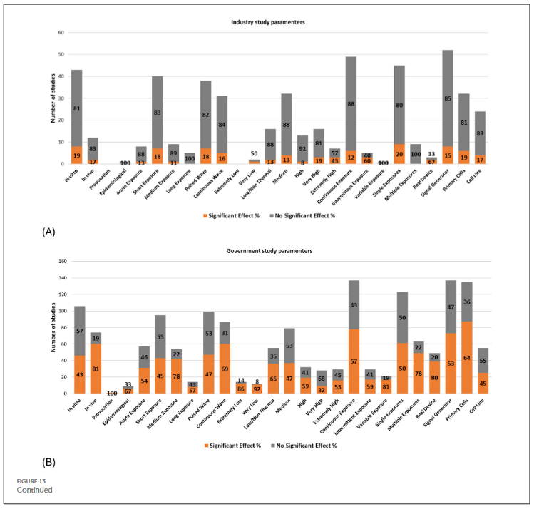

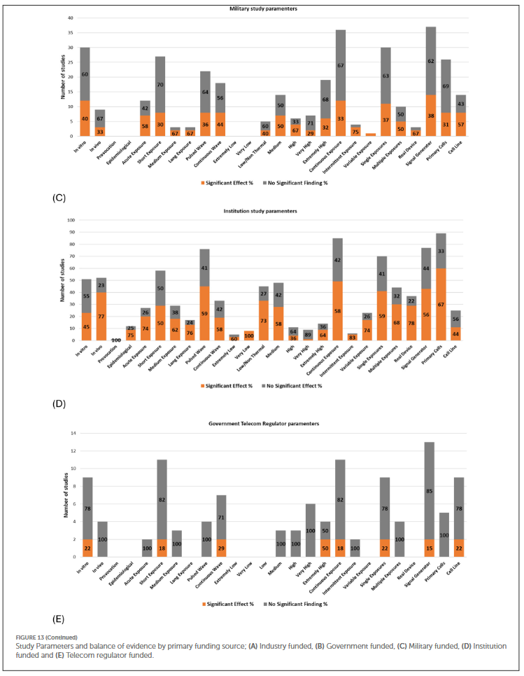
The authors comment “This pattern of bias has been documented in other lucrative industries, such as pharmaceuticals (99), agriculture, and chemical manufacturing (100). Such biases must be acknowledged and accounted for to ensure the integrity and reliability of published findings, particularly when conducting future systematic reviews.”

----

The above comments give a partial overview of important issues in making sense of the impacts and implications of RF-EMR technology.

----

To close, here is a set of Practical Recommendations (source: https://emfhaven.com/who-iarc-emf-classification/)

The following strategies are straightforward and widely recommended by public health guidance:
- Increase distance from your device. Signal strength (and therefore absorption) drops significantly with distance. Using speakerphone or a wired accessory keeps the phone away from your head.
- Use an air tube earphone. Traditional wired earphones carry the electrical signal — and associated RF — right up to your ear canal. Radiation-free air tube earphones replace the final section of wire with a hollow acoustic tube, so sound reaches your ear without a conductor transmitting EMF near your head.
- Consider a shielding phone case. A case engineered to attenuate RF emissions on one side of your device can help reduce exposure to the body when the phone is carried in a pocket or held in the hand. The EMF Haven Phone Case for Samsung Galaxy S24 is designed with a shielding layer to help reduce direct RF exposure to your body while keeping the antenna side unobstructed for normal signal function.
- Limit phone use when signal is weak. Devices transmit at higher power when coverage is poor, increasing RF output. Texting or waiting for better coverage in low-signal areas can help.
- Keep phones away from sleeping areas. Overnight proximity to a transmitting device extends cumulative exposure time unnecessarily.

Topics from http://dx.doi.org/10.1016/j.pathophys.2013.08.001

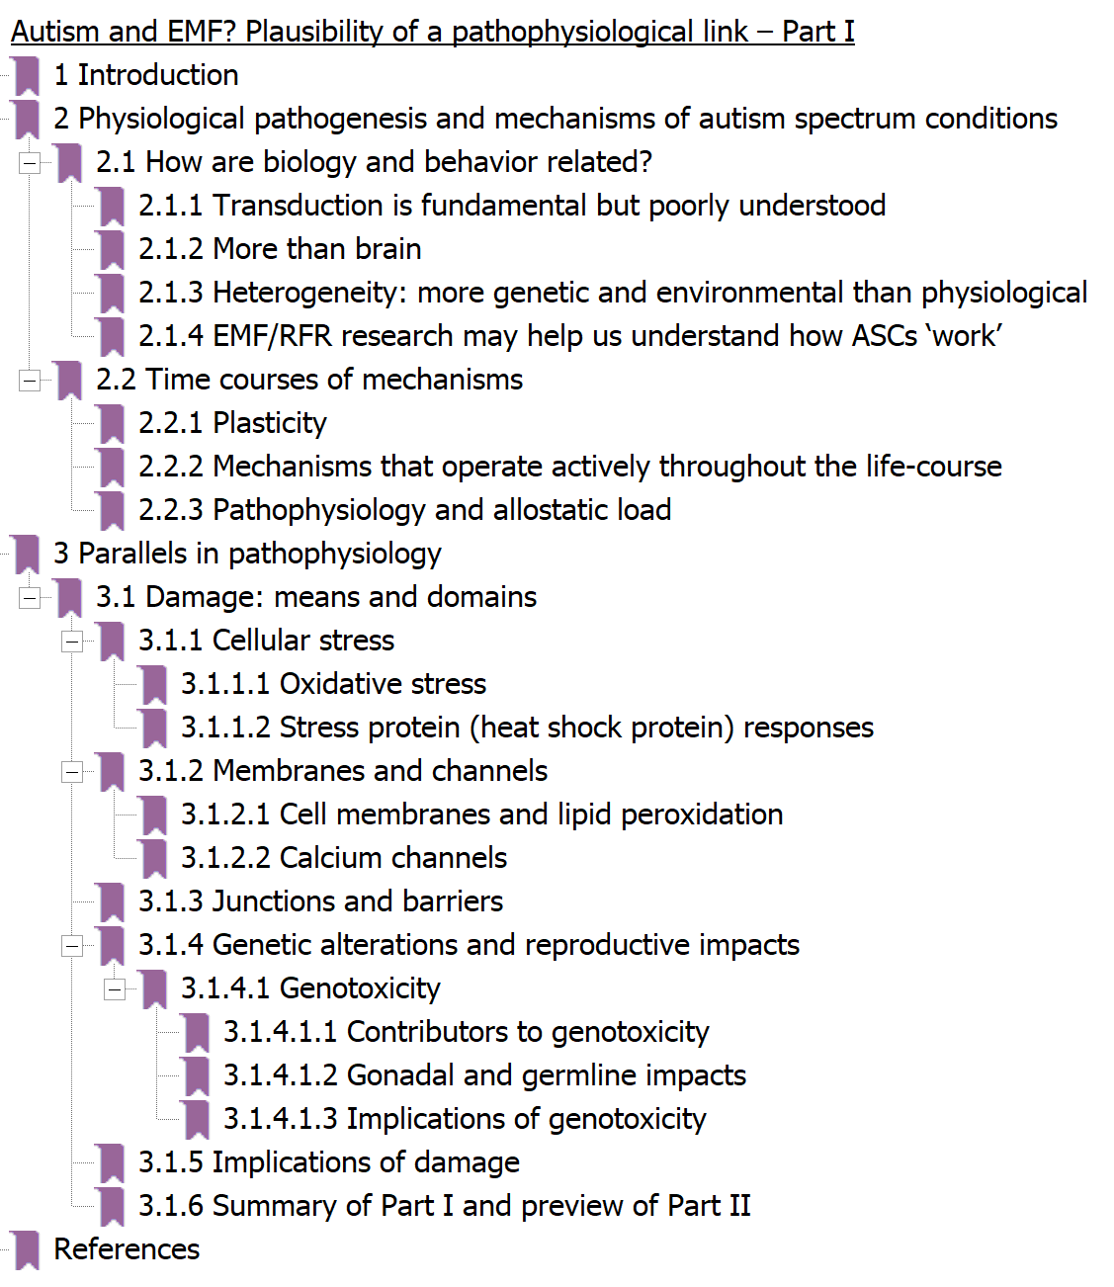

Topics from http://dx.doi.org/10.1016/j.pathophys.2013.08.002

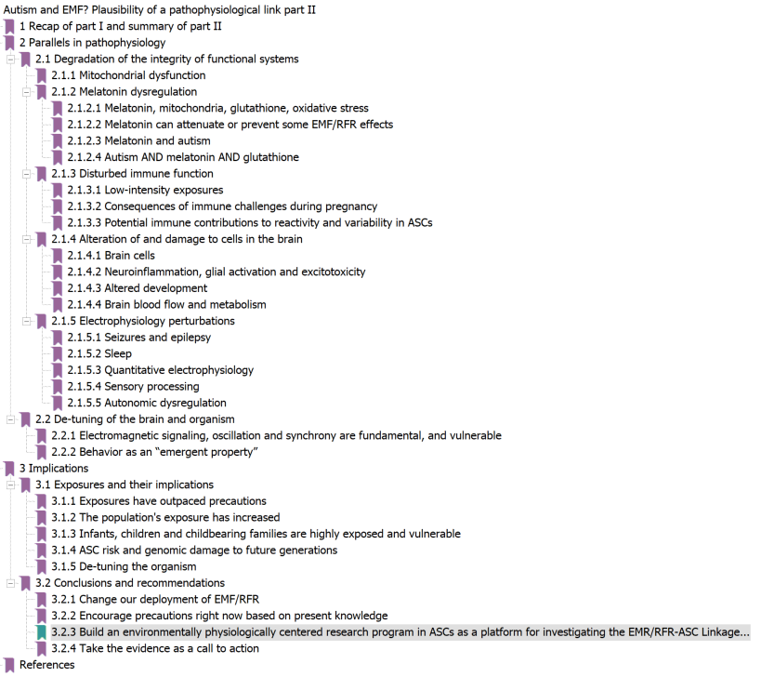

Clearly most people involved in EMF science, policy and clinical care will not digest this level of detail. That said, the papers are freely available and I am offering the above outlines to entice those who would like to at least peruse if not study this work.

Thank you for your attention.

