
https://mdsafetech.org/hematologic-effects/

  - Advisory Board
    - David Blask, Ph.d., M.D.
    - Victoria Dunckley, M.D.
    - Scott Eberle, M.D.
    - Beatrice Golomb, MD, PhD
    - Joel Moskowitz, Ph.D.
    - Jerry L. Phillips, Ph.D.
    - Cindy Russell, M.D.
    - Cindy Sage, M.A.
    - John West, M.D.

Hematologic Effects
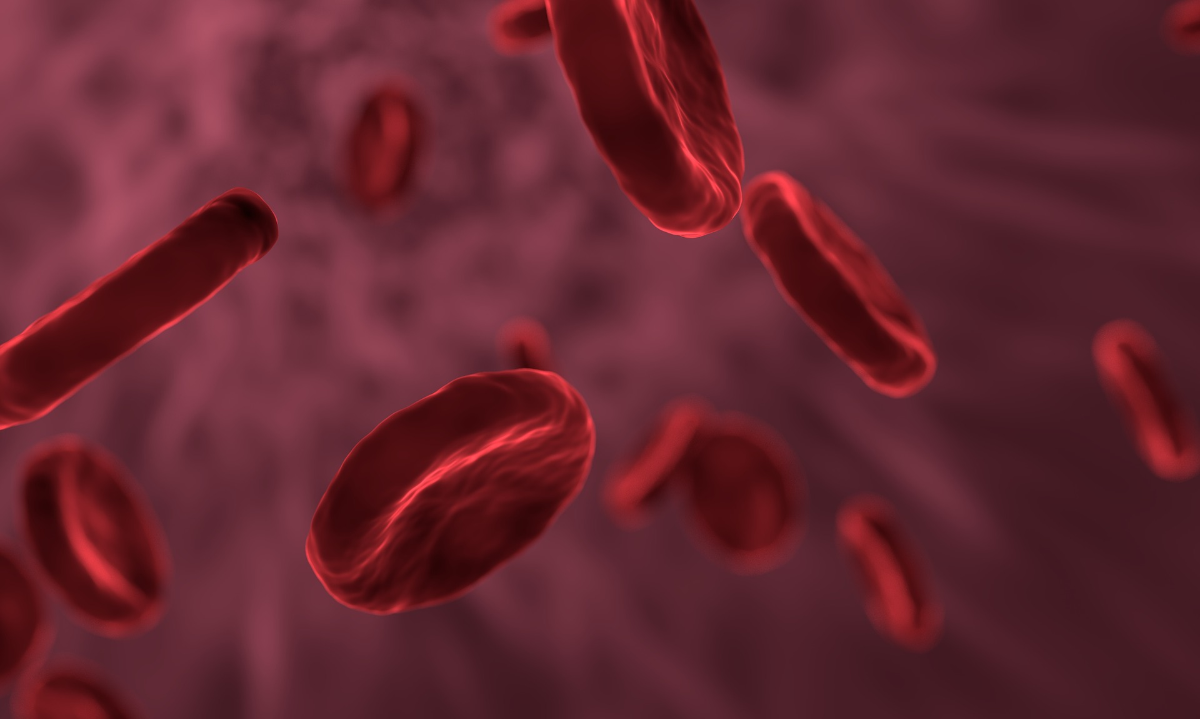
Updated 4/7/20
There is growing scientific evidence that wireless non ionizing radiofrequency radiation causes adverse effects on our white blood cells and red blood cells. The common mechanism of oxidation, found in over 100 studies of electromagnetic radiation is a likely contributor. A pilot study by the Weston Price Foundation in 2015 looked at the effects of cell phone radiation using live blood analysis under the microscope of healthy young volunteers on a whole food Weston A Price Foundation diet, “WAPF ” diet, versus controls. In both groups they observed abnormal red blood cell aggregation during and after short term cell phone use.
They concluded, “Results show substantial changes in the blood from short-term cell phone radiation exposure in nine out of ten human subjects. RBC aggregation and stickiness were mainly observed following 45 minutes of exposure to a smart phone in receiving mode worn by subjects in a backpack. By contrast, RBC morphological (shape) changes including the formation of echinocytes (spiky cells) were dominant after subjects actively used the phone for an additional 45 minutes. It appears that RBC stickiness with clumping is the first stage of the cell phone radiation effect.”
They also noted, “The observation that peripheral blood taken from a finger and toe of the same subject showed the same blood changes in response to cell phone radiation exposure suggests the blood changes we observed are systemic.”
In a new article from University of Surrey published in Nature, researchers found that biological cells generate an electric field outside the cell. Scientists demonstrated that red blood cells act as micro electrodes. This impacts how well the red blood cells stick together. In addition like other living cells, red blood cells exhibit a circadian rythym. Professor Mike Hughes, the lead engineers in the study, stated, “Biology is often reduced to interactions between big molecules, but cell-scale science is an essential area of study. By reintroducing the electrical element, we are looking for—and finding—a whole new way to understand how the body works.”

Scientific Literature
- The discovery of red blood cells acting as micro-electrodes opens new doors in medical research. (2021) University of Surrey. Phys.Org. Oct 8, 2021. https://phys.org/news/2021-10-discovery-red-blood-cells-micro-electrodes.html
- Vm-related extracellular potentials observed in red blood cells. (2021) Sept 30, 2021. Pycraft Hughes, M et al. Nature. Scientific Reports. https://www.nature.com/articles/s41598-021-98102-9
- Electromagnetic Fields and Calcium Signaling by the Voltage Dependent Anion Channel. (2021) Ullrich V and Apell H. Open Journal of Veterinary Medicine, 2021, 11, 57-86. https://www.researchgate.net/publication/348840701_Electromagnetic_Fields_and_Calcium_Signaling_by_the_Voltage_Dependent_Anion_Channel
- Effects of mobile phone radiation on certain hematological parameters. (2020) Christopher B et al Radiation Physics and Chemistry. Vol 166. January 2020. https://www.sciencedirect.com/science/article/pii/S0969806X19305481
- Aluminium foil dampened the adverse effect of 2100 MHz mobile phone-induced radiation on the blood parameters and myocardium in rats. (2019) Kalanjati VP. Environ Sci Pollut Res Int. 2019. Apr;26(12):11686-11689. https://www.ncbi.nlm.nih.gov/pubmed/30806932
- Disturbance in haematological parameters induced by exposure to electromagnetic fields. (2018) Jbireal JM et al. Hematology Transfusion International Journal. Dec 2018. https://www.researchgate.net/publication/329972405_Disturbance_in_haematological_parameters_induced_by_exposure_to_electromagnetic_fields
- Effects of exposure to electromagnetic field from 915 MHz radiofrequencyidentification system on circulating blood cells in the healthy adult rat. (2018) Kim HS et al. Bioelectromagnetics. 2018 Jan;39(1):68-76. https://www.ncbi.nlm.nih.gov/pubmed/29171038
- Exposure to 1.8 GHz electromagnetic fields affects morphology, DNA-related Raman spectra and mitochondrial functions in human lymphs-monocytes. (2018) Lasalvia M et al. PLoS One. 2018 Feb 20;13(2):e0192894. https://www.ncbi.nlm.nih.gov/pubmed/29462174.
- Effect of electromagnetic radiation of mobile phones on hematological and biochemical parameters in male albino rats. (2018) Sani A et al. European J of Experimental Biology. https://www.researchgate.net/publication/325363366_Effects_of_Electromagnetic_Radiation_of_Mobile_Phones_on_Hematological_and_Biochemical_Parameters_in_Male_Albino_Rats
- Electromagnetic Fields of Mobile Phone Jammer Exposure on Blood Factors in Rats. (2018)Shojaeifard MB et al. J Biomed Phys Eng. 2018 Dec 1;8(4):403-408. https://pubmed.ncbi.nlm.nih.gov/30568930/
- The effect of Base Transceiver Station waves on some immunological and hematological factors in exposed persons. (2017) Taheri M et al.Hum Antibodies. 2017;25(1-2):31-37. https://www.ncbi.nlm.nih.gov/pubmed/27911288https://www.ncbi.nlm.nih.gov/pubmed/27911288
- Impact of radiofrequency radiation on DNA damage and antioxidants in peripheral blood lymphocytes of humans residing in the vicinity of mobile phone base stations. (2017) Zothansiama et al. Electromagn Biol Med. 2017 Aug 4:1-11. https://www.ncbi.nlm.nih.gov/pubmed/28777669
- Effect of Radiofrequency Radiation on Human Hematopoietic Stem Cells. (2016) Glaser K et al.Bio One Complete.Oct 6, 2016. https://bioone.org/journals/Radiation-Research/volume-186/issue-5/RR14405.1/Effect-of-Radiofrequency-Radiation-on-Human-Hematopoietic-Stem-Cells/10.1667/RR14405.1.short
- Does Short-term Exposure to Cell Phone Radiation Affect the Blood? (2015) Weston Price Foundation. https://www.westonaprice.org/health-topics/does-short-term-exposure-to-cell-phone-radiation-affect-the-blood/
- Effects of Electromagnetic Fields on Automated Blood Cell Measurements. (2014) Vagtatli E et al.J Lab Autom. 2014 Aug;19(4):362-5. https://www.ncbi.nlm.nih.gov/pubmed/24464815
- Non-thermal radio frequency and static magnetic fields increase rate of hemoglobin deoxygenation in a cell-free preparation. (2013) Meusham D et al. PLoS One. 2013 Apr 12;8(4):e61752. https://www.ncbi.nlm.nih.gov/pubmed/23593496
- “Effects of Exposure to Electromagnetic Field on of Some Hematological Parameters in Mice,” (2012) Alghamdi M et al.. Open Journal of Medicinal Chemistry, Vol. 2 No. 2, 2012, pp. 30-42. https://m.scirp.org/papers/19684
- Effect of Radiofrequency Electromagnetic Field Exposure on Hematological Parameters of Mice. (2012) Usman AD et al. World Applied Sciences Journal 16 (5): 656-664, 2012. https://pdfs.semanticscholar.org/6a5e/746e9b77973bb1a56eab91808a3cfa330f83.pdf
- Effects of mobile phone radiofrequency on the structure and function of the normal human hemoglobin. (2009) Mousavy SJ et al. International Journal of Biological Macromolecules 44 (2009) 278–285. https://pubmed.ncbi.nlm.nih.gov/19263507/ or https://www.researchgate.net/publication/24179387_Effects_of_mobile_phone_radiofrequency_on_the_structure_and_function_of_the_normal_human_hemoglobin
- The effects of broad-band electromagnetic field exposure on mice (Mus musculus).(2000) Journal of Environmental Science and Health, Part A: Toxic/Hazardous Substances and Environmental Engineering. Volume 35, Issue 3, 2000. https://www.tandfonline.com/doi/abs/10.1080/10934520009376972
- The effect of ultrahigh-frequency radiation on adaptation thresholds and the damages to blood system cells. (1998) Obukhan KI, [Article in Ukrainian]. Lik Sprava (7):71-73. https://www.ncbi.nlm.nih.gov/pubmed/10050464
- Epidemiological studies of radio-frequency radiation: current status and areas of concern. (1996) Goldsmith JR. Science of the Total Environment. Volume 180, Issue 1,2. February 1996 , Pages 3-8. https://www.sciencedirect.com/science/article/pii/0048969795049142
- Assessment of radio-frequency electromagnetic radiation by the micronucleus test in Bovine peripheral erythrocytes. (1996) Zanda Balode. Science of the Total Environment. Volume 180, Issue 1,2. February 1996, Pages 81-85. https://www.sciencedirect.com/science/article/pii/0048969795049231
- The biological effects of radiofrequency radiation: a critical review and recommendations. (1986) Robert, N.J. Jr et al. Int. J. Radiat. Biol., 50: 379-420. https://www.ncbi.nlm.nih.gov/pubmed/3528012

