Submitted by Anonymous: An 80-year old Massachusetts widow and grandmother driven from my owner-occupied townhouse –
by smart meter radiofrequency radiation, when harm had already been reported years earlier

In response to HHS QUESTION # 1 Public Experience and Reported Potential Adverse Health Effects
a. The type(s) of wireless technology or RF/EMF source(s) Smart Meters
b. The nature, duration, frequency, and approximate timing of the reported exposure(s). Commencing 11/10/2025 immediately upon installation of meters on owner-occupied townhouse
c. The potential adverse health effects experienced. Dangerously high blood pressure, rapid heart rate, sleep interruption, excess urination, balance issues, exhaustion, weight loss, muscle cramps, tingling feet
d. When potential adverse health effects first appeared relative to when exposure began and whether any changes in exposure coincided with potential adverse health effects. Symptom onset was immediate. The symptoms disappear when I sleep at the campground away from home.
e. Whether medical evaluation or treatment was sought, including any diagnoses received (if the respondent chooses to share them). I was diagnosed by a physician
f. Whether steps to reduce or eliminate exposure were taken and, if so, whether any subsequent changes in potential adverse health effects were observed. I spent thousands of dollars attempting to mitigate and was driven from my home where I planned to age in place

My Story: 2025-2026: From Healthy, to Health-Vulnerable, to Disabled Without Accommodation - and Endangered
Through most of my life, I was very active and healthy, riding my bicycle, running marathons, gardening, skiing, traveling, eating a clean diet, raising my children, enjoying gatherings with a large extended family
But then the start of my life chapter with “environmental illness” suddenly began when I was 65, after two vaccines, one in each arm.
I was eventually diagnosed with MCS- Multiple Chemical Sensitivity.
After I finally figured out what was wrong, I was able to enjoy my life again as long as I avoided triggering exposures.
I spent a lot of money on treatments, medication, and supplements to support my immune system.
My diagnosis meant that I had to avoid some activities, like senior outings on a bus filled with perfume, but it was worth the price to protect my health.
And I was safe in my own home.
Then, everything went downhill again, and over a cliff, in 2025 -2026 to the present, with no relief in sight, due to continuous, juxtaposed, involuntary, inescapable exposure to biologically-active radio frequency radiation.

Smart Meter Installation #1 The Beginning of the End: Nov. 2025
I know exactly when my life was turned upside down the second time, (after the earlier diagnosis on MCS): Monday, November 10, 2025, when I was 80 years old.
I was at a holistic expo over the week-end. I was in and out of the house on Monday morning.
On Nov. 10 I saw a small white van headed for the electrical closet on the outside wall. It had been in the neighborhood all day. At 2pm I heard loud banging on the wall.
The utility was installing new electric meters in a bank of meters adjacent to the townhouse I had shared with my late husband.
There is another bank of 7 meters on the building across the street facing my unit, with 2 more on another building, and more across the street near the mailboxes.
That day, they were supposed to install 7 meters for our building, but they only had 2 left on the truck.
I never received a notice that they were coming, but some neighbors did.
Within 10 minutes my blood pressure had spiked to 191/101.
From that moment on, I was constantly on edge. I couldn’t sleep. I was overcharged and exhausted at the same time. My head hurt, and I had brain fog. My nerves were frazzled. I was very unsteady on my feet.
I lost my equilibrium due to an environment al exposure that I cannot avoid, in my own home.
In an instant, I became an EMF refuge. My former life was over.
Eventually, I lost my house, my community, and my health.
Thank goodness they only had 2 meters that day.
I Requested Accommodation from the Utility
Right away, I contacted the electric utility about a medical waiver or opt out.
I sent a note from my doctor to the utility about the need for an opt out.
A few days later I received a phone message from a supervisor that there were no medical waivers, and that I would need to convince all six of the other neighbors in the building to opt out and to pay the fees; $26/month for the non-transmitting meters and $33 installation fees.
That would have been an extra $182/month for protection money for seven opt out fees, plus the installation fees, in part because I did not live in a stand-alone building with only one electric meter.
And I was already being surcharged on my electric bill for the meters.
I realized that I had to move to protect my life. There was no other option.
My family agreed that I should offer to pay the installation charge for the opt out meters, and the monthly opt out fees for everyone in the building of seven units, until I could move.
I had to speak with 6 neighbors and share my personal private health information and to beg them to protect me.
No one should ever be forced into this position, begging others to protect their lives.
Three neighbors initially agreed to opt out until I could move out, and 3 did not. Even though I said would pay the fees. (Some thought they would save money with the new meters.)
I Attempted to Mitigate at My Own Expense
I knew that there was an expert, dedicated Building Biologist in the state, and I contacted him to see if it would be possible to mitigate to keep me safe - until I could move out.
From November to January we experimented with different approaches including shielding and using a whole house filter and other strategies.
I have spent thousands of dollars on both health care and mitigation, a protective sleep tent, and other attempts to safeguard my health.
I spent many nights sleeping in my car across the street, in a parking lot, because the house was unbearable.
I didn’t know what to do.
My health was getting worse and worse.
More Meters, New Year’s Eve Day, December 2025
After the two meters were installed in November, I lived in fear that the truck would return with the other 5 meters.
On New Year’s Eve Day, December 31, 2025, the truck showed up again with work orders for 5 more meter installations, but with 2 opt outs, for mine and one neighbor.
The Body Pays the Price: Dangerously High Blood Pressure
I have lost so much weight, and am under so much stress, since the meters were installed, with no relief in sight.
Since “life with a new smart meter” I was and still am suddenly waking up in the middle of the night from a deep sleep with a racing heart rate and high blood pressure, in very unnatural, startled, shock reaction.
I can’t get back to sleep.
We should be able to measure and verify that this is happening in response to exposures.
The Readings for My Townhouse with Multiple Meters, Explanation Courtesy the Certified Building Biologist:
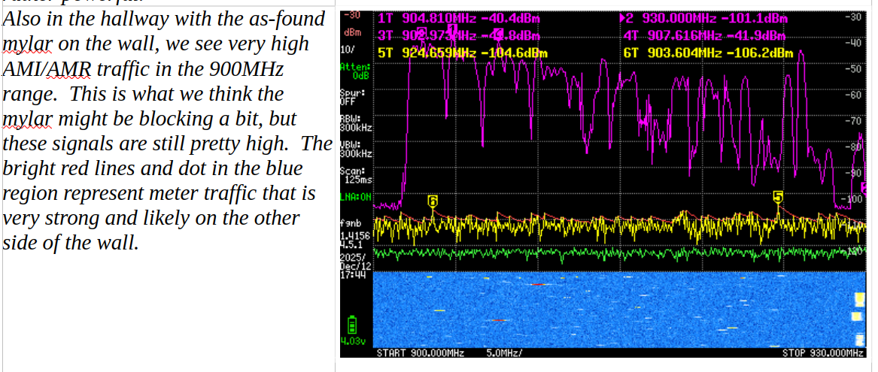

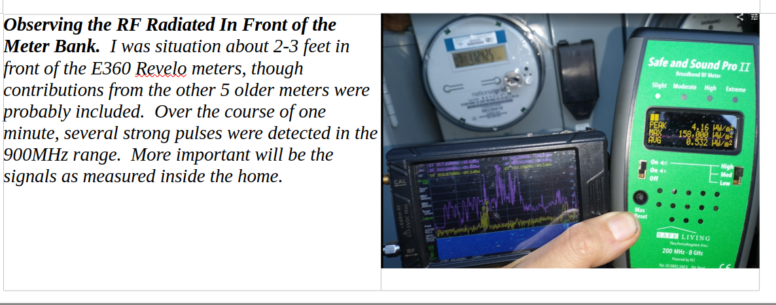
There is a very strong local FM radio station but the smart meters were at least double that strength (>= 4 dB).
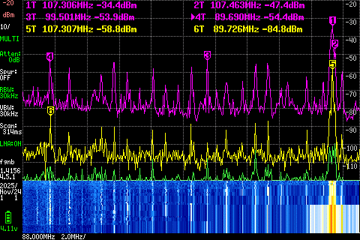

Other signals in the condo were generally at least 4X - 40X lower in peak value than the ongoing smart meters (~6 - 16 dB). The owner does not employ much wireless technology in her home, except for short periods.
When the neighbor is active, then their WI-FI or cell signal do increase the exposure, but it is for a relatively short time period by comparison to the 24/7 impact of the smart meters for those dozens of condos.
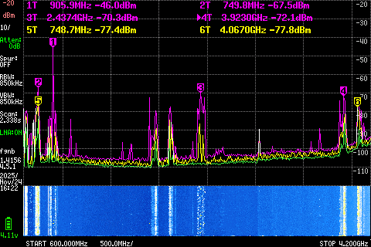

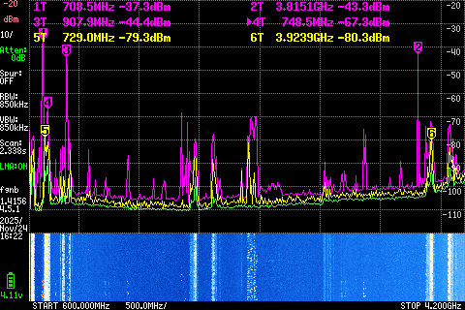

Everywhere in the apartment, there is a constant assault from the NGrid AMI/AMR meters.
The blue represents the history of the last 10 seconds.
Every little horizontal 'dash' represents a short data pulse portion on the order of a few milliseconds in duration.
There is not a second that went by in which some AMI/AMR RF broadcast was detected inside her condo.
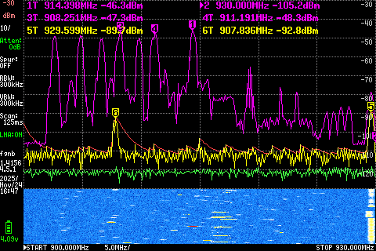

On the Run - from My Own House
I could no longer bear to be in my house. It was torture.
In January after more meters were installed, I left my home and spent the winter on the run.
Thankfully a friend let me stay at her house in the colder months, but I had to sleep on the living room floor because it was the room that had the least exposures, and it wasn’t great.
The bigger problem was that now I was not only reacting to the meters. Cell towers, and the EV charger next door, were now new obstacles.
I felt like I had one foot on the brakes and one foot on the gas. I was overcharged and tired at the same time.
I know of other EMF refugees who are sleeping in larger rooms in their homes to avoid the electricity in the walls, and/or who had to give up their bedroom because it is on a shared wall with a transmitting smart meter. Some find refuge in the bathtub.
Others, like me, are also turning to power off at night in search of relief.
I know fuse boxes are not designed to be used this way but we have no choice.
This poses a hazard, for example when getting up at night to use the bathroom, etc. with no lights.
Through the spring and summer and now fall of 2026, I have been camping, and sleeping in my car, and looking for another house while paying for a home and condo fees - where I can’t even live.
I can’t even pack my house to move because I can’t spend time there without getting sick.
Blood Pressure In a Home with Only One Meter
I own a blood pressure meter. My meter keeps track of the readings.
Here are a few recent readings.
Early morning readings- taken within the hours of midnight to 2 am when I am jolted awake:
Sept 2 168/86
Oct. 2 161/85
Oct. 4 180/106
Oct. 8 180/100
Oct. 11 180/96
I get woken up from a deep sleep with a racing heart. My blood pressure skyrockets.
Even though I escaped the bank of meters at my townhouse, I have not regained my equilibrium and my baseline health.
Blood pressure with sudden spikes as high as mine is extremely dangerous and my family is very concerned about the possibility of a stroke.
I can’t manage this by diet or eating less salt or drinking more water.
I am now taking multiple blood pressure medications that I might not need if the meter could be removed. And/or the nighttime data transmissions would stop. The medication does not even work.
When I sleep at the campground or in my car in the parking lot across the street my blood pressure is not impacted and I am not being awaken during the night with a racing heart. I can actually rest.
But with winter coming the campground is now closed and it’s too cold to sleep in the car.
The problem is not in my physiology. It’s in the house.
My elevated blood pressure is being induced by the environmental exposure and when I am protected from the exposure, my blood pressure is not affected.
When I am awoken suddenly at night, it affects me the whole next day. I am exhausted. I feel hung over and am in a fog. I can’t function.
I need to sleep.
I have been suddenly unsteady on my feet, needing to grab the wall.
I know that not everyone has the same symptoms, but my escalating heart rate and blood pressure pose a true survival risk.
I never should have been placed in harm’s way in the first place by a wrong technology choice - when reports of harm had already been made, and ignored.
No Relief, No Safety, No Sleep
Now, I am staying in another home in another town but the house already has a new transmitting smart electric meter and smart water meter.
Two individuals are both experiencing simultaneous sleep interruption and symptom onset from separate parts of the house.
The other individual reports “microwave hearing” which ranges in intensity, with sudden onset which also corresponds to my being awoken with elevated blood pressure.
The electromagnetic environment changes over the course of the day and night, but the sleep interruption issue at night is especially damaging.
It seems that the body is more reactive and disturbed by the night time peaks in exposures.
Why are data transmissions not being scrutinized relative to the need for sleep? Testing people in a sleep center is of no use when the exposures in the home are not being considered.
When I drove myself to the hospital during one episode, by the time I arrived, my blood pressure had gone down.
We need actual investigation in real world circumstances where the symptoms can be correlated with the actual peak (not averaged) exposures.
Utility Non-Response
Since leaving my townhouse to stay in another town, we contacted the investor-owned electric company and reported dangerous issues with night-time high blood pressure spikes.
I requested an opt out meter. I followed up with a phone call a few days later, and was told that I may need to wait a month for the opt out meter (because it is installed by a different contractor?)
Then the utility sent a letter questioning the fact that I requested to opt out, and giving me information about how to cancel my opt out request.
Ratepayers are funding the elaborate stall tactics. This is not consumer outreach. It is harassment and neglect.
I spent 30 minutes on the phone with another follow up call.
The utility was using the same talking points that they have been using for years, for example comparing a smart meter favorably to other wireless devices.
Where is the data for harm, injury, and acute onset disability for the new meters from the last fifteen to twenty years?
The Industry Talking Points for Smart Meters Deserve More Scrutiny and a Requirement for Transparency, Accuracy, and References
The website for National Grid Meter Safety | National Grid includes the statements:
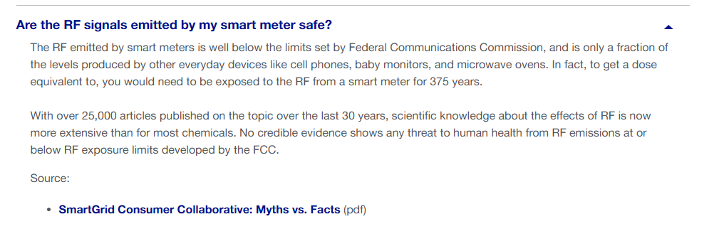
Source: SmartGrid Consumer Collaborative: Myths vs. Facts (pdf)
The sentence – “to get a dose equivalent to” does not even make sense.
No one has held the industry or the Smart Grid Consumer Collaborative accountable to provide the explanation for the comparison of a smart meter vs. a cellphone, and they are not equivalent. Where is the science of any reference or math to support the 375-year claim?
Who are the experts that the Smart Grid Consumer Collaborative references to support its safety claims?
Ratepayers are paying all of the costs, for the administrative delay tactics.
The utility is taking its time processing the opt out requests, even though the meter is causing stress and harm to health.
The industry should have been required to provide the pre-market safety science, and not shift the burden to the public after the fact.
Why is there no pre-market or post-market research on the impact on blood pressure (or blood sugar, or sleep) from the involuntary exposures to smart meters? Or investigation of reports of harm?
The Science was Already There
I have learned that there was already research dating back decades about the effects of radiofrequencies on the heart.
I found a study from 1998, and it is not good:
Braune S, Wrocklage C, Raczek J et al.
Resting blood pressure increase during exposure to a radio-frequency electromagnetic field The Lancet, 351, 1857-1858

“A 1998 Lancet study found that exposure to a GSM 900 MHz mobile phone radio-frequency field for 35 minutes raised resting systolic and diastolic blood pressure by about 5–10 mm Hg compared with sham exposure, likely due to increased sympathetic activity and vasoconstriction.”
Also the more recent study: ENVIRONMENTAL HEALTH TRUST VP PUBLISHES STUDY REVEALING REAL TIME IMPACT OF CELL PHONE EXPOSURE ON HUMAN BLOOD
LAUSANNE, SWITZERLAND, February 11, 2025 – Frontiers in Cardiovascular Medicine today published a study by Dr. Robert R. Brown, Environmental Health Trust Vice President of Scientific Research and Clinical Affairs, revealing ground-breaking research on the impact of mobile phone radiation on human blood. Dr. Brown’s peer-reviewed study includes ultrasound images of a healthy volunteer’s blood changing to rouleaux formation (clumping together) when in close proximity to a cell phone.

Also as reported by Dr. Magda Havas:
#024: Microwave Radiation Affects the Heart – Dr. Magda Havas, PhD.: https://magdahavas.com/from-zorys-archive/pick-of-the-week-24-microwave-radiation-affects-the-heart/
[] “We know that pacemakers can malfunction if they are exposed to interfering microwave frequencies and people with pace makers are told to stay away from microwave ovens and other microwave emitting devices. The newer pacemakers have shielding to prevent interference. But the human heart comes without a shield. So it is not only the child or adult with a pace maker that needs to be careful about their exposure to microwaves, all of us need to be aware that this radiation may affect the heart.
This concept is supported by the early research on microwave radiation. Cardiovascular problems seem to be common among microwave workers.
In #022: A Very Important Symposium! – Dr. Magda Havas, PhD., Healer (1970) stated that:
“In the interest of occupational hygiene, many Soviet investigators (and at least one U.S. researcher) have recommended that cardiovascular abnormalities be used as screening criteria to exclude people from occupations involving radio-frequency exposures.”
Glotova, KV, Sadchikova MN. 1970. Development and clinical course of cardiovascular changes after chronic exposure to microwave irradiation, Effect of Microwave Irradiation, Arlington, VA, Joint Publication Research Service, (JPRS 51238), 3 pp.
Development and Clinical Course of Cardiovascular Changes After Chronic Exposure to Microwave Irradiation
The authors of this publication were with the Institute of Labor Hygiene and Occupational Diseases, USSR Academy of Medical Sciences, Moscow. This is just one in a series of study from the Soviet Union that examines the effect of microwave radiation on the nervous and cardiovascular system.” – Dr. Magda Havas

We had access to research in the 1970s showing that some individuals had cardiac reactions to exposures to radiofrequency (RF) radiation and/or pulse-modulated RF radiation.
Rather than expecting consumers to provide science showing harm, at this point shouldn’t the industry be required to show that the exposures are not causing changes to the circulatory and nervous system?
Should independent investigators follow up on reports of harm?
We have no idea how many people can’t sleep and are just taking medications, with no idea that the sleep interruptions could be addressed with safer technology choices.
A Housing Crisis - Caused by Inadequately Regulated Technology
Now I can’t avoid the triggering effects of other exposures that did not bother me before, in stores, walking outside, driving, etc.
I haven’t been able to recover my health baseline since the smart meters were installed.
My acute-onset downslide and disability could have been avoided if policy makers and the industry had paid attention to what was happening in other states where and when new transmitting smart meters and infrastructure were already installed.
Now I have to look for a house without shared walls so that I am protected from neighbors’ wireless, EV chargers, etc.
I have to look for a house that is not near a cell tower.
I should not have to be buying a new house now.
I have been advised to seek housing where I can avoid a transmitting meter, or opt out of a smart meter. That means looking for a house that does not have a wireless water, gas, electric, propane, or other transmitting meter, and/or in an area where the utilities or municipality will provide an analogue opt out meter.
They don’t exist.
There are no reasonably priced, convenient, accessible refuges where people who have been harmed and go and rest and heal.
There are no services or accommodations.
Very few doctors have been trained in this area.
Options like densified and community senior housing are not even available to some ratepayers because more and more wireless is being added everywhere.
(This also includes the elimination of landline corded phones, creating more vulnerability in the case of a power outage.)
There is No Transparency or Disclosure
The specifications for the data transmissions are not know to the public or their health care providers, and the actual functionality of the meters has been obscured, including how often they transmit, as described here:
PG&E’s Big Confession – EMF Safety Network
Several PG&E bulletins and spokespersons make varying claims on how often the Smart Meter electric meters transmit RF, anywhere from every hour to every 4 to 6 hours to 2% or 4% of the time.
California Public Utilities Commission administrative law judge Amy Yip-Kikugawa ordered all investor owned utilities (IOU’s ) to answer Smart Meter radio frequency (RF) questions.
PG&E’s answers Question 2: How many times in total (average and maximum) is a smart meter scheduled to transmit during a 24-hour period? PG&E says the average number of RF pulses for the electric meter would be about 10,000, per meter, per day and the maximum number over 190,000.” – EMF Safety Network
Not Just Electric Meters, Also Gas and Water: Financial Penalties for Protecting Sleep and Health
National Grid posted on its website that it is charging a $66 installation fee for an opt out meter for gas customers, and a $25 opt out fee for the monthly reading.
I have heard that ratepayers with solar who have 2 meters are being charged 2 opt out fees.
Forcing customers to pay opt out fees when the infrastructure was never tested for health and safety, and when early reports of harm were never independently investigated, is unfair.
This never should have happened to anyone, and never to anyone my age.
We Knew Already that the Meters Could Cause Harm
In the early days of smart meter installations, doctors working with chronic illnesses knew that those patients who had chemical sensitivity were also developing electromagnetic hypersensitivity.
I have a question.
Why were people not provided with a medical accommodation for an opt out meter?
Isn’t this discrimination?
A Medical Expert Warned Regulators that the Meters Could Cause Harm and Disability
In 2019, in Massachusetts DPU 20-69, environmental health expert Beatrice Golomb MD PHD Dr. testified to the Massachusetts Department of Public Utilities that:
”the installation of a smart meter was the most frequently reported variable associated with the acute onset of electromagnetic hypersensitivity.“
That is what happened to me.
Where is the science from the industry about the actual biological testing of the meters, or banks of meters?
Why isn’t there anyone who could come to investigate, or to measure the nighttime transmissions in the house vs what is happening to my blood pressure?
Maybe if I could rest my health could recover.
The Industry Relied on Mercenary Scientists
What is even more upsetting?
I learned that the utilities and public utility commissions and politicians used actual tobacco scientists to override reports of harm.
(You can read about it in the transcript for the Feb. hearing for MA DPU 12-76, but it happened in all the states that relied on the same experts.)
Instead of demanding that the public provide evidence of harm and scientific studies, shouldn’t health agencies ask to review the premarket safety studies, the data for injury reports, and the investigation that the industry and independent experts did in response to reported harm?
Even if there is none?
And do an accurate, biological assessment, for example, working with individuals who report issues with blood pressure, or blood sugar, or even just sleep interruption, and verifying their observations of simple stimulus/response using accepted medical protocols and engineering measurements?
The Cities of Boston and Philadelphia said it in 2013: This is Negligence.
November 18, 2013, the cities of Boston and Philadelphia filed a joint submission with the FCC.
They accused the FCC and federal health agencies of negligence for failing to investigate whether electrosensitive persons are harmed by non-ionizing radiation:
“The FCC admits its own lack of expertise in the field. But the overlap of federal agency responsibilities for RF radiation protection and the merely advisory status of the Radiofrequency Interagency Work Group often leaves leadership unclear and encourages a pass-the-buck attitude.”
“The 1999-2000 judicial challenge to the FCC’s 1996 rules never reached the issue of “electrosensitivity” as a cognizable disability under the Americans with Disabilities Act. (“ADA”)
“Here again, an agency responsible for ADA implementation acknowledges that the impairment may be disabling but has promised merely further inquiry. After more than a decade, that investigation remains unopened. The dockets here have been updated with massive additional evidence of the crippling effects of RF radiation on an admitted minority – but a suffering minority – of U.S. citizens. The FCC and its sister regulatory agencies share responsibility for adherence to the ADA and should replace promises with serious attention to a serious medical problem. This is one area where the FCC could lead in advice to electrosensitive persons about prudent avoidance.”
I Wanted to Live in My Home for the Rest of My Life
I moved to the townhouse I loved with my late husband in 2005.
He passed away following eight years with Parkinson’s disease. I was his caretaker.
I intended to age in place in the home we loved.
We had installed a custom-made $18,000 stairway chair lift and added other investments that made the house a perfect fit for me for life. I will never recover the value of those investments.
There was room for family to come visit. I had my gardens, and community, including the local senior center, and neighbors. I gave the dogs dog bones. I did pilates, yoga, bingo, and other activities.
Then came the meters.
This is so unfair.
We are paying for the meters in our bills already, and they are not only of no use to me, but I am being charged even more fees to opt out, when I finally get an opt out meter.
Couldn’t we have compared early reports of harm with actual engineering measurements of exposures from the grid and in the airwaves, when the smart meters were first installed? Why are we assuming that only heat from short-term exposures causes harm, when so much neurological harm is occurring?
I have been on the run.
The worst part of it is the family and friends who do not believe me.
Who would make this up?
When people think you are nuts?
Why is no one paying attention?
Immediate Relief is Needed: Mandate a No-Fee Opt Out, and Provide Refuge, and Dedicated, Protected Housing, Now
The priority should not be protecting the earnings/ROI of the investor-owned utilities.
Denial of sleep is recognized in international law as a form of torture.
I have three suggestions:
- A most helpful and responsible response would be for decision makers to mandate an emergency, immediate no-fee opt out for all meters placed on premises where risk and/or harm is already being reported and/or where health vulnerable ratepayers live, until a safe approach to metering can be re-engineered. The opt out meter needs to be analogue, and not a digital meter with the transmitter turned off. Vermont has a no-fee opt out, so we know it can be done. There should be a priority placed on protecting people in their own homes.
- We need protected zones where people who have been injured can recover and rest, without undo expense.
- We need dedicated, protected housing. When the Snowflake Arizona community responded to the need for dedicated housing for individuals with MCS, the telecom company came in with a plan to install a cell tower, ruining lives.
Without an adequate system of checks and balances, bullying and cruelty by these industries is growing.
The public deserves far more care and protection than the industry and its regulators have provided.
The issue of protection of health and the environment can’t remain under the purview of the FCC.

This testimony for Anonymous was prepared with the assistance of a volunteer, courtesy Safe Tech International. Should HHS need more information or need to investigate this complaint, please contact team@safetechinternational.org

