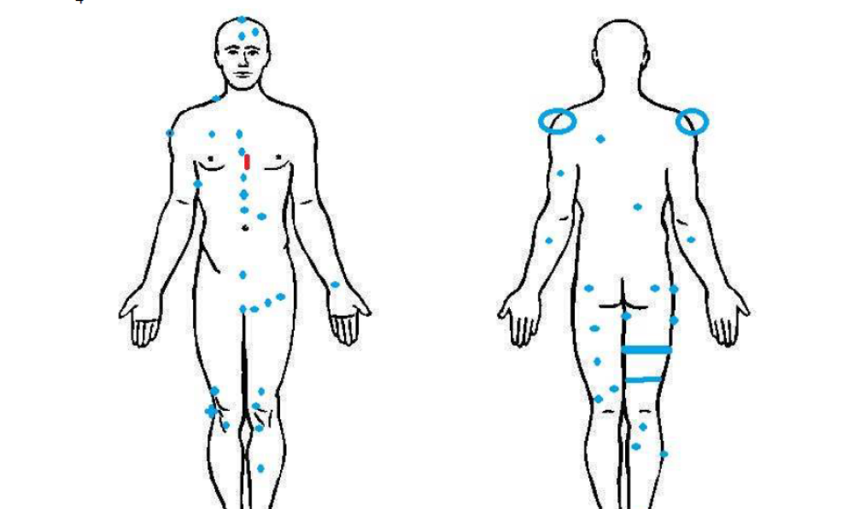

SCAN OBSERVATIONS OF NOTE
Using Method Standard One, with Black lying prone, the ELF/EMF Scan readings varied. The standardfor the room was 0.00-0.01μ. Testing on a brewing coffee pot in an adjacent room showed 0.32 μ.
With equipment showing readings within normal limits, testing proceeded. Normal for Black was 0.00-0.01μ except at the following locations: 0.02μ at crown of the skull; 0.02μ at the Ⓛ parietal bone (forehead); 0.02μ at the center of the parietal (forehead); 0.02μ at the ® trapezious; 0.02μ-0.05μ oscillating at the ® pectoralis minor; 0.02μ at the ® deltoid; 0.02μ at the ® medial bicep; 0.02μ at six points in what appears to be a line starting from mid sternum, past a scar, and ending at the pubic bone; 0.02μ-0.05μ oscillating at the Ⓛ lower quadrant of the abdomen; 0.02μ in three points that appear to be a line across the Ⓛ hip flexor; 0.02μ at the Ⓛ wrist; 0.02μ at the Ⓛ rectus femorus (quadriceps); 0.02μ at the Ⓛ knee with two points superior and one point inferior; 0.02μ with one point superior and one point inferior to the ® knee; 0.02μ-0.04μ oscillating just inferior to the ® patella; 0.02μ-0.05μ oscillating at the ® distal phalanges of the foot; 0.02μ at the median of the Ⓛ tibia; 0.02μ at the fifth distal phalange of the Ⓛ foot; -0.00-0.02μ oscillating at the shoulders, bilaterally (negative readings are unusual in this investigator’s experience); 0.05μ at the Ⓛ scapula; 0.02μ at the Ⓛ tricep; 0.03μ at the Ⓛ brachioradialis (forearm muscle); 0.03μ at the ® kidney; 0.02μ
at the ® brachioradialis (forearm muscle); 0.02μ, bilaterally, at the TrP2 of the gluteus maximus; 0.02μ-0.04μ oscillating at the ® gracillis (groin); 0.02μ at the ® lateral cutaneous nerve of the thigh; 0.02μ at the Ⓛ median of the semitendinosis (hamstring); 0.02μ-0.08μ oscillating, at the Ⓛ inferior semitendinosis; 0.02μ in a band across the median of the ® semitendinosis; 0.02μ in a band across the inferior of the ® semitendinosis; 0.02μ at the Ⓛ biceps femoris, short head; 0.02μ at the Ⓛ inferior semitendinosis; 0.02μ at the ® inferior semitendinosis; 0.02μ at the ® lateral cutaneous nerve of the calf; 0.02μ at the ® Achilles tendon; 0.02μ at the ® cuboid bone of the foot; 0.03μ at the Ⓛ cuboid bone of the foot. An image reflecting these points is shown on the following page:
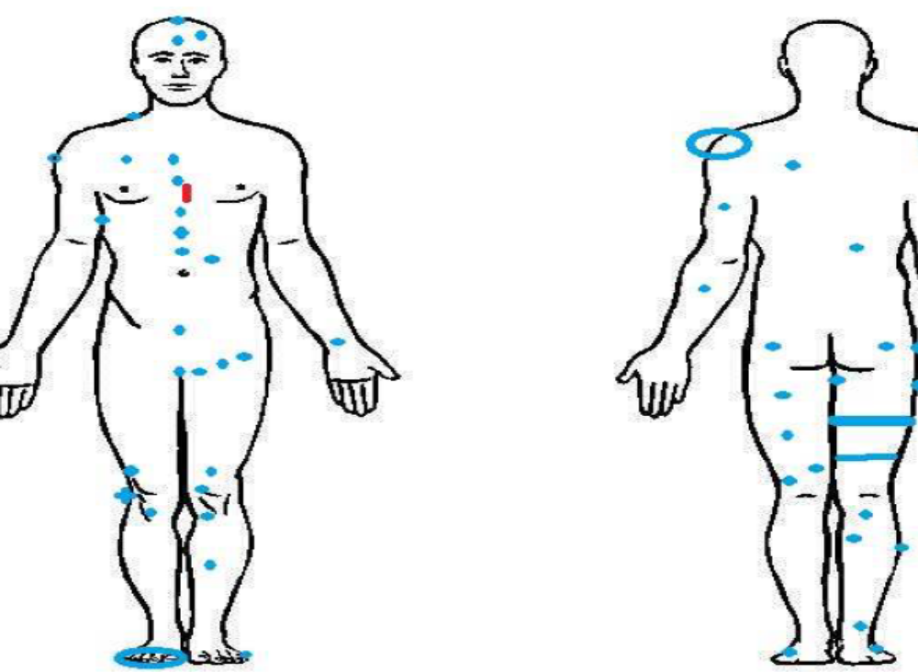
SCAN OBSERVATIONS OF NOTE
Using Method Standard One, with Black lying prone, the ELF/EMF Scan readings varied. The standardfor the room was 0.00-0.01μ. Testing on a brewing coffee pot in an adjacent room showed 0.32 μ.
With equipment showing readings within normal limits, testing proceeded. Normal for Black was 0.00-0.01μ except at the following locations: 0.02μ at crown of the skull; 0.02μ at the Ⓛ parietal bone (forehead); 0.02μ at the center of the parietal (forehead); 0.02μ at the ® trapezious; 0.02μ-0.05μ oscillating at the ® pectoralis minor; 0.02μ at the ® deltoid; 0.02μ at the ® medial bicep; 0.02μ at six points in what appears to be a line starting from mid sternum, past a scar, and ending at the pubic bone; 0.02μ-0.05μ oscillating at the Ⓛ lower quadrant of the abdomen; 0.02μ in three points that appear to be a line across the Ⓛ hip flexor; 0.02μ at the Ⓛ wrist; 0.02μ at the Ⓛ rectus femorus (quadriceps); 0.02μ at the Ⓛ knee with two points superior and one point inferior; 0.02μ with one point superior and one point inferior to the ® knee; 0.02μ-0.04μ oscillating just inferior to the ® patella; 0.02μ-0.05μ oscillating at the ® distal phalanges of the foot; 0.02μ at the median of the Ⓛ tibia; 0.02μ at the fifth distal phalange of the Ⓛ foot; -0.00-0.02μ oscillating at the shoulders, bilaterally (negative readings are unusual in this investigator’s experience); 0.05μ at the Ⓛ scapula; 0.02μ at the Ⓛ tricep; 0.03μ at the Ⓛ brachioradialis (forearm muscle); 0.03μ at the ® kidney; 0.02μ
at the ® brachioradialis (forearm muscle); 0.02μ, bilaterally, at the TrP2 of the gluteus maximus; 0.02μ-0.04μ oscillating at the ® gracillis (groin); 0.02μ at the ® lateral cutaneous nerve of the thigh; 0.02μ at the Ⓛ median of the semitendinosis (hamstring); 0.02μ-0.08μ oscillating, at the Ⓛ inferior semitendinosis; 0.02μ in a band across the median of the ® semitendinosis; 0.02μ in a band across the inferior of the ® semitendinosis; 0.02μ at the Ⓛ biceps femoris, short head; 0.02μ at the Ⓛ inferior semitendinosis; 0.02μ at the ® inferior semitendinosis; 0.02μ at the ® lateral cutaneous nerve of the calf; 0.02μ at the ® Achilles tendon; 0.02μ at the ® cuboid bone of the foot; 0.03μ at the Ⓛ cuboid bone of the foot. An image reflecting these points is shown on the following page:

