Request for Information (RFI) on electromagnetic field (EMF) exposure and human health
2. Perspective: I am an individual consumer.
3. I have never experienced any adverse health effects attributable to exposure to RF/EMFs, nor am I aware of any compelling scientific data of such effects at the extremely low levels of EMF to which members of the public are exposed.
4. Regarding reported potential adverse health effects associated with RF/EMF: Some online businesses run websites selling fear of EMF. Googling “electrosmog” reveals many such revenue generators, all of which make baseless claims of alleged health effects and feature a prominent “DONATE” button. While we should not begrudge these entrepreneurs for cashing in on ignorance and fear, in a world of finite resources, they do real harm by distracting from the actual dangers currently facing humanity (e.g., global warming).
The types of potential adverse health effects most often reported on these sites invariably focus on “opinion” studies with no dosimetry (i.e., no measurement of actual EMF exposure, just self-reported recollection of subjective proximity to devices and exposure duration) and no clinical assessment of the vague and very common symptoms (i.e., self-reported recollection of “headaches” etc. they attribute without evidence to unquantified EMF exposure). In any other context, claims of health effects from any chemical, physical, or biological agent with no actual measurements of the dose or clinical assessment of the health effects would not be seriously considered.
Some people believe that they are “hypersensitive” to EMFs the rest of us cannot sense, but there’s no evidence to back up that belief; Rubin, G. James; Hillert, Lena; Nieto-Hernandez, Rosa; van Rongen, Eric; Oftedal, Gunnhild (December 2011). "Do people with idiopathic environmental intolerance attributed to electromagnetic fields display physiological effects when exposed to electromagnetic fields? A systematic review of provocation studies". Bioelectromagnetics. 32 (8): 593–609).
5. The biological effects from exposure to very high levels of microwave radiation are very well understood (tissue heats up – the basis of microwave cooking). The levels to which members of the public are exposed (from cellular networks, WiFi, Bluetooth, etc.) are far, far too low to have any effects. The recognized exposure limits are fully adequate to protect the public. Actual exposures are well below these exposure limits. See e.g., Bushberg JT and Butcher MJ. Measurement of ambient millimeter wave exposures levels around small base stations (January 2025). Health Physics 128(2):1-7.
The groups running for-profit fear-mongering “electrosmog” websites point to the “NTP study” as a scientific basis of their claims that cell phone radiation causes cancer. They refer to the 2018 DHHS National Toxicology Program Report on the toxicology and carcinogenesis studies in B6C3F1/N mice [https://ntp.niehs.nih.gov/go/tr596] and Hsd:Sprague Dawley SD Rats [https://ntp.niehs.nih.gov/go/tr595] exposed to whole-body radiofrequency radiation used by cell phones. The rodents were exposed to levels near the public exposure limits for 9 hours a day, seven days a week, for two years. These studies showed no statistically significant effects on female mice, male mice, or female rats (except some heat-related weight loss in pregnant rats), and a HUGE increase in life span for the exposed male rats. Thermal effects can explain the significant effects in the rats. See e.g., Kuhne J, Schmidt JA, Geschwentner D, Pophof B, Ziegelberger G. Thermoregulatory Stress as Potential Mediating Factor in the NTP Cell Phone Tumor Study. Bioelectromagnetics. 2020 Sep;41(6):471-479 [https://pmc.ncbi.nlm.nih.gov/articles/PMC7522680/]. The NTP study also found a small number of rare heart tumors in the warmed male rats, but not in the mice or female rats. The NTP researchers did not control for warming the male rats (i.e., the controls were not heated the way the exposed rats were), so the most obvious explanation for the tiny number of excess heart tumors is that the exposed male rats heated up more than the mice or female rats (male rats are larger and hence have a smaller surface area to volume ratio than mice or female rats, so the male rats can’t cool as efficiently and therefore heat up more than the mice or female rats). As the study’s own peer reviewers noted, “…panelists agreed that information to specifically rule out a thermal or non-thermal effect was insufficient.” (NTP TR595 p. 420).
A review of the NTP study by internationally-recognized scientific experts on RF effects noted “…substantial limitations preclude conclusions being drawn concerning RF EMFs and carcinogenesis” and “…a preponderance of reported effects in the male rats, whose body core temperature would have increased more than either the female rats or either male or female mice (due to their smaller surface area-to-mass ratio), which would have put them under greater metabolic stress due to their greater thermoregulatory requirements.” ICNIRP Note on recent animal carcinogenesis studies (2018) [https://www.icnirp.org/cms/upload/publications/ICNIRPnote2018.pdf]
John Bucher, the lead writer on the NTP report, noted that he is not changing his cellphone use or asking his family to, and that the findings of the rare nerve-tissue tumor found in the hearts of male rats does not mean humans should be worried. [https://learningenglish.voanews.com/a/health-lifestyles-researchers-say-no-cancer-from-cellphone-use/4244699.html]
In conclusion, far from being the slam dunk evidence, the NTP study shows no effect on mice and most significantly a huge increase in the lifespan of exposed male rats. The tiny number of heart tumors in the exposed rats could most rationally be explained by tissue heating.
The electrosmog revenue generating websites also claim that cell phones cause brain cancer. They point to the International Agency for Research on Cancer (IARC) 2011 classification of radiofrequency as “possibly carcinogenic” [https://www.iarc.who.int/wp-content/uploads/2018/07/pr208_E.pdf], without mentioning that IARC’s “possibly” category has the lowest certainty of any IARC rating (below “probable” and “known” carcinogen categories), and that the “possible” rating includes things like aloe vera and ginkgo biloba [https://monographs.iarc.who.int/list-of-classifications].
The most significant source of cell phone radiation to which we are exposed is our own personal device (Bushberg et al 2020), suggesting that cell phone subscriptions are a reasonable surrogate for exposure. However, brain cancer rates have actually been steadily declining for decades, at the same time cellular device use has grown tremendously. The lack of a positive correlation between the massive increase in cell phone use and the decrease in brain cancer undermines the plausibility of this claimed health effect.
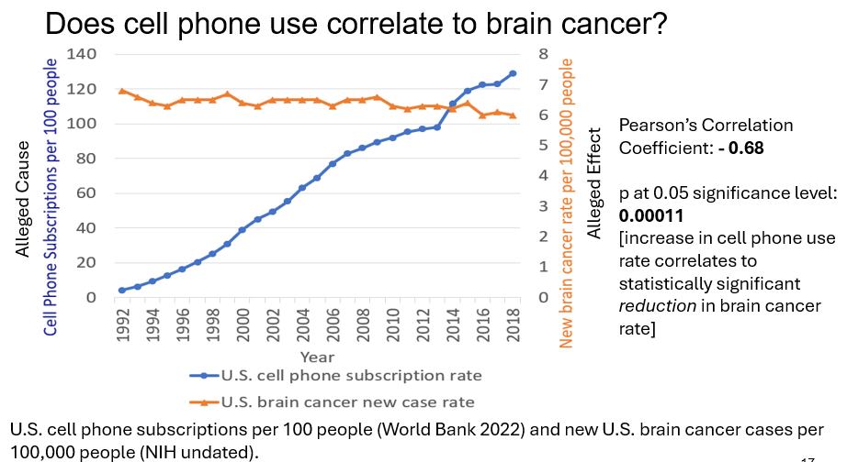
While blaming Cellular network (millimeter wave) exposure for basically every health effect endemic in the population, the electrosmog profiteers fail to produce evidence of any causal link between those effects and low level MMW phone exposure. Physics precludes many of these health effects. The tissue penetration is very shallow (a centimeter or less, decreasing at higher frequencies) and heating is the main physical effect, which is easily dissipated at the very low levels to which the public is exposed. As Wood et al’s Meta-analysis concludes, “Overall, the results of this study do not confirm an association between low-level MMWs and biological effects.” Wood, A., Mate, R. & Karipidis, K. Meta-analysis of in vitro and in vivo studies of the biological effects of low-level millimetre waves. J Expo Sci Environ Epidemiol 31, 606–613 (2021) [https://www.nature.com/articles/s41370-021-00307-7].
6. What scientific evidence exists about potential adverse health effects caused by current exposure limits? There is no converging or compelling scientific evidence of any health effects from exposures below the recognized exposure limits.
7. What scientific methods are currently available for accurately characterizing individual and population-level RF radiation exposure? The gold standard is direct measurement of cell phone and other RF device exposure levels. These measurements have already been done, and generally show exposures well below the recognized exposure limits.
9. What, if any, technical and exposure-related information should be disclosed to consumers, residents, workers, schools, healthcare providers, and local governments? Just the facts, none of the baseless claims of the electrosmog businesses.
12. What scientific evidence exists regarding potential adverse health effects associated with RF radiation exposure at levels below current federal exposure limits? None.
14. What scientific evidence exists regarding potential adverse environmental effects associated with RF radiation? None
18. Please identify any additional scientific evidence, technical information, data, or recommendations that federal health agencies should consider when evaluating potential adverse health effects associated with RF/EMF radiation exposure. See previous comments.

