Mobile phone and cordless phone use and the risk for glioma – Analysis of pooled case-control studies in Sweden, 1997–2003 and 2007–2009

Key Findings

Introduction
With 1,498 brain cancer cases and with more than 25 years of multiple types of wireless phone use, this study is the most important study on the risk of tumors from wireless phone use published to date. Most of the analysis was for glioma (92.1% of all brain cancers) as are the results shown below. The risk for the other tumor types are similar as would be expect because a tumor’s histology is unrelated to the damage caused to brain cells.

The study reports risks for analog cellphone (radiating 1 Watt), second generation (G2, GSM modulate) cellphones (average radiated power tens of mW), third generation (G3, UMTS modulated) cellphone (average¹ radiated power ten of µW) and cordless phones (radiated power 250 mW). It also reports the risk from use of various combinations of cellphones.

Key Findings
3G Phones
Counter intuitively, these phones had reported the highest risk of any phone at the same level of exposure.
- For > 5 to 10 years since first use OR=4.1;
  - Next closest risk, OR=1.7 for 2G cellphone (thousand times higher power)
- Risk increase per 100 cumulative of hours of risk was 4.7%;
  - Next closest risk, 4.3% analog cellphone (900 thousand times higher power)
- Risk increase per year since first use was 15.7%;
  - Next close risk, 5.5% analog cellphone (900 thousand times higher power)
- Risk from ipsilateral use, OR=2.3;
  - Next closest risk, OR=2.0 analog cellphone (900 thousand times higher power)
- Risk of contralateral use, OR=1.9;
  - Next closest risk, OR=1.3 analog cellphone (900 thousand times higher power)
- For > 5 to 10 years since first ipsilateral use, OR=1.9;
  - Next closest risk, OR=1.8 cordless phone (thousand times higher power)
- For > 5 to 10 years since first contralateral use, OR=1.3;
  - Next closest risk, OR=1.2 cordless phone (thousand times higher power)
- From 512 to 1,466 cumulative hours of use², OR=3.0
  - Next closest, OR=1.8 analog cellphone (900 thousand times higher power)
Comparative Risk for 2nd and 3rd Generation Cellphones
Risk per Cumulative hours of use

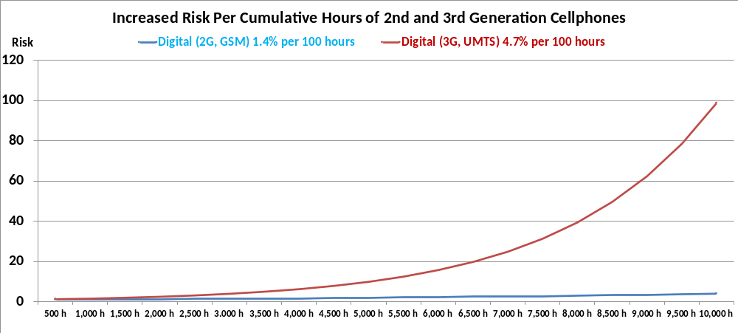

Figure 1. Increased Risk per Cumulative Hours of 2nd and 3rd Generation Cellphone Use

As can be seen over 10,000 cumulative hours the risk of using a 3rd generation cellphone is about 25 times higher. Over a 20 year period, 10,000 cumulative hours is about 1 hour, 11 minutes per day; over a 30 year period it is about 47 minutes per day.

Mechanisms
The paper describes a possible mechanism why a particular modulation technique could explain why a thousand fold less radiated power by a 3G, UMTS modulated phone relative to a 2G, GSM modulate phone would have a significantly highest risk of brain cancer. The authors write:
To our knowledge, there are only two mechanistic studies, which compare effects of 2G and 3G signals using the same experimental approach under well-defined conditions of exposure [32,34]. UMTS MWs affected chromatin and inhibit formation of DNA double-strand breaks (DSB) co-localizing53BP1/gamma-H2AX DNA repair foci in human lymphocytes from hypersensitive and healthy persons [32]. The data were in line with the hypothesis that the type of signal, UMTS MWs, may have higher biological efficiency and possibly larger health risk effects compared to GSM radiation emissions. The effects of UMTS MWs and GSM-915 MHz MWs on the formation of the DNA repair foci, were statistically different for hypersensitive but not for control subjects [32].Chronic exposure to GSM and UMTS signals resulted in significant inhibition of DSB repair in human stem cells[34]. Statistical analysis revealed that UMTS exposure affected human stem cells more strongly than did the GSM exposure [34]. Inhibitory effects of MW exposure on DSB repair in stem cells may result in formation of chromosomal aberrations and therefore origination of cancer. Alternatively, MW exposures may induce a stress response. Both possible interpretations provided a mechanistic link to increased cancer risk because stem cells are considered as most relevant targets for origination of tumours of different types including glioma [34].

There are two additional studies from the EU funded REFLEX study of human fibroblast cells reported greater risk from 3G UMTS modulated cellphone radiation compared to 2G, GSM modulated cellphone radiation.

The REFLEX study that examined the SAR threshold for genotoxic damage (i.e., mutated DNA) to human fibroblast cells from exposure to 2G cellphone radiation reported the threshold SAR=0.30 W/kg (Risk Evaluation of Potential Environmental Hazards From Low Frequency Electromagnetic Field Exposure Using Sensitive in vitro Methods, QLK4-CT-1999-01574 / REFLEX / Final Report, Section 3.2.1.2 Human fibroblasts and granulosa cells of rats (Participant 3), Figure 94, page 128).

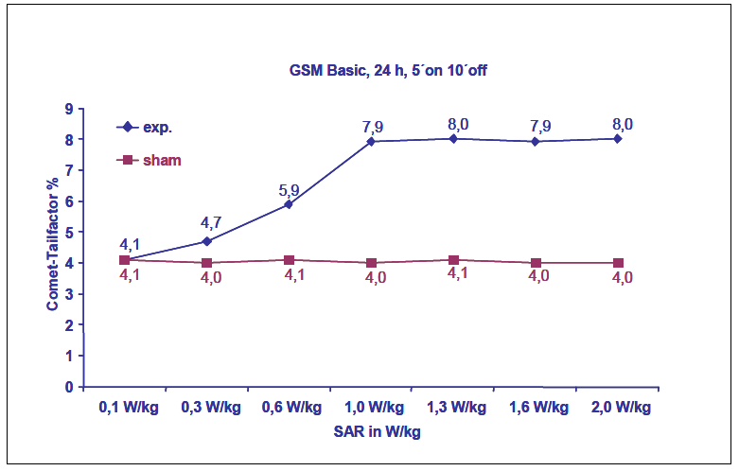
Figure 94. Dose dependent increase of DNA single and double strand breaks in human fibroblasts determined with the Comet assay under alkaline conditions

The REFLEX study that examined the SAR threshold for genotoxic (i.e., mutated DNA) damage to human fibroblast cells from exposure to 3G cellphone radiation reported the threshold SAR=0.05 W/kg was Claudia Schwarz, Elisabeth Kratochvil, Alexander Pilger, Niels Kuster, Franz Adlkofer, Hugo W. Rüdiger. Radiofrequency electromagnetic fields (UMTS, 1,950 MHz) induce genotoxic effects in vitro in human fibroblasts but not in lymphocytes. Int Arch Occup Environ Health (2008) 81:755–767.

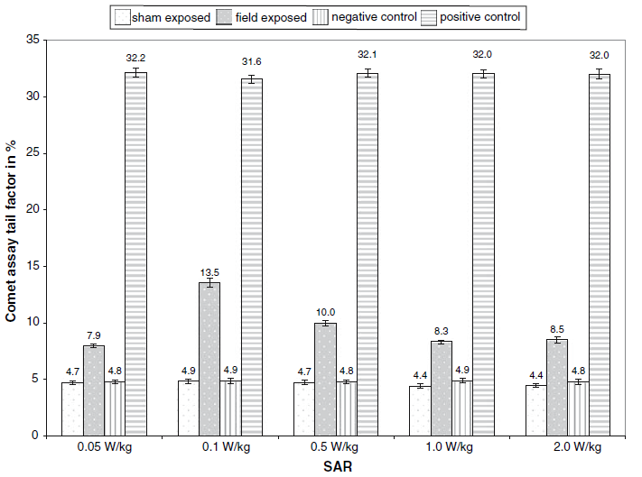
Fig. 1 Specific absorption rate dependent increase of the comet assay tail factor after 24 h exposure. Figures and bars represent mean and standard deviation of three independent exposures/SAR level, using fibroblasts of donor ES-1. Negative, positive, and sham exposed controls were performed for each exposure. The CTF increase was statistically significant
(P = 0.02) for all SAR levels, calculated for each individual SAR using three EMF exposed versus the combined values of three sham-exposed plus three negative controls.

In other words, the threshold for damaged DNA in human fibroblast cells was 6 times lower from G3 UMTS modulation compared to G2 GSM modulation.

In summary there are at least 4 peer reviewed science papers that report stronger adverse effects from G3 UMTS cellphone radiation compared to G2 GSM cellphone radiation, and this latest Hardell & Carlberg study reporting the highest risk from G3 UMTS modulated cellphone radiation compared to any other type wireless phone with average radiated power between 1,000 and 900,000 time lower than the wireless phone type with the closest, but lower, risk factor.

Cancer Promotion and Initiation
The authors write “For ipsilateral mobile phone use and latency, the curve was slightly different compared with total wireless phone use, with an increased risk for short latency (<10 years), which dropped off slightly before increasing again with longer latency >20 years (non-linearity P = 0.01). This finding differs from contralateral mobile phone use, compare Figs. 3 and 4. It should be noted that contralateral use was defined as less than 50% of the time. Similar results were found for cordless phone use. These results indicate an early effect in brain tumourigenicity (initiation) and a late effect (promotion), as discussed elsewhere [24].”

This becomes clear when we closely examine Figures 3 and 4. Figure 3 is for ipsilateral exposure (higher risk) and Figure 4 is for contralateral risk (lower risk). We see in Figure 3 the Odds Ratio (OR—the risk factor) increase to about OR=2.4, peaking around 5 years. It then decrease to an Odd Ratio of about OR=1.5 around 11 years since first use. This is a classic indication of a cancer promotion effect. A pre-existing tumor is promoted to grow faster such that it is diagnosed sooner than it would have been if its growth rate had not

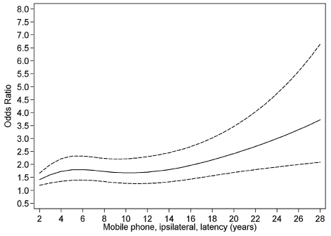
Fig. 3. Restricted cubic spline plot of the relationship between latency of ipsilateral mobile phone use and glioma. The solid line indicates the OR estimate and the broken lines represent the 95% CI. Adjustment was made for age at diagnosis, gender, SEI-code, and year for diagnosis. Population based controls were used.

increase. The risk falls afterwards until cancers initiated begin to be diagnosed. As we can see from around 11 years onward, the risk increases exponentially.

By comparison Figure 4, with its lower risk barely shows a decrease risk
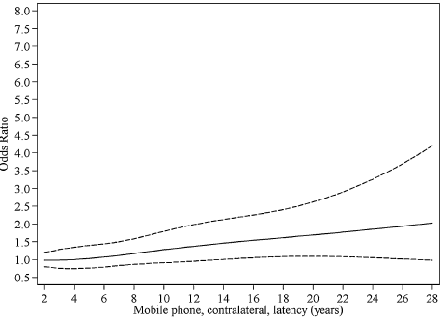
Fig. 4. Restricted cubic spline plot of the relationship between latency of contralateral mobile phone use and glioma. The solid line indicates the OR estimate and the broken lines represent the 95% CI. Adjustment was made for age at diagnosis, gender, SEI-code, and year for diagnosis. Population based controls were used.

Conclusions
The evidence continues to grow that all wireless transmitting devices (WTDs), not just wireless (cell and cordless) phones are a risk for cancer. The WTDs known as laptop computers, tablets, note books etc. kept in immediate proximity to the user may be even more hazardous the wireless phones. This is because these WTDs exposure limits are certified at a distance of 20 centimeters (about 8 inches). Certainly a laptop computer kept on the lap is not 8 inches away from the user.

Studies, including this study show, that children are at greater risk from exposure to any carcinogen compared to adults; And, the younger the child the higher the risk.

No other research group has yet to report risk on the 3rd generation cellphones. Nevertheless a 4th generation LTE modulated cellphone was introduced some time ago. LTE’s (Long Term Evolution) modulation appears to be a hybrid between GMS and UMTS modulation techniques. It is based on the GSM/EDGE and UMTS/HSPA network technologies. The G4, LTE modulated cellphones may be better, or may be worse that the G3 UMTS modulated cellphones. We can only wait and see.

Meanwhile work is underway for a 5th generation cellphone.

Hardell L, Carlberg M. Mobile phone and cordless phone use and the risk for glioma – Analysis of pooled case-control studies in Sweden, 1997–2003 and 2007–2009. Pathophysiology 2014 In-Press
“Average” because phones Adaptive Power Control (APC) circuitry controlled by cell tower that reduces the power to a level sufficient to have an adequate signal to noise ratio (SNR).
Because 3 G phones were recently introduced this is the maximum category of use available to date; the Hardell team is the only study reporting risk of 3G phones.
Ipsilateral use, ≥50% of the time phone held on side of head where tumor was located.
Contralateral use, <50% of the time phone held on side of head where tumor was located.
I.Y. Belyaev, E. Markova, L. Hillert, L.O.G. Malmgren, B.R.R. Pers-son, Microwaves from UMTS/GSM mobile phones induce long-lasting inhibition of 53BP1/-H2AX DNA repair foci in human lymphocytes, Bioelectromagnetics 30 (2009) 129–141.
E. Markova, L.O.G. Malmgren, I.Y. Belyaev, Microwaves from mobilephones inhibit 53BP1 focus formation in human stem cells more strongly than in differentiated cells: possible mechanistic link to cancer risk, Environ. Health Perspect. 118 (2010) 394–399.
DSB: DNA double strand breaks
SEI-code: socio-economic index

