Title: Oxidative Stress: The Cause of Autism and Disease in General
Author: Martin T. Moore M.S. Professor of Kinesiology
Institutions: USC, UWM, Dallas College, Tarrant County College
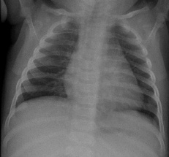
A review of literature indicates that many researchers have confirmed that oxidative stress (OS) not only correlates with neurological disease but may cause disease. (1,2,4 ). While many individuals that undergo oxidative stress may escape the cellular damage or death which leads to a disorder, it seems to be determined quite often by the activity of HIF (Hypoxia Inducible Factor) (3). The oxidative stress created by mitochondrial dysfunction can affect gene expression and development of the immature brain (20, 21). Oxidative Stress causes are numerous, especially given the changes in lifestyle during the last 45 years. The focus of this paper is the prevention of disease by safeguarding against the triggers of OS detailed in this review. Prospective parents and especially mature adults should become familiar with OS causes and make their best effort to reduce the risk of OS during pregnancy for the mother, in the child post birth, and adults as they age. Testing for OS during illness or testing routinely is a reasonable screen to perform, as detailed in this Pilot Study. Hydrogen Peroxide is a ROS (reactive oxygen species which accompanies OS and inflammation (13,14, 20, 21, 23) and maybe an easy in-home test to perform for a cost of approximately 45 cents per test!
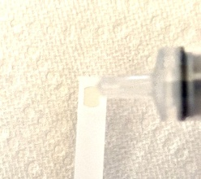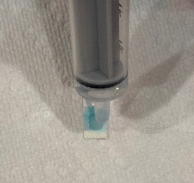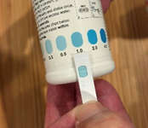
Harvest saliva with a pipette. Apply to a test strip until saturated. Wait one minute and compare any color change to the chart provided. More than .3 ppm requires immediate medical attention. Color chart measures may vary by manufacturer, so I regard any color change post application as a medical emergency.

