5G/nextG Towers. Are you seeing what scientists clearly tell us is remote-killing, remote-vaccinating, and remote-bio-robot-control technology every few miles where you live? Please read and share this flyer, which is a tip of the iceberg.
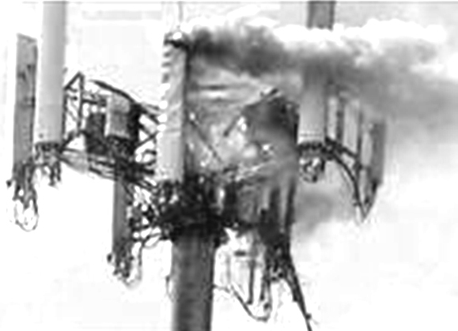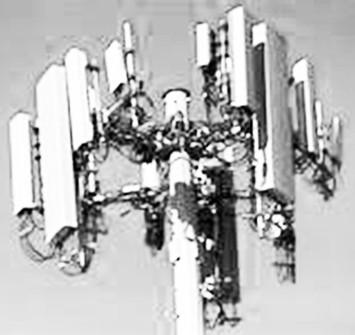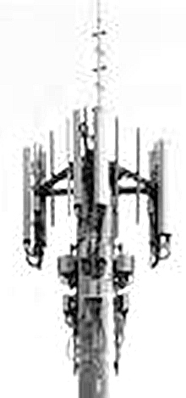

- But did you know people worldwide are setting up locally-controlled
SAFE-G broadband fiber networks and choosing safe alternatives?
See side 2.

- Did you know safe-G guidelines are being added to municipal codes

so cities have a safe alternative to remote-source 5G/nextG signal?

WHAT DO INDUSTRY LEADERS THEMSELVES SAY ABOUT 5G/nextG?
Are you seeing towers like these where you live?

1/ "5G Systems Are Critical for the Use of Hypersonic Weapons"
https://www.asdnews.com/news/defense/2021/07/09/5g-systems-are-critical-use-hypersonic-weapons
https://web.archive.org/web/20230129133536/https://www.nationaldefensemagazine.org/articles/2022/9/1/upcoming-darpa-program-to-allay-5g-security-concerns
Excerpts: 5G "has the ability to build a centralized infosphere with … targeting, surveillance, and signals intelligence. … smart hypersonic missiles with … quick access to … the frontline of the battlefield, and unmanned aircraft that can fly safely alongside passenger aircraft in commercial airspace … critical for the use of hypersonic weapons, [ie] missiles that fly faster than Mach 5 and can carry nuclear warheads. … to guide them on unpredictable trajectories, changing direction in a split second to avoid interceptor missiles … In the event of attack … the only option is … 5G automatic systems. … in … the future war network. … 5G would combine fragmented networks into a single network, allowing soldiers to be more aware of their position and make better decisions. …Secret services and special forces are expected to benefit greatly from 5G. … It will increase the lethality of killer drones and war robots by allowing them to recognize, track, and target people based on facial recognition and other characteristics. As a high-tech arm, the 5G network is also expected to be a target for cyber-attacks and wars [with] next-generation weapons..." 2/ Factual reports: https://www.civilianintelligencenetwork.ca/?s=5g
2 Timothy 1:7 "God has not given us a spirit of fear, but of power, love, and a sound mind." https://karenkingston.substack.com

3/ 5G and Health: https://pubmed.ncbi.nlm.nih.gov/?term=5g+health

4/ 5G and Wildlife: https://pubmed.ncbi.nlm.nih.gov/34047144

5/ High-bandwidth brain-computer interfaces: https://neuralink.com

6/ 5G Graphene Transceivers --- (Graphene is in the vaccines)
Robert F. Kennedy, Jr.'s website: https://childrenshealthdefense.org/?s=5g
https://graphene-flagship.eu/innovation/spearheads/c2-sh01-5g

7/ Lockheed, Verizon testing 5G-linked drone swarm for intel collection:
https://www.c4isrnet.com/battlefield-tech/it-networks/5g/2022/09/28/lockheed-verizon-testing-5g-linked-drone-swarm-for-intel-collection

8/ Nano-tech for intra-body bio networks, wireless antennas in everything including human bodies, connecting brains
to machines, etc. https://unlab.tech/team_members/josep-miquel-jornet 9/ Search: Synthetic Telepathy

10/ Mind control using sound waves? The WEF asks a scientist: 11/ Search: Remote Neural Monitoring https://web.archive.org/web/20181211093235/https://www.weforum.org/agenda/2018/11/mind-control-ultrasound-neuroscience

12/ Huawei Owns Majority of the 87,771 5G Patents (so far): https://www.greyb.com/blog/5g-patents

13/ 3-mm biosensors implanted 2 to 4 mm below skin surface communicate with smartphone apps via optical readers: https://www.digitaltrends.com/cool-tech/darpa-awards-profusa-grant-for-implantable-biosensor
14/ Search: forced chips Bob Boyce, James Walbert
Sample List of Weather-Modification Patents: https://geoengineeringwatch.org/links-to-geoengineering-patents

15/ Conductive polymer hydrogels are a platform for electronic sensors in soft materials
and organic conductors: https://pubmed.ncbi.nlm.nih.gov/31367298 Also includes a list of links to similar articles.

16/ DARPA hydrogel transmits radio signal to living cells: 17/ Search: US Army Psyops Jobs 5G graphene
https://raggioindaco.files.wordpress.com/2021/04/analysis-of-test-sticks-from-surface-testing-in-the-slovak-republic.pdf
18/ Genetically engineered 'Magneto' protein remotely controls brain and behavior:
https://www.theguardian.com/science/neurophilosophy/2016/mar/24/magneto-remotely-controls-brain-and-behaviour

Some ways to protect yourself a bit:

1 WestonAPrice.org/health-topics/5g-negative-health-effects/#gsc.tab=0

2 HomeopathyForWomen. org/vaccine_detox_program.htm

3 ehtrust.org/ten-steps-to-safe-tech

4 youtube.com/watch?v=T3Ik6Qe9-R0

19/ DARPA Bio-Technologies Office: https://www.darpa.mil/about-us/offices/bto

20/ Tactile Internet in 5G/nextG: https://ieeexplore.ieee.org/document/9034103

21/ Graphene history, etc.: https://pandemictimeline.com/?s=graphene

22/ 5G weapons are a Pentagon/DARPA priority for electronic-warfare battlefields;
MICHIGAN war simulation: https://spectrum.ieee.org/lockheed-martin-5g

23/ Peer-reviewed research on 5G as possible cofactor/contributor to COVID-19:
https://www.ncbi.nlm.nih.gov/pmc/articles/PMC8580522

24/ China dominates global fiberoptic market (and 5G): https://www.fortunebusinessinsights.com/fiber-optics-market-102904

25/ Proposal to prevent humans from intervening in demographically-targeted, remote-controlled “vaccination” deployments by means of tiny drones (UAVs), 5G-tactile-internet, and a database that tracks who's been “vaccinated”:
https://pubmed.ncbi.nlm.nih.gov/34388100 Has links to similar articles. 26/ KILLBOX: https://files.catbox.moe/34ubr1.pdf
27/ NEUROWEAPONS control souls Dr. Robert Duncan Project Soul Catcher amazon.nl/-/en/Robert-Duncan/dp/1452804087 Jim Giordano’s neurobattlefields pennybutler.com/giordano-2017-2022 A bibliography pmc.ncbi.nlm.nih.gov/articles/PMC5028939

28/ Microsoft's patent for paying workers cryptocurrency according to their remotely-monitored “body-activity data.”
Discussion and link to the patent: https://bitcointalk.org/index.php?topic=5242473.0 "A sensor … in the device of the user may sense body activity … The cryptocurrency system … may verify if the body activity data satisfies … conditions … and award cryptocurrency to the user whose body activity data is verified." 29/ https://gangstalkingmindcontrolcults.com/?s=5g
_________________________________
30a/ Patent: http://patents.justia.com/patent/10461421 5G street-light control

Who Owns the 5G Cellular Towers in the United States?
30b/ Remote Control - LED Lightbulbs https://stop5g.cz/us/optogenetics-li-fi-light-fidelity-dangers-of-5g-led-street-light-phototoxicity-smart-light

https://dgtlinfra.com/who-owns-the-5g-cellular-towers (Also see ee.co.uk/our-company)
https://AmericanTower.com NYSE, ticker AMT. 40.6k US towers; 179k global.
https://SBASite.com NASDAQ, ticker SBAC. 16.5k US towers; 32.7k global.
31/ https://drloveariyana.substack.com/p/updated-graphene-oxide-the-vector Graphene oxide is for bioweapon delivery.
https://CrownCastle.com NYSE, ticker CCI. 40.1k US towers; 0 global.
Without local oversight, companies like these find and privately buy or rent small squares of land on which to build a tower. Data-transmission equipment is stacked on different levels at the tops of the towers. Each level is rented out to carriers like T-Mobile and Verizon. The higher the level, the higher the rent.
LOCATE TOWERS: 1 cellmapper.net 2 scadacore.com/tools/rf-path/cell-tower-map-united-states
32/ 2013 "We … remote-control [‘medical’] nano-robots with a joystick" https://www.youtube.com/watch?v=MzLTWU2EqP4

3 emf-guard.com/5g-towers-near-me 4 whistleout.com/CellPhones/Guides/5g-coverage-maps-compared
5 lifewire.com/5g-availability-us-4155914 6 speedtest.net/ookla-5g-map 7 towermaps.com/the-map.html
33/ Search: Electronic Warfare
How can this be happening so quickly? https://www.fcc.gov/media/over-air-reception-devices-rule
To rush, somebody who was paid tax-money via the U.S. “Federal Communications Commission” invented the OTARD Rule.
It claims it “prohibits restrictions that impair a person's ability to install, maintain, or use an antenna covered by the rule.”
Top Five U.S. 5G-Research Leaders https://www.fiercewireless.com/special-report/top-5-academic-institutions-leading-5g-research
Six major banks rehearse for ESG climate-induced financial crisis: https://www.federalreserve.gov/newsevents/pressreleases/other20220929a.htm
https://www.WorldCouncilForHealth.org/what-is-5g
A Few Resources (of 1000s) for Contending With 5G/nextG
Responsible Tech Toolkit has: | Municipal Codes  Sample Letters | Webinars  Lobbying Basics | Flyers  Rally Signs |  | Sample Resolutions  Sample Legislation | OTARD Materials  "Undeniable Risk" Booklet
https://www.americansforresponsibletech.org/tool-kit  Friendly Tech Edu/Resources https://takebackourtech.org/about |  |  |  | Overturn Section 704! https://704nomore.org
https://www.americansforresponsibletech.org/first-steps
B. Blake Levitt Fiber To The Home. FTTH. https://emrabc.ca/?p=14812&cpage=1#comment-724045 Into the HOME.
Read the comment there too!!!
Locally-Controlled Fiber Networks. LOCALLY CONTROLLED. FIBEROPTIC NETWORKS.
https://muninetworks.org/content/our-vision https://muninetworks.org/fact-sheets
https://cyber.harvard.edu/sites/cyber.harvard.edu/files/2018-01-10-Pricing.Study_.pdf
https://www.addonnetworks.com/solutions/insights/fiber-networks-expand-worldwide
EU stop5g.cz/us UK nationalresidentsassociation.co.uk Canada c4st.org Australia stopsmartmeters.com.au/?s=5g | CommunityNets.org
INTERNATIONAL Stop 5G Earth & Space …………………………………………………………………………………………………..………………….5GSpaceAppeal.org | Fiber Broadband Association accelerates and deploys fiber/broadband so every community can get the benefits only fiber/broadband provides. U.S. fiberbroadband.org
EMR Health emrabc.ca ElectroMagneticHealth.org | https://www.fcc.gov/consumer-help-center-data
Self-Reliance Institute ilsr.org/broadband 5GExposed.com SafeG.net OurTownOurChoice.org .
HealthImpactNews.com 350 Self-Reliance Resources | EHTrust.org/educate-yourself/ten-steps-to-safe-tech
https://www.conservativereview.com/horowitz-reconstituting-the-america-we-once-loved-in-red-states-part-1-medical-freedom-2659060793.html

Solari Report – Things We Can Do home.solari.com/?s=5g |  | Solutions Lists pennybutler.com/c19 |  |  |  | Mainstream Fiber-News Site fibre-systems.com
 |  | BioInitiative.org | signstop5g.eu | ehsciences.org/?s=5g
Environmental Health Trust  Protect Children EHTrust.org | InPowerMovement,org  Learn and Respond: Send Notices of Liability |  |  | Brain Privacy Rights  neurorightsfoundation.org |  |  | Europe Safe Connections esc-info.eu
"Entire species … sterilized or weaponized ... Species-wide behavioral modulation ... peer-reviewed ... in open-access journals. ... nanotransducers can interface with neural structures without physical contact using ... ultrasound, magnetic, optical. ... a population neurologically responsive to [radio] signal, without ever implanting a chip. It is the ... potential end of unmediated thought." iceni.substack.com/p/the-invocation-of-the-one-who-remembers
Scientists: Scientists4WiredTech.com  CISTech.info TI Investigations, Resources |  |  | CitizensFor5GAwareness.org |  | Actions: SafeTechInternational.org
Is Fiber Better? eff.org/wp/case-fiber-home-today-why-fiber-superior-medium-21st-century-broadband
Fiber To The Home (FTTH) Network Design: thefoa.org/tech/ref/appln/FTTH-design.html ElectronicSilentSpring.com
Broadband Global Growth oecd.org/digital/broadband/broadband-statistics Rural US Broadband: ntca.org
“Make an appointment to meet” bailiwicknews.substack.com/p/on-quietly-bringing-county-state?publication

Get Fiber/Broadband U.S. https://broadbandnow.com/report/fiber-optic-availability-map - Make sure it says Fiber or Cable or DSL

Contending With Reality. Is our neighborhood being transformed into a remote-weapon battlefield that people we don’t know control? What’s being done here—without our knowledge, consent, or participation? Do we want remote automated-surveillance, kill-tech, and human radio-signal transceivers in our area? In our bodies? Who controls this tech? Where are they? What are their names? Are local authorities and qualified engineers aware of and responding to what's happening? Would people who work in robo-kill tech choose safe alternatives if they could? Who can you pass this flyer on to? (Be create -ive!).

GET THE PDF OF THIS PRINTABLE FLYER FROM
35/ Strangers can see you via your wifi. https://www.blacklistednews.com/article/ 85349/your-wifi-can-see.html
34/ "Viruses" in hydrogel activated by 5G. https://rumble.com/v1owcgh-parasites-a-new-paradigm.html
https://t.me/For_5G_Solutions_Awareness/38
Please print and post and host!
Stop5gFlorida.com
MartinGeddes.com/?s=5g
V. 38

