I am reporting drones on our property for 9 months every day from the hours of 3 am to 6 am, pressing against my sleep room windows. They are thermal radiation drones. I am complaining that the drones are causing a nuisance and disturbing us, they press against our windows in the sleep room at night time and play their little war games here. I want it to stop. They don't just fly over, or hover, they actually press against our windows & play wargames and follow me in to whatever room I am sleeping in and take photos and I stay awake waiting for it and watch what they do every night. I am a mother and I am not young, I am in my fifties, 52 years old, I have a doctor’s note saying I cannot have wifi on my property, I do not use a cellphone and I live on 16 acres in the middle of the woods, the forest so I am far away from everything.
I need my sleep and rest and I do not have any lights at night time, I turn the outdoor lights off because we don’t want bugs, and I have EHS-electrosensitivity and a doctor’s note saying I cannot have excess radiation, no wifi is allowed here on my 16 acres I have a measuring meter that measures the amount of radiation and it is only high level when the drones are here. I need to identify these drones. I don't know how big or small the drones are but they need to be identified, even if they do not have an ID on them. In the past I complained about drones doing this at my last home and nothing was done about it. For these 9 months since the day we moved here and the day the drones started pressing up against our windows, I made drone shields made of aluminum reflectix and cardboard, window shields and it looks sad and dark here with these in the windows, it looks like I live in a cave in my logcabin.
I now sleep in a different room and had to put window shields up, I have to sleep in a room with no windows because the drones keep bothering me each night, I am a health practitioner and this is not healthy and I want the drones to stop encroaching on our property. They are taking photos of me sleeping and they need to mind their own business, I am tired of them harassing me. I did not want to complain every day about this and I did not want to deal with this so that is why I waited 9 months to report this with you regarding the drones flying at my property in Carthage, NC 28327. I finally filed a report with the Sheriff today and the file report number is:2026-040-235.
I need this investigated. The person at the Fort Bragg Office on the phone said that she wants me to know that there is a Military Housing Area called Linden Oaks near me, I looked up the address and it looks like it is in Cameron, she told me they practice flying drones but she said not the hours of 3 am - 6 am. I notice they are mostly here at 4 am if not then the other hours they spend a lot of time here, for hours pressing in my windows staying there. I am thinking they are here playing their wargames off hours, messing with me. I don't want to have to hire an attorney to help me fend off the drones wherever I live. It is a serious drone issue problem and I am documenting everything and reporting it to the government, FCC, and MAHA as well. I am planning on setting up a drone abuse support page, for others who are experiencing drones on their property because other people told me they are experiencing similar things, it is not just me and this should not be allowed.
There needs to be better drone laws, more strict rules, limitations and not abuse and misuse, there needs to be better drone regulations and each drone whether small or big needs to be identified. Enough is enough. Hope you can help us. ~sent from an ethernet cabled computer, no wifi
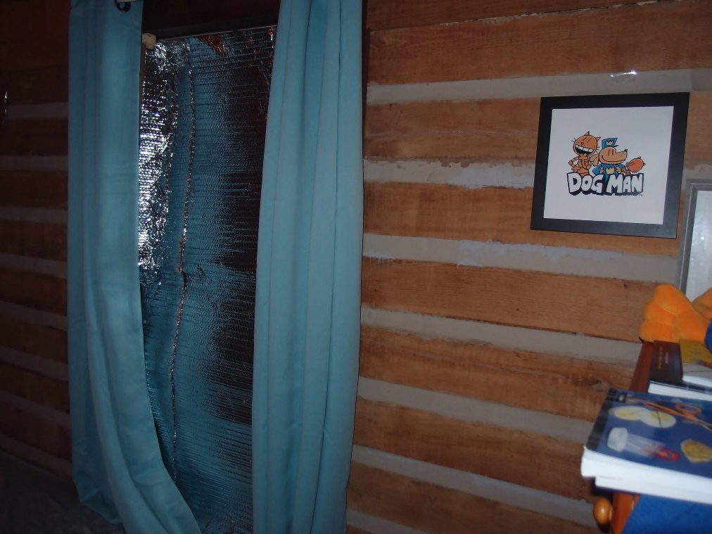
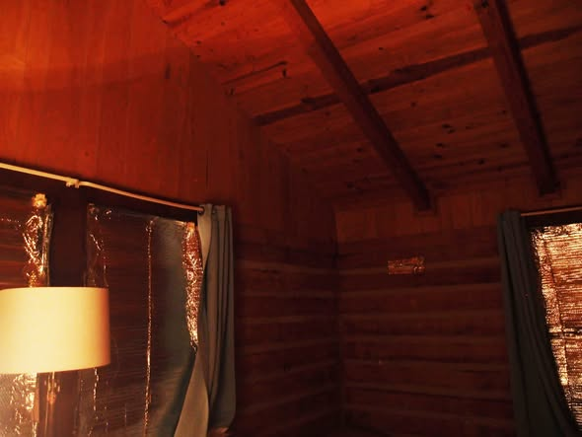
Photos above are drone window shields with 3 layers of Reflectix, 2 layers of cardboard, window shutters, drones pressing In our windows are such a nuisance and we have been living with darkened windows for 11 years since the drones started doing this in every home it is the same privacy problem. And I made window shutter that is made of wood and aluminum but it was too heavy for me to lift in and out of the window, so we keep these here and it is sad and dark for the family sleep room, we like lots of light but the drones used to sit in my 7 ft. skylight windows that I had to paint to black them out so the drones wood not spy on us. Same with the last skylight home and we can no longer get skylights because of this. These are regular windows and we have to sleep in a room with no windows in order to not be harassed. Please help stop these serious drone issues. I also jump every time they beam their thermal radiation on me and I get symptoms, they still come here each night even though I blacked out the windows and they also follow me to whatever sleep room I am in and press against my window and I believe they take photos, their thermal radiation scans MY BODY. My cats also need to avoid it and they are messing with all of us.
Here is a letter response from Fort Bragg, and my response concerning this matter:
