September 22, 2026

Dear Mr. Kennedy,

You are my HOPE! And I am your proof.

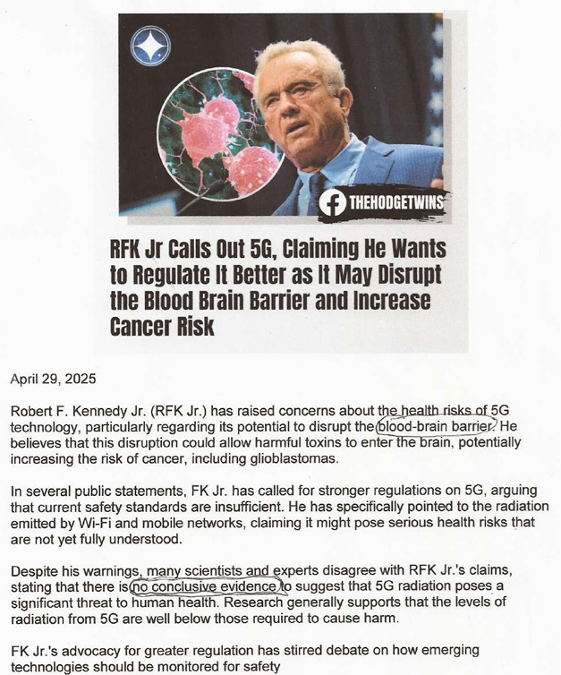

Your April 25, 2025 article indicated you are raising awareness concerns about 5G. The scientists claim there is “no conclusive evidence”, but my blood brain barrier has been affected (broken through) by exposure to WiFi and mobile networks. Use me as your evidence. My husband is submitting these online comments for me.

I worked in major corporations for years and was fully trained for utilizing computers. My last job was in a call center with fluorescent lighting in cubicles housing 125 computers plus telephone headsets. My body weakened each day until I was finally overcome by seizures and was forced to leave my job, home and friends seeking a more remote setting away from EMF.

I was diagnosed in 2010 with Electromagnetic Field (EMF) Hypersensitivity (EHS) by the late Dr. William Rea at the Environmental Health Center in Dallas, TX and was awarded disability under sections 216(i) and 223(d) of the Social Security Act in 2011. I suffer from EMF generated by electrical wiring, cell phones, WiFi, fluorescent and LED lighting, cell towers, smart electrical meters and 5G. Today, it seems everybody, even children, are carrying cell phones, but now there are also smart watches, smart sunglasses, smart rings, smart household appliances with WiFi connecting everything, even implanted health monitoring devices. Where will it end? There are fewer places for those of us with EHS to hide. It has been 16 years since I could shop in a store, visit the library, eat in a restaurant, attend church or be anywhere in public.

In 2010, EHS was deemed a rare disorder, but classified as the “up and coming” environmental illness. Electromagnetic frequency is poisoning each of us as our bodies cannot evolve fast enough to tolerate it, some people more than others. Symptoms such as insomnia, headaches, tinnitus, vertigo, nausea, heart palpitations, body aches, hand and face numbness and sporadic flu symptoms are all indications of EMF overexposure. Even Nicola Tesla, the inventor of alternating-current electricity, radio, fluorescent lights, remote control, robotics and the electric motor, found himself experiencing all of the above symptoms later in life and is possibly the first victim of EMF poisoning, caused by his experiments.

A U.S. National Toxicology Program $25m two-year study found clear evidence linking RF radiation to cancer, including malignant brain tumors (gliomas) and heart tumors (schwannomas) in animal studies. The Internation Agency for Research on Cancer has classified non-ionizing EMFs as possible human carcinogens, while some view it as known carcinogens. A 2022 Polish Department of Environment study of honeybees exposed to man-made EMF found bees can lose their ability to pollinate and navigate, which threatens our food supply.

My brother challenged me to write a book about my life as he could not believe what he was witnessing in my reactions to EMF. I did write the book, published in 2019, entitled “PLUCK, A Faith Based Memoir of Living with Electromagnetic Hypersensitivity”. I could not publicly promote it with book signings or set up a booth as I couldn’t function in public, which inhibited the book’s ability to reach and educate the public.

I wanted to reach even one person who was unaware of the cause of what was affecting them physically. I did receive letters from various people who had read my book, even from a surgeon who could no longer practice her skills because of EHS. Dr. Rea told me that 9 out of 10 people with a diagnosis of EHS committed suicide. He was adamant that I be the one to make a difference.

And I am not alone. My husband participates in a Facebook “Electrical Sensitivity Support Group” with 11,400 members and growing, all of whom have adverse reactions to electromagnetic fields, sharing experiences and information on how to survive. (20+) Electrical Sensitivity Support Group | Facebook

Arthur Firstenberg spent his entire career documenting the biological effects of the electromagnetic spectrum - from the extremely low frequency (ELF) fields generated by power lines and household wiring at 50/60 Hz, through the radio frequency radiation (RFR) of broadcast towers, radar systems, mobile phones, WiFi routers, and satellite constellations operating at MHz and GHz frequencies. His book “The Invisible Rainbow” was one of the books which helped me understand how the evolution of electricity has affected us all. Norman James wrote an excellent article March 12, 2026 Arthur Firstenberg: The Man Who Listened When Nobody Else Would describing how Firstenberg’s life was cut short by the ever-increasing EMF signatures. His symptoms were typical of others suffering from EHS:

- Nausea - persistent and debilitating, triggered by proximity to electronic devices
- Severe headaches - reported consistently in the presence of wireless signals
- Insomnia - chronic inability to sleep in electromagnetically polluted environments
- Heart arrhythmia - cardiac irregularities linked to EMF exposure events
- Vertigo and loss of balance - inner ear disruption from electromagnetic fields
- Diarrhea - gastrointestinal disturbance as a consistent EHS symptom
- Tinnitus - ringing in the ears, a hallmark of electromagnetic sensitivity
- Crippling joint pains - musculoskeletal symptoms that worsened with exposure
- Impaired vision - visual disturbances connected to EMF proximity
- Memory difficulties - cognitive impairment during exposure events
- Nerve pain - neuropathic symptoms throughout the body

He was able to trace each new symptom to an introduction of new source of EMF.

In 1997, Firstenberg’s Cellular Phone Task Force was the lead petitioner joined by dozens of other parties to challenge the Federal Communications Commission (FCC) RF radiation exposure limits. The FCC continues to rely upon outdated safety guidelines established in the 1990s, which consider only the thermal effects of RF-EMF and not the non-thermal biological effects such as DNA damage, oxidative stress and cellular dysfunction which pose significant health risks, especially to children. The FCC must immediately update its safety guidelines to reflect current scientific understanding and place an immediate halt to 5G expansion and prioritize public health over corporate profits.

My husband designed and built a low-EMF home for us in a small community remote from any nearby cell towers and having all underground utilities without 5G. The home incorporates metal-clad (MC) electrical cabling which shields from generating EMF, has wired ethernet (no WiFi), remote attic exhaust fan motors, a shielded mechanical room for the HVAC and water heater, no microwave, no dishwasher, a streaming projector and screen instead of a TV and a refrigerator without a motorized ice dispenser located in a room adjacent to the kitchen. The home is not immediately near neighboring homes without such design protections, and I can enjoy having the convenience of electricity there without the health hazards.

A planned community comprised of all low-EMF facilities and homes would give refuge and hope to thousands, if not millions, of those suffering from EHS. Green Bank, WV, part of the 13,000 square mile National Radio Quiet Zone for the National Radio Astronomy Observatory located there meets some of the requirements for such a planned community. There is no existing community infrastructure today and many of the Green Bank locals resent EHS sufferers who have moved there. It would require government support to create the climate for creation of such a planned community, but it might prove to be a model for the entire world.

I continue to pray for you, Mr. Kennedy, and President Trump and am hopeful the overwhelming EMF proliferation will be addressed.

